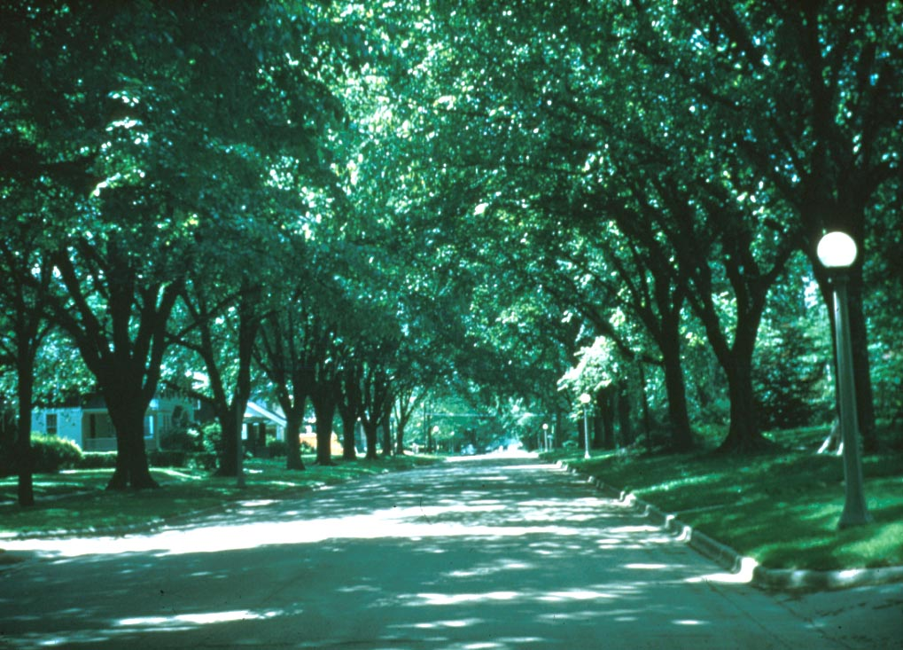

Recommended Urban Trees:

Site Assessment and

Tree Selection for Stress Tolerance

Urban Horticulture Institute
Department of Horticulture
Cornell University
Ithaca, New York

RECOMMENDED URBAN TREES:
Site Assessment and
Tree Selection for Stress Tolerance

URBAN HORTICULTURE INSTITUTE
DEPARTMENT OF HORTICULTURE
CORNELL UNIVERSITY
ITHACA, NEW YORK
Nina Bassuk
Deanna F. Curtis
BZ Marranca
Barb Neal
Urban Horticulture Institute
Cornell University
134A Plant Science Building
Ithaca, New York 14853
(607) 255-4586 [Phone]
(607) 255-9998 [Fax]
nlb2@cornell.edu [e-mail]

To Order Contact: urbanhort@cornell.edu
Copies - $15.00 (Bulk order discount available)

A companion video, ‘Tough Trees for Tough Sites’
is available from the e-mail address above for $20.00

©Urban Horticulture Institute, 2003

TABLE OF CONTENTS

Acknowledgments……………………………………………………………...  Introduction………………………………………………………………….....  Using this book……………………………………………………………...…  Site assessment checklist…………………………………………………...….  Completing the site assessment checklist……………………………………...  USDA plant hardiness zone map………………………………………………  Recommended urban trees for USDA plant hardiness zone 6 and colder…….  I. Small trees (< 30’) suitable for city environment plantings  under low overhead utility wires or in restricted spaces………….  II. Medium to large trees (>30’) suitable for city environment  plantings…………………………………………………………  Trees grouped by site or planting conditions  Soil moisture and pH chart…………………………………………..  - Trees that tolerate partial shade……………………………………..  - Trees observed to have some salt tolerance…………………………  - Trees sensitive to salt………………………………………………..  - Trees suitable for use in CU-Structural Soil™……………………...  - Trees easy to transplant < 2” caliper bare root……………………...  - Trees moderately difficult to transplant bare root…………………...  Trees difficult to transplant bare root………………………………..  Transplanting guide…………………………………………………………… | iv  1  2  6  8  12  13  13  50  117  117  119  120  120  121  122  123  123  124

ACKNOWLEDGMENTS

We wish to thank:

Schichtel's Nursery, Orchard Park, NY along with David Swaciak and Jamie Blackburn for their tree silhouette drawings.

We gratefully acknowledge the support from Cornell’s Integrated Pest

Management Program in producing this publication.

We are grateful for the support and collaboration from the Cornell University Landscape Horticulture , Community Forestry and Community Horticulture Program Work Teams in producing this resource.

INTRODUCTION

The following book, containing trees with a USDA Plant Hardiness listing of Zone 6 or colder, is designed to help you choose appropriate trees for a variety of urban situations. However, there is no one perfect tree for any situation! The most successful approach is to select trees to match site conditions and limitations, based upon a thorough site assessment. Diversity is one key to a successful tree planting program. Over-planting of one species in an area can result in monocultures that encourage the build-up of insect populations and diseases that can destroy an entire planting.

A reasonable strategy for most urban plantings is to limit any one species to between 5% and 10% of a total urban population. Consequently, if a disease or insect infestation should occur, 90-95% of the tree population would remain unaffected and intact. Unfortunately, in most urban areas perhaps only five or fewer species make up the great majority of trees planted.

Why do a site Assessment?

If there is no one perfect tree, it is because there is no one homogeneous urban environment or site. The urban environment is a conglomeration of soils, microclimates and other site conditions. Both above ground and below ground conditions can change dramatically in the space of ten feet. Needless to say, the lists of trees that follow are provided only as a guide for selection. A comprehensive site assessment should occur which considers plant requirements such as climate and microclimate considerations (hardiness zone, light conditions, heat, wind), soil factors (pH, texture, compaction levels, drainage characteristics, yearly salt application), above-ground limitations (wires, proximity to structures), and below-ground limitations (rooting space, utility issues). Only when there is a thorough understanding of the environmental variables at a potential planting site will we be able to make appropriate tree selections. The cost of skipping this step can be counted by dead or poorly growing trees and unrealized benefits to the community.

The information in this list has been gleaned from many sources. Among them are Landscape Plants for Eastern North America, by Harrison Flint (2nd Edition, 1982), Manual of Woody Plants by Michael Dirr (5th edition, 1998) and The Proceedings of the Metropolitan Tree Improvements Alliance (METRIA). Numerous nursery owners, city foresters and arborists as well as nursery catalogues were also consulted. Furthermore, our observations and research at the Urban Horticulture Institute in the Department of Horticulture at Cornell University figured prominently in the final project. Given the wide breadth of sources, I feel this is reliable information that nevertheless is subject to regional variations and interpretation. Observe trees in your area before planting to see if there are any species that are doing particularly well or poorly. Also important to note is that tree tolerances described by this book refer to trees that have become established in the landscape. All newly transplanted trees are much more prone to damage from environmental stresses.

Nina Bassuk
Program Leader
Urban Horticulture Institute
Department of Horticulture
Cornell University

USING THIS BOOK

Scientific Name & Common Name: A species is the most important unit in plant selection. A species is written as two words, the genus as in Acer (the genus for maple) and saccharum (the specific epithet). The genus and species (spp. for plural abbreviation and sp. for singular abbreviation) names are either underlined or italicized in print. Together, Acer saccharum describes the species name for the commonly named Sugar Maple.

A species is a group of plants that share many of the same characteristics that are passed along from generation to generation. However, each member of the species is genetically distinct. In some species there may be considerable variation between individuals in terms of leaf shape and color, flower color, fruit size, growth habit, performance and vigor, while in others there may be little variation.

When a distinct variation within a species can be in inherited from generation to generation by seed it is said to be a variety (var.) or subspecies (ssp). Acer saccharum ssp. nigrum describes a subspecies of Sugar Maple, Black Maple, from the western part of the Sugar Maple’s range in the United States. It can be written Acer saccharum nigum. However, it is worth noting that some people feel that A. nigrum is a separate species unto itself. There may still be considerable variation within a variety or subspecies.

A cultivar (for cultivated variety) is a tremendously important designation in horticulture. A cultivar is chosen because of distinctly superior notable traits such as form, autumn leaf coloration, flower color or size, vigor, cold hardiness or disease resistance to name a few. Most of the time, cultivars are genetically identical or clonal. It is possible to have a cultivar of a variety or of a species. They are propagated asexually in order to maintain the genetic character of a specific plant. Acer saccharum ‘Bonfire’ is an example of a cultivar of the species, Acer saccharum. Acer saccharum nigrum ‘Green Column’ is an example of a particularly drought tolerant selection of Acer saccharum nigrum. The cultivar is always capitalized and put in single quotes. When the species derivation is complex, cultivar names can be added to the genus name directly as in Malus ‘Adirondack’ (Adirondack Crabapple) or Crataegus ‘Vaughn’ (Vaughn Hawthorn).

Trademarked™ or Registered Trademark® names are also noted where they apply. These are names given to cultivars to aid in marketing. For example, the Crabapple (Malus sp.) cultivar ‘Sutyzam’ has the registered trademark name Sugartyme®. The trademarked or registered trademark name is typically (although not correctly) listed in place of the cultivar name by many nursery retailers.

Environmental Conditions: It is important to note that some trees are adaptable to a fairly wide range of environmental conditions while others have a narrow range in which they will grow well. By presenting the following tree list we are providing information about adaptability. All trees will grow well under near optimal conditions with a pH of 6.8 and consistently moist but well drained soil. However, we rarely find these conditions in the urban environment. It is our purpose to highlight those trees that tolerate broader, less ideal conditions while still providing the benefits for which we planted them. These more adaptable plants don’t prefer poorer conditions, but can still grow adequately in them. This specific information is key to making informed plant selections.

Hardiness Zone: All trees listed here are hardy to Zone 6 (minimum winter temperature of -5° to -10° F) or colder based on the USDA Plant Hardiness Zone Map (see on page 12). A hardiness zone listed in parenthesis for a tree or cultivar indicates that there is some speculation or literature supporting the tree’s hardiness extending into that noted colder zone.

Soil Moisture: The following graph lists soil moisture with a 1-12 numerical range: 1-3 represent occasionally saturated or very wet soil conditions; 4-6 represent consistently moist, well drained soil conditions; 7-9 represent occasional periods of dry soil; and 10-12 represent prolonged periods of dry soil conditions. The shaded portions on the chart represent the conditions under which each tree can survive reasonably well. We felt this was the most beneficial and accurate way to convey soil moisture tolerance, as it is extremely difficult to make absolutes in this area.

occasionally  saturated or  very wet soil |  |  | consistently  moist, well  drained soil |  |  | occasional  periods of  dry soil |  |  | prolonged  periods of  dry soil
1 | 2 | 3 | 4 | 5 | 6 | 7 | 8 | 9 | 10 | 11 | 12

*A note of caution: Trees become acclimated to these less than ideal soil-moisture conditions after they have become established in the landscape. Newly transplanted trees are not as acclimated as their established counterparts. It is critical to give newly transplanted trees several years of supplemental watering to hasten their establishment before expecting them to possess wider soil moisture level tolerance.

Sun/Shade: Most trees require full sun, although some will tolerate the lower light levels of partial shade and a small few will tolerate full shade. Full sun plants require more than 6 hours of direct sunlight a day. Partial shade plants tolerate direct sun for less than 6 hours a day, or filtered light for most of the day. Full shade plants tolerate little or no direct sunlight, or less than 6 hours of filtered sunlight a day.

Salt: Salt can impact trees in two ways: as salt spray and as salt in the soil. There is only anecdotal information about salt tolerance in trees, much of which doesn’t differentiate between spray and soil. This section is referencing only the plant’s observed tolerance or sensitivity to salt in the soil. Salt spray can be more obviously damaging to plant stems and buds. Soil salt may be leached away before active growth begins in spring. However, salt applied during an early snowfall (late October or early November) may also damage trees, as will a late salt application (April) because soil temperatures are warmer and roots are more active. Heavy salt applications are always damaging regardless of reported tolerance. In areas where high levels of road salt or sidewalk salts are used, trying to choose species that have some observed tolerance and avoiding the sensitive ones may minimize damage later.

pH: Most urban soils have a higher pH (from near neutral to alkaline) than surrounding rural areas due to limestone-containing materials in the street environment. A simple pH test can determine your site’s characteristics. Trees that require acid soil with a pH of 5.0-7.0 are listed as < 7.0. Trees that can tolerate acid to neutral soil with a pH of 5.0-7.5 are listed as < 7.5. Trees that can tolerate acid to alkaline soil with a pH of 5.0-8.2 are listed as < 8.2.

Other: This section addresses additional environmental sensitivities and tolerances to consider for certain trees, such as wind exposure or heat.

Insect/Disease Factors: This section does not attempt to list all potential pests related to each of these trees. Rather, it attempts to note specific pests that may pose a serious threat to these trees, limiting their usefulness in certain situations. This section also makes note of pest-resistant or pest-tolerant species and cultivars. Trees may be more susceptible to insects and disease problems, such as borers, when they are under stress. Reducing the potential risk of pests attacking a tree is another reason for proper site assessment and plant selection. However, some pests indiscriminately attack trees, healthy or stressed. We recommend consulting your local County Cooperative Extension Office or local nursery growers to find out specific insect and disease problems in your area.

Growth Characteristics: The following trees are broken down into two categories: small trees only reaching 30 feet or under in height and large trees reaching over 30 feet in height. This division is due to the 30 foot average height of overhead utility wires, the most common above-ground limiting factor for urban tree selection. After this initial division, specific tree growth information is listed in this category under Height, Width, Form/Habit and Rate. There is often, but not always, a direct relationship between growth rate and wood strength. Slow growing trees typically have stronger wood, just as faster growing trees typically have weaker wood. Stronger wooded trees generally hold up well to storm (snow/ice/wind) damage, while weaker wooded trees are more susceptible. Branch angle attachment is also often a contributing factor to storm damage susceptibility. Typically the 90 degree angle (to the trunk) is considered the strongest branch attachment.

Ornamental Characteristics: Flower, Fruit, Seasonal Foliage Color, and Bark categories address these aesthetic attributes. The Other category is included when needed to address additional noteworthy aesthetic attributes.

Transplant Issues: In general, whether transplanted balled and burlaped (B&B) or bare root, the larger the caliper tree, the longer it will take to become established after transplanting. As a ‘rule of thumb’, allow 1 year for every inch caliper before the tree is growing normally in its new site. Easy to transplant trees may take a shorter time to establish successfully while more difficult to transplant trees take longer. Choose the smallest caliper tree appropriate for the job, taking into consideration the site complexities and design intents. There are very few compelling reasons that justify planting a tree larger than 3” caliper at most sites. Bare root planting potential (if currently known) is listed in this section for each tree. Bare root transplanting has time constraints with a smaller window for planting but poses a less expensive option for some communities and the trees weigh less so they may be planted without machinery.
*For more information on Bare Root transplanting contact the Urban Horticulture Institute to receive the Creating the Urban Forest: The Bare Root Method booklet and/or video. The booklet is available on line at the UHI website: <http://www.hort.cornell.edu/uhi>

Management Issues: This section includes warnings regarding potential management concerns to consider when planting these trees: such as fruit litter, pruning concerns, susceptibility to storm damage, and graft incompatibility problems.

Suggested Uses: This section includes: narrow street trees lawns/pits, wide street tree lawns/pits, parks, and suitable for CU-Structural Soil™. Street tree lawns or pits (without structural soil) 4-6’wide are considered narrow, while those greater than 6’ wide are considered wide. This narrow or wide designation assumes that these lawns or pits are continuous (soil extending length wise, sometimes under grass, brick or even concrete) and have a 3’ soil depth. When possible, trees should not be planted in tree pits smaller than 4’ by 4’ without CU-Structural Soil™.

Trees Suitable for growing in CU- Structural Soi™: The major impediment to establishing trees in paved urban areas is the lack of an adequate volume of soil for tree root growth. Soils under pavements are highly compacted to meet load-bearing requirements and engineering standards. This often stops roots from growing, causing them to be contained within a very small useable volume of soil without adequate water, nutrients or oxygen. Subsequently, urban trees with most of their roots under pavement grow poorly and die prematurely. It is estimated that an urban tree in this type of setting lives for an average of only 7-10 years, where we could expect 50 or more years with better soil conditions. Those trees that do survive within such pavement designs often interfere with pavement integrity. Older established trees might cause pavement failures when roots grow directly below the pavement and expand with age. Displacement of pavement can create a tripping hazard. As a result, the potential for legal liability compounds expenses associated with pavement structural repairs. Moreover, pavement repairs that can significantly damage tree roots often result in tree decline and death.

The problems as outlined above do not necessarily lie with the tree installation but with the material below the pavement in which the tree is expected to grow. New techniques for meeting the often-opposing needs of the tree and engineering standards are needed. One new tool for urban tree establishment is the redesign of the entire pavement profile to meet the load-bearing requirement for structurally sound pavement installation while encouraging deep root growth away from the pavement surface. The new pavement substrate, called ‘structural soil’, has been developed and tested so that it can be compacted to meet engineering requirements for paved surfaces, yet possess qualities that allow roots to grow freely, under and away from the pavement, thereby reducing sidewalk heaving from tree roots.

Structural soil mixes are two-part systems comprised of a stone lattice for strength and soil for horticultural needs. Structural soils depend on a load-bearing stone lattice to support the pavement. The lattice provides stability through stone-to-stone contacts while providing interconnected voids for root penetration, air, and water movement. The friction between the stones provides the strength. A narrow particle size distribution of the stone is chosen to provide a uniform system of high porosity after compaction. The system assumes full compaction to construction standards. Angular stone is selected to increase the porosity of the compacted stone lattice. As the stone is the load-bearing component of the system, the aggregates should meet regional standards for aggregate soundness and durability requirements for pavement base aggregates.

‘Structural soil’ is a designed medium, which can meet or exceed pavement design and installation requirements while remaining root penetrable and supportive of tree growth. Cornell’s Urban Horticulture Institute has been testing a series of materials over the past five years focused on characterizing their engineering as well as horticultural properties. The materials tested are gap-graded gravels that are made up of crushed stone, clay loam, and a hydrogel stabilizing agent. The materials can be compacted to meet all relevant pavement design requirements yet allow for sustainable root growth. The new system essentially forms a rigid, load-bearing stone lattice and partially fills the lattice voids with soil. Structural soil provides a continuous base course under pavements while providing a material for tree root growth.

The structural soil developed at Cornell University has been patented and licensed to insure quality control. Its trademarked name is ‘CU-Structural Soil’ or ‘CU-Soil.’ By specifying this material, the designer or contractor is guaranteed to have the material mixed and tested to meet research-based specifications.

Structural soils in the context of this discussion have specific intended uses. The material supports pavement designed to withstand pedestrian and vehicular traffic. The materials can be designed for use under pedestrian malls, sidewalks, parking lots, and possibly some low-use access roads. The material is intended as a tool to be used when there are no other design solutions to provide adequate soil volumes for trees surrounded by pavement.

The basis for plant selection for structural soils should aim toward alkaline-tolerant and drought tolerant plant species. The stone used, whether limestone or granite, or other aggregates, will heavily influence pH. Structural soils made with limestone generally end up with a soil pH of about 8.0, regardless of the soil pH when the material was first mixed. For many parts of the country this is not unusually high even in normal soils and especially in urban areas. Using structural soil aggregates that do not influence pH, such as granite may not affect pH as quickly, but the pH will continue to climb as the concrete slowly breaks down. A structural soil system provides an opportunity for choosing alkaline-tolerant species that require good drainage and are drought tolerant.

Cultivars: Not all cultivars are listed for all species. The commercially available and appropriate cultivars are listed, along with some rarer cultivars worth noting. Any cultivar characteristics that differ from the listed species characteristics are listed after the cultivar in parentheses.
SITE ASSESSMENT CHECKLIST

1. Site Location ______________________________________________________________

2. Site Description ____________________________________________________________

- Climate  a. USDA Hardiness Zone  __6b __5b __4b __3b  __6a __5a __4a __3a  b. Microclimate Factors  __Re-reflected heat load  __Frost pocket  __Wind  Other ____________  4. Soil Factors  a. Range of pH Levels _______  (Note actual readings on sketch)  b. Texture  __Clayey  __Loamy  __Sandy  c. Compaction Levels  __Severely compacted  __Moderately compacted  __Somewhat compacted  __Uncompacted  d. Drainage Characteristics  Presence of mottled soil  Low-lying topography  Indicator plants suggest site drainage:  wet well-drained dry  Percolation test results (in./hr.)  poorly drained (< 4"/hr.)  moderately drained (4"- 8"/hr.)  excessively drained (> 8"/hr.)  5. Structural Factors  a. Limitations to above-ground space  ___Overhead wires (height:________)  Proximity to buildings/structures:  Other_________________________ | c. Sunlight Levels  __Full sun (6 hrs. or more)  __Partial sun or filtered light  __Shade  d. Irrigation Levels  __No supplemental irrigation  __Automatic irrigation system  Irrigation amount and rate:  ____________________  e. Other Soil Considerations  __Indications of soil layer disturbance  __Evidence of recent construction  __Presence of construction debris  __Noxious weeds present:  _______________________  _______________________  _______________________  _______________________  __Evidence of excessive salt usage  __Erosion of soil evident  __Evidence of soil contamination  __Usage that compacts soil  f. Specific Soil Problems  __________________________  __________________________  __________________________  __________________________  __________________________  __________________________  __________________________  b. Limitations to below-ground space  __Utilities marked and noted on sketch  Approximate rooting volume for site  Length:__ Width: __ Depth: __
6. Visual Assessment of Existing Plants

a. Species b. Size c. Growth Rate d. Visual Assessment

Sketch of Site
Note north arrow; circulation patterns; pH readings; location of overhead wires, underground utilities, buildings and pavement, as well as problem drainage areas.

COMPLETING THE SITE ASSESSMENT CHECKLIST

Suggested Tools and Materials
Cornell pH test kit and instructions shovel and trowel
soil texture by feel instructions plastic bags
wash bottle filled with water wristwatch or timer
at least 4 gallon jugs of water weed identification manual
paper towels ornamental plant identification manual
measuring tape hand pruners
yardstick pencil/pen and extra paper
Optional tools: diameter tape, penetrometer, soil probe, vials containing alcohol
for unknown insects, infrared thermometer

1. Site Location
Note the address of the site. You may also wish to note the nearest cross streets and/or page and grid of the maps your firm uses.

2. Site Description
A brief overview of the site including: general use or function, approximate size, accessibility, general topography (steep hill, gentle slope, etc.)

3. Climate

a. USDA Hardiness Zone
Check the USDA hardiness zone of the site. If planting in containers above ground you may want to regard the site as a zone colder than listed, as trees in containers are more susceptible to cold winter temperatures than trees in the ground.

b. Microclimate Factors
Re-reflected heat load: Determine if the site, or some portion of it, has heat pockets due to reflected and reradiated heat loads from pavement, automobiles, buildings or other surfaces. This can cause a tree to heat up and lose water from its leaves at a faster than normal rate. These pockets are often south facing and have a tremendous amount of heat load. On sunny days, these areas will be noticeably warmer than nearby spots. Drought-resistant trees should be chosen in these situations.
Frost pocket: Frost pockets are often found in low areas at the bottom of a slope or bowl. Cooler air, being heavier, collects in these areas, lowering air temperatures.
Wind: Excessively windy sites will often place stress on trees, particularly those with large leaves which may result in leaf tatter. Also, trees in these sites may need supplemental watering to prevent them from drying out as quickly. Signs of excessive wind are trees leaning or growing in the same direction. Plants will have stunted growth on the side that faces the full force of the prevailing wind. Wind tunnels are common in urban areas where wind is funneled between tall buildings.
Other: Are there other factors that might affect the climate or precipitation levels? For example, are there wide rain shadows formed by the overhang of a building? Is the site located near a large body of water that may moderate the climate?

c. Sunlight Levels
Shady sites determined by the sun and shade patterns around buildings may limit the choice of trees. Consider that a site has full sun if it receives more than 6 hours of direct sunlight. Partial sun has direct sun (often morning sun) for less than 6 hours, or filtered light (as would be common under a tree with fine textured eaves) for most of the day. An area is consider shady if it receives little or no direct sunlight, or if it receives less than 6 hours of filtered light.

d. Irrigation Levels
Note the presence or absence of an automatic irrigation system. If possible record the method of delivery (overhead, drip, mini-sprinkler), the weekly amount of water applied and the rate at which it is applied. You may wish to test the system by setting out collection containers in different on the site and running the system for a specified amount of time to test the delivery rate. Comparing the actual amount delivered with the manufacturer’s specifications for the system will indicate its efficiency.

4. Soil Factors

a. Range of pH Levels
Check the pH for several areas on the site. Pay particular attention to the pH near sidewalks and parking areas, concrete or masonry buildings or foundations. These limestone-containing materials in the street environment result in the high ph levels (from neutral to alkaline) of most urban soils. Note the range of levels on the front side of the checklist. Note the sample locations and exact readings on the sketch on the back of the checklist.

b. Texture
In the field, test the soil texture using the soil texture-by-feel technique, and record the results on the checklist. If you must know the exact soil texture, record the general soil type on the checklist and collect several samples to be analyzed by a soils lab. A sandy soil will suffer less from the effects of compaction but may be less able to supply water to trees. Conversely, compaction may render a heavy clay soil too wet, making oxygen less available.

c. Compaction Levels
There are several ways to test for soil compaction. A simple one is to use a penetrometer. Record the average depth of penetration at which the probe measures 300 psi. Alternately, you may take several soil cores using a soil probe and analyze them for soil density. Perhaps the simplest test is to dig a small pit and gauge the difficulty of hand digging. Repeat the ‘shovel test’ in several spots.

d. Drainage Characteristics
Determining the drainage characteristics of your site is a multi-faceted task.
Presence of mottled soil: The strongest indication of poor drainage is mottled soil. Dig a soil pit at least 12” to 15” deep and remove several clods for examination. Clods that have grey mottling and/or have a foul odor indicate poor drainage.
Low-lying topography: Study the topography for low-lying areas that collect surface runoff and that may be poorly drained.
Indicator plants: Plants that indicate poorly drained (wet) sites include Willow, Pin Oak, Swamp White Oak, and Tupelo. Plants that indicate moist soils are sycamore and tulip trees. Plants that indicate well-drained sites are sugar maple, red oaks and hickories.
Percolation test: To perform a percolation test, dig a pit approximately one foot deep. Fill the pit with water and allow this water to drain completely. Once the water has completely drained, refill the pit with water, measure the depth of water in the pit and note the time. After 15 minutes, note the depth of water and calculate the rate of drainage in inches per hour. (The initial filling and draining of the pit is to saturate the soil to test more closely for gravitational water movement.) Classify the soil into one of the three drainage classes: poorly drained (< 4”/hr); moderately drained (4”-8”/hr); or excessively drained (> 8”/hr).

e. Other Soil Considerations
Indications of soil layer disturbance: Look for areas that show evidence of regarding cuts or fills. Clues include mature trees that do not show a trunk flare (due to soil piled against the trunks), or have retaining walls near their bases. You may wish to dig a pit approximately two feet deep in order to examine the soil horizons, especially if the site has recently had construction activity. Soil layers that are noticeably lighter in color than lower layers indicate that subsoil has been spread on top of the original grade. Conversely, the absence of a rich brown, organic layer at the top may indicate that the topsoil has been removed.
Evidence of recent construction: Clues include newly-pave surfaces, turf that is noticeably thinner than in surrounding areas, new retaining walls, soil ‘humps’ or subsidence, and the like. Also consider the route or routes taken by heavy equipment into the site and where materials were stored during construction.
Presence of construction debris: Construction debris is likely on almost all construction sites, particularly if tipping fees for debris are high in your area, and if construction involved the renovation or removal of a building or pavement.
Noxious weeds present: Use a guide to identify weeds. Pay particular attention to perennial noxious weeds that must be eradicated before landscape installation. Perennial weeds that are commonly found in urban landscapes include: bindweed, poison ivy, mugwort, wild violet, nutsedge, quackgrass, and healall.
Evidence of excessive salt usage/salt injury: Look (particularly near walks and parking areas) for white powder that has precipitated out on the soil surface. Prostrate knotweed is a weed that indicates salty compacted soil. Brown needle tips, marginal leaf scorch, or witches’ broom on ornamentals indicate salt injury. Carefully examine areas where salt-laden snow has been dumped. These areas are likely to have high soil salt concentrations.
Erosion of soil evident: Determine the extent and severity of soil erosion. Note the presence and size of eroded gullies, rills, or soil slumps. Factors that affect soil erosion include: rainfall intensity, quantity, and runoff; slope length and gradient; amount of stabilizing plant material or other erosion control practices; the infiltration rate and the structural stability of the soil.
Evidence of soil contamination: Look for signs of dumping by restaurants or open-air food stalls of wash water, old dumping areas, construction dumping areas, oil and gas dumping, and the like.
Usage that compacts soil: Is the area used for open-air markets or parties? Are there pathways that pedestrians have created? Is the area sometimes used for parking? Are there other social activities that are planned for the site that tend to compact the soil?

f. Specific Soil Problems
Use this space to record specific soil problems that occur on the site.
Problems might include an inability to surface drain a site, possible soil chemical
contaminants, and the like.

5. Structural Factors

a. Limitations to above-ground space
Overhead wire height: Describe the location and estimate the height of over head utility wires.
Proximity to buildings and structures: Note the location of buildings and structures on the back of the checklist. Check the box on the front side of the checklist if you anticipate buildings or structures having an impact on the canopy space of landscape plantings.
Other: Are there any other limitations to above-ground space? Examples include: building or planting setbacks, emergency access lanes that must be kept clear, heat vents, and signs that must be readable from the road.

b. Limitations to below-ground space
Utilities: Mark utilities on the sketch. Identify individual utilities if possible. Know that you must hand dig within two feet on either side of the marked line.
Estimate rooting volume: In order to estimate the available rooting volume of a planting site, measure the length and width of available soil, and multiply area by the estimated depth of rooting. Remember that compacted soil will have a very shallow rooting depth.

6. Visual Assessment of Existing Plants

a. Species
Identify the species of plant. The more specific identification is, the better. You may
wish to collect leaf and/or bud samples to bring back to the office for identification of
obscure plants or plants not in leaf.

b. Size
Approximate the height and spread of the plant material using the following field method: Place a yardstick (or other object of known height) against the trunk. Step back so that the whole tree is in your sight. While holding a pencil or pen at arm’s length, line up the top of the yardstick with the tip of the pencil. Using your thumbnail, mark the base of the ruler on the pencil. Sighting up the tree, determine how many ‘rulers’ fit into the tree. Multiply this number by the length of the yardstick for a height approximation. Use the same method to estimate the canopy spread. You may also wish to note the diameter of the trunk at breast height (4.5’ above ground level).

c. Growth rate
Quantify this year’s annual shoot extension by measuring the twig length between growth tip (terminal bud) and the bud scale scar. Past years’ growth is the length between bud scales. Measure several branches growing in the sun in the upper 2/3 of the canopy. Record the average growth rate. Less than 2” of growth is considered poor, 2” to 6” is moderate growth, and greater than 6” per year is vigorous growth.

d. Visual Assessment
In general: Note aesthetic quality and general health of each plant. Indicate mechanical injury to plant parts. Also note the presence of insects or disease. Keep in mind that diseases and insects often attack stressed trees and may not be the primary cause of health problems.
Trunk assessment: Look for evidence of mower or string trimmer damage at the base of the trunk. Also look for excessive suckering or bark splitting. Note any trees that do not exhibit a trunk flare (indicative of recent regrading activity or that it was planted too deep).
Roots: Note excessive surface rooting and girdling roots. These may signify poor drainage, too-deep planting, and/or compacted soils. Test the stability of newly planted trees by gently rocking them. If there is excessive movement, the trees may have root problems, or the roots were never able to establish after transplanting.
Leaves and branches: Stressed trees often exhibit small, off-color leaves that drop early in the fall. Also note trees whose leaves show marginal leaf scorch and whose branches have tip die-back. If there is significant die-back, is it all on one side of the canopy or is it on both sides? Do all of one species on the site exhibit the same symptoms? Note the presence of witches’ broom, watersprouts, or other abnormalities.
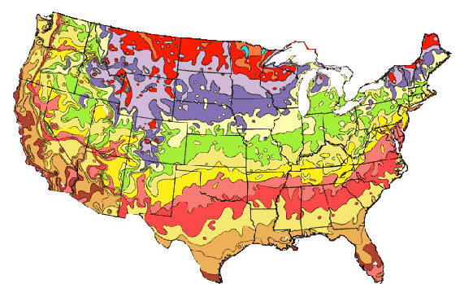
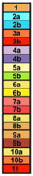
USDA PLANT HARDINESS ZONE MAP
Temperature ° C-45.6 & below-42.8 to 45.5-40.1 to 42.7-37.3 to -40.0-34.5 to -37.2-31.7 to -34.4-28.9 to -31.6-26.2 to -28.8-23.4 to -26.1-20.6 to -23.3-17.8 to -20.5-15.1 to -17.7-12.3 to -15.0-9.5 to -12.2-6.7 to -9.4-3.9 to -6.6-1.2 to -3.81.6 to -1.14.4 to 1.74.5 & above
Temperature ° Fbelow -50-45 to -50-40 to -45-35 to -40-30 to -35-25 to -30-20 to -25-15 to -20-10 to -15-5 to -100 to -55 to 010 to 515 to 1020 to 1525 to 2030 to 2535 to 3040 to 3540 & above
AVERAGE ANNUAL MINIMUM TEMPERATURE
zone
AVERAGE ANNUAL MINIMUM TEMPERATURE

zone

RECOMMENDED URBAN TREES FOR
USDA PLANT HARDINESS ZONE 6 AND COLDER

I. SMALL TREES (< 30’) SUITABLE FOR CITY ENVIRONMENT PLANTINGS UNDER LOW OVERHEAD UTILITY WIRES OR IN RESTIRCTED SPACES

Scientific Name: Acer buergerianum

Common Name: Trident Maple

Environmental Conditions:

Hardiness Zone: 6a

Soil Moisture:

occasionally  saturated or  very wet soil |  |  | consistently  moist, well  drained soil |  |  | occasional  periods of  dry soil |  |  | prolonged  periods of  dry soil
1 | 2 | 3 | 4 | 5 | 6 | 7 | 8 | 9 | 10 | 11 | 12

Sun/Shade: full sun

Salt: some observed tolerance
pH: < 7.5

Insect/Disease Factors: none serious or limiting

Growth Characteristics:

Height: 20’ - 25’
Width: 20’ - 25’
Form/Habit: round, low branching tendency often creates short trunk, single leader typically absent
Rate: slow to medium, typically slow

Ornamental Characteristics:
Flower: not ornamentally important, inconspicuous, greenish-yellow clusters, spring

Fruit: 1” samara
Seasonal Foliage Color: new growth often bronze to purple maturing to glossy dark green, fall color late and variable (yellow/orange/red)

Bark: gray/brown/orange, platy, exfoliating
Transplant Issues: difficult to transplant B&B

Management Issues: low branching may require pruning for street tree use
Suggested Uses: wide street tree lawns/pits, narrow tree lawns/pits with pruning, parks
Cultivars: Street Wise® (‘ABTIR’) selected for ability to be easily trained into a single leader (oval habit, medium growth rate, new growth emerges reddish-purple, burgundy fall color)

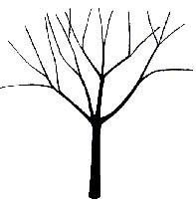

Scientific Name: Acer campestre

Common Name: Hedge Maple

Environmental Conditions:

Hardiness Zone: 5b

Soil Moisture:

occasionally  saturated or  very wet soil |  |  | consistently  moist, well  drained soil |  |  | occasional  periods of  dry soil |  |  | prolonged  periods of  dry soil
1 | 2 | 3 | 4 | 5 | 6 | 7 | 8 | 9 | 10 | 11 | 12

Sun/Shade: full sun

Salt: some observed tolerance
pH: < 8.2

Insect/Disease Factors: relatively pest free

Growth Characteristics:

Height: 25’-35’
Width: 25’-35’
Form/Habit: round, low branching tendency often creates short trunk
Rate: slow to medium

Ornamental Characteristics:

Flower: not ornamentally important, inconspicuous, green clusters, spring

Fruit: 1 ½” samara
Seasonal Foliage Color: dark green in summer, yellowish in fall

Bark: not ornamentally important, gray-black, lightly ridged and furrowed
Transplant Issues: easy to transplant B&B or < 2” caliper bare root
Management Issues: low branching may require pruning for street tree use, adapted to severe pruning
Suggested Uses: wide street tree lawns/pits, narrow street tree lawn/pits with pruning, parks, suitable for CU-Structural Soil™
Cultivars: Queen Elizabeth™ (‘Evelyn’, 6b, more upright, oval habit, vigorous), ‘Schichtel’s Upright’ (narrower form resulting in an oval crown), St. Gregory™ (‘Stgrezam’, smooth bark, uniform canopy, strong central leader)
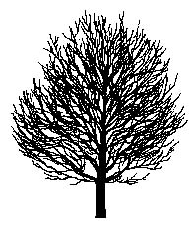

Scientific Name: Acer platanoides ‘Globosum’ or ‘Globe’
Common Name: Globe Norway Maple

Environmental Conditions:

Hardiness Zone: 4a

Soil Moisture:

occasionally  saturated or  very wet soil |  |  | consistently  moist, well  drained soil |  |  | occasional  periods of  dry soil |  |  | prolonged  periods of  dry soil
1 | 2 | 3 | 4 | 5 | 6 | 7 | 8 | 9 | 10 | 11 | 12

Sun/Shade: prefers full sun, tolerates full shade
Salt: some observed tolerance
pH: < 8.2
Insect/Disease Factors: none serious, tar spot is a common aesthetic problem with the species and may be a limiting factor for selection, Verticillium wilt, anthracnose, and leafhoppers are occasional problems for species

Growth Characteristics:

Height: 15’-18’
Width: 15’-20’
Form/Habit: dense, round, globose, top-grafted at 6’ or 7’

Rate: slow

Ornamental Characteristics:

Flower: yellow to greenish yellow, early spring before leave emerge

Fruit: 1 ½”-2” samara
Seasonal Foliage Color: dark green in summer, yellow fall color

Bark: not ornamentally important, gray-black, ridged with shallow furrows
Transplant Issues: easy to transplant B&B or < 2” caliper bare root

Management Issues: very likely to naturalize when planted next to open areas
Suggested Uses: narrow or wide street tree lawns/pits, parks, suitable for CU-Structural Soil™
Cultivars: above info is cultivar specific, readily available Acer platanoides cultivars are large trees except ‘Crimson Sentry’, an intermediate size (zone 4b, 25’-30’ high, 15’-20’ wide, broad-columnar form, same dark maroon foliage as ‘Crimson King’ but slower growing)
Scientific Name: Acer tartaricum ssp. ginnala (formerly Acer ginnala)

Common Name: Amur Maple

Environmental Conditions:
Hardiness Zone: 3a (2)

Soil Moisture:

occasionally  saturated or  very wet soil |  |  | consistently  moist, well  drained soil |  |  | occasional  periods of  dry soil |  |  | prolonged  periods of  dry soil
1 | 2 | 3 | 4 | 5 | 6 | 7 | 8 | 9 | 10 | 11 | 12

Sun/Shade: prefers full sun, tolerates partial shade
Salt: some observed tolerance
pH: < 8.2
Insect/Disease Factors: none serious or limiting, occasionally injured by Verticillium wilt, bacterial blight, or other maple diseases and insects, ‘Flame’ may be more susceptible to Verticillium wilt

Growth Characteristics:

Height: 15’-25’
Width: 15’-25’
Form/Habit: rounded, sometimes irregular outline, often shrub-like and available multi-stemmed, overtime could prune multi-stemmed form into low branching tree, should specify single-leader if desire tree form (although may still require pruning)
Rate: slow to medium

Ornamental Characteristics:

Flower: fragrant, yellowish-white clusters, spring as leaves emerge

Fruit: ¾”-1” samara, red or brown in summer, abundant
Seasonal Foliage Color: glossy dark green in summer, variably yellow, orange, or red in fall
Bark: not ornamentally important, gray-brown, smooth with darker striations on older bark

Transplant Issues: easy to transplant B&B or < 2” caliper bare root
Management Issues: suckering at trunk base can be a problem, may require pruning to maintain single trunk tree form, may naturalize in spacious environments, abundant seed may be a litter problem in some areas
Suggested Uses: wide street tree lawns/pits, narrow street tree lawns/pits with pruning, parks
Cultivars: Beethoven™ (‘Betzam’, columnar habit, 10’-15’ wide, more moderate growth rate, bright red samaras, deep hunter-green foliage in summer, gold and red in fall, possibly Acer ginnala x tartaricum hybrid), ‘Embers’ (red fruit, excellent red fall color), ‘Flame’ (zone 2, seed-grown selection and hence somewhat variable, form reportedly easily trained into excellent small low branching or multi-stemmed tree, orange-red to deep red fall color, fruit bright red in summer and darker red in fall), Mozart™ (‘Mozzam’, pyramidal and symmetrical habit, more moderate growth rate, stronger central leader, bright red samaras, bright green foliage in summer changing to red in fall)

Scientific Name: Acer tartaricum

Common Name: Tartarian Maple

Environmental Conditions:
Hardiness Zone: 3 (not as hardy as A. tartaricum ssp. ginnala)

Soil Moisture:

occasionally  saturated or  very wet soil |  |  | consistently  moist, well  drained soil |  |  | occasional  periods of  dry soil |  |  | prolonged  periods of  dry soil
1 | 2 | 3 | 4 | 5 | 6 | 7 | 8 | 9 | 10 | 11 | 12

Sun/Shade: prefers full sun, tolerates partial shade
Salt: some observed tolerance
pH: < 8.2
Insect/Disease Factors: none serious or limiting, susceptible to Verticillium wilt and cankers

Growth Characteristics:

Height: 15’-25’
Width: 15’-25’
Form/Habit: rounded, sometimes irregular outline, often shrub-like and available multi-stemmed, overtime could prune multi-stemmed form into low branching tree, should specify single-leader if desire tree form (although may still require pruning)
Rate: slow to medium

Ornamental Characteristics:

Flower: greenish-white clusters, spring as leaves emerge
Fruit: 1” samara, turning green to red in summer on most trees, can be very ornamental
Seasonal Foliage Color: larger leaves and softer green in summer than A. tartaricum ssp. ginnala, yellow fall color, sometimes red, leaves drop earlier than A. tartaricum ssp. ginnala

Bark: not ornamentally important, similar to A. tartaricum ssp. ginnala
Transplant Issues: easy to transplant B&B or < 2” caliper bare root
Management Issues: suckering at trunk base can be a problem, may require pruning to maintain single trunk tree form, may naturalize in spacious environments, abundant seed may be a litter problem in some areas
Suggested Uses: wide street tree lawns/pits, narrow street tree lawns/pits with pruning, parks
Cultivars: ‘Rubrum’ (blood-red foliage color in fall)

Scientific Name: Acer truncatum

Common Name: Shantung Maple or Painted Maple

Environmental Conditions:
Hardiness Zone: 5a (species is variable, hybrid cultivars zone 5)

Soil Moisture:

occasionally  saturated or  very wet soil |  |  | consistently  moist, well  drained soil |  |  | occasional  periods of  dry soil |  |  | prolonged  periods of  dry soil
1 | 2 | 3 | 4 | 5 | 6 | 7 | 8 | 9 | 10 | 11 | 12

Sun/Shade: full sun

Salt: unknown
pH: < 8.2
Insect/Disease Factors: none serious or limiting, good resistance to leaf scorch

Growth Characteristics:

Height: 25’-35’
Width: 25’
Form/Habit: round (species variable), low branching tendency often creates short trunk

Rate: slow

Ornamental Characteristics:

Flower: greenish-yellow, spring, can be showy
Fruit: 1 ¼” samara
Seasonal Foliage Color: emerging leaf color purplish-red changing to green, fall color variable (yellow/orange/red)

Bark: not ornamentally important, gray-brown, rough and fissured with age
Transplant Issues: easy to transplant B&B or < 2” caliper bare root
Management Issues: currently available plant material typically branches low, may require pruning for street tree use
Suggested Uses: wide street tree lawns/pits, narrow tree lawns/pits with pruning, parks, suitable for

CU-Structural Soil™
Cultivars: hybrids with A. plantanoides - Norwegian Sunset™ (‘Keithsform’, upright oval, good uniform branch structure, glossy dark green foliage, yellow-orange to red fall color, more heat and drought tolerant than A. platanoides) and Pacific Sunset™ (‘Warrenred’, rounded, upright spreading, very glossy dark green foliage, finer branched, brighter yellow-orange to red fall color, turns fall color earlier than Norwegian Sunset™)
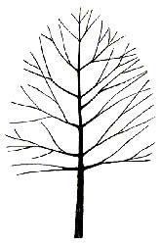
'Norwegian Sunset'
Scientific Name: Amelanchier spp. (A. arborea, A. canadensis, A. laevis, and A. x grandiflora)
Common Name: Serviceberry Species and Hybrids, Tree Forms

Environmental Conditions:
Hardiness Zone: 4 (3b)

Soil Moisture:

occasionally  saturated or  very wet soil |  |  | consistently  moist, well  drained soil |  |  | occasional  periods of  dry soil |  |  | prolonged  periods of  dry soil
1 | 2 | 3 | 4 | 5 | 6 | 7 | 8 | 9 | 10 | 11 | 12

Sun/Shade: prefers full sun, tolerates partial shade

Salt: sensitive
pH: < 7.5
Other: poor heat tolerance
Insect/Disease Factors: none limiting, foliage diseases can be a problem but are very rarely fatal, fireblight, mites, scales can be serious problems if site requirements not met, ‘Autumn Brilliance’ and ‘Princess Diana’ resistant to leaf spot, ‘Autumn Brilliance’ reportedly somewhat fireblight tolerant

Growth Characteristics:

Height: 20’-30’
Width: 15’-25’
Form/Habit: oval, multi-stem or single-stem forms available, must specify tree form as Amelanchier is also grown as a large shrub

Rate: medium

Ornamental Characteristics:
Flower: white erect or pendulous clusters (depending on species or hybrid), in spring as leaves emerge or after (depending on species or hybrid), almost always showy

Fruit: edible reddish-purple to black berries
Seasonal Foliage Color: varies with cultivar, gray-green to dark green in summer, yellow to red in fall, reliably good fall color regardless of culitvar
Bark: attractive, smooth gray streaked with darker longitudinal fissures, becoming ridged, furrowed and scaly with extreme age

Transplant Issues: easy to transplant B&B or < 2” caliper bare root
Management Issues: rootstock suckering possible on some cultivars, typically Sorbus is used for rootstock, although Tradition® has Crateagus rootstock which could produce thorny suckers

Suggested Uses: narrow or wide street tree lawns/pits, parks
Cultivars (Tree forms only): ‘Autumn Brilliance’ (heavy flowering, lustrous dark green foliage, bright orange to red in fall, excellent heat and drought tolerance for species), ‘Cole’s Select’ ( 15’ wide, thicker and glossier small green foliage, orange-red to red in fall), ‘Cumulus’ (12’-18’ wide, faster growing, yellow to orange-scarlet fall color, may sucker at root collar), ‘Majestic’ (fast growing, difficult to find in tree form, open/airy and irregular form, large flower clusters, large foliage emerges with red tint then turns dark green, copper-orange to scarlet fall color), ‘Princess Diana’ (may be difficult to find in tree form, green foliage, bright red in fall, reportedly early and long lasting fall color), Reflection™ (‘Refzam’, 10’-15’ wide, heavy flowering, gray-green foliage, yellow-orange in fall, Crateagus rootstock), ‘Robin Hill’ (12’-15’ wide, pink buds, early bloomer, bronze-tinged green foliage, yellow to red in fall), ‘Snowcloud’ (15’ wide, open habit, foliage reportedly emerges with red tint, blue-green to dark green in summer, copper-orange to scarlet in fall), Spring Glory® (‘Spirzam’, 10’-15’ tall, 8-10’ wide, gray-green foliage, amber-orange fall color), Tradition® (‘Trazam’, strong central leader, good branchinghabit, heavy fruiting, gray-green foliage, orange and red fall color)
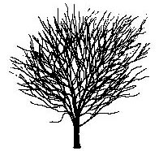 ‘Cumulus’

Scientific Name: Carpinus caroliniana

Common Name: Ironwood, Musclewood, or American Hornbeam

Environmental Conditions:

Hardiness Zone: 3b

Soil Moisture:

occasionally  saturated or  very wet soil |  |  | consistently  moist, well  drained soil |  |  | occasional  periods of  dry soil |  |  | prolonged  periods of  dry soil
1 | 2 | 3 | 4 | 5 | 6 | 7 | 8 | 9 | 10 | 11 | 12

Sun/Shade: prefers partial shade, tolerates full shade

Salt: sensitive
pH: < 7.5

Insect/Disease Factors: relatively pest free

Growth Characteristics:

Height: 30’
Width: 25’
Form/Habit: rounded, spreading, sometimes more flat-topped, often irregular, clump or single stem forms available

Rate: slow

Ornamental Characteristics:

Flower: 2”-4” long pendulous clusters of green leafy bracts
Fruit: small nutlets partly enclosed by green leafy flower bracts
Seasonal Foliage Color: dark green, often lustrous in summer, yellow to orange-red in fall

Bark: attractive, smooth gray, irregularly fluted “muscled” look
Transplant Issues: difficult to transplant B&B or bare root, somewhat slow to establish
Management Issues: none of significance
Suggested Uses: narrow or wide street tree lawns/pits, parks
Cultivars: none available commercially

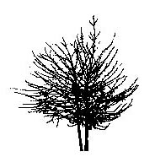

Clump Form

Scientific Name: Cercis canadensis

Common Name: Eastern Redbud

Environmental Conditions:
Hardiness Zone: 5b (use in 4b and 5a is dependent on a cold hardy seed source)

Soil Moisture:

occasionally  saturated or  very wet soil |  |  | consistently  moist, well  drained soil |  |  | occasional  periods of  dry soil |  |  | prolonged  periods of  dry soil
1 | 2 | 3 | 4 | 5 | 6 | 7 | 8 | 9 | 10 | 11 | 12
*western seed sources are thought to be more drought tolerant than eastern sources

Sun/Shade: prefers full sun, tolerates partial shade
Salt: some observed tolerance
pH: < 8.2
Insect/Disease Factors: none limiting, cankers can occasionally be a serious problem

Growth Characteristics:

Height: 20’-30’
Width: 25’-35’
Form/Habit: open, spreading and somewhat flat-topped, typically multi-stemmed or low branching tree, multi-stem and single-stem forms available

Rate: medium

Ornamental Characteristics:

Flower: very showy, purplish-pink, early spring before leaves emerge, edible
Fruit: 2”-3” pod, changes from light green to brown
Seasonal Foliage Color: new growth emerge glossy reddish-purple, medium to dark green in summer, greenish-yellow to golden yellow in fall
Bark: dark gray-brown in youth, attractive with age, trunk and branches become scaly and expose cinnamon colored inner bark
Other: attractive heart-shaped foliage
Transplant Issues: easy to transplant B&B, moderately difficult to transplant bare root, better success in transplanting bare root in fall, do not attempt to transplant > 2” caliper trees bare root

Management Issues: none of significance
Suggested Uses: wide street tree lawns/pits preferred if using multi-stemmed form, narrow street tree lawns/pits if using standard or with pruning, parks, suitable for CU-Structural Soil™
Cultivars: ‘Forest Pansy’ (zone 5b or 6, slightly smaller than species, slow growth rate, exceptionally glossy new growth, red-purple spring foliage, bronze summer foliage, yellow-orange fall color), ‘Northern Strain’ or ‘Minnesota Strain’ (more cold hardy seed produced variety, availability may be limited), f. alba (commonly called Whitebud, cold hardiness also depends on seed source, fast growth rate, foliage slightly lighter green than species, white flowers)

Scientific Name: Cornus mas

Common Name: Corneliancherry Dogwood

Environmental Conditions:
Hardiness Zone: 5a (4)

Soil Moisture:

occasionally  saturated or  very wet soil |  |  | consistently  moist, well  drained soil |  |  | occasional  periods of  dry soil |  |  | prolonged  periods of  dry soil
1 | 2 | 3 | 4 | 5 | 6 | 7 | 8 | 9 | 10 | 11 | 12

Sun/Shade: prefers full sun, tolerates partial shade
Salt: some observed tolerance
pH: < 8.2

Insect/Disease Factors: relatively pest free

Growth Characteristics:

Height: 20’
Width: 20’
Form/Habit: round to oval, often multi-stemmed, low branching tendency creates very short trunk, single leader typically absent although available, must specify single-stem form if desirable
Rate: slow to medium

Ornamental Characteristics:

Flower: very showy, small, yellow, early spring before leaves emerge

Fruit: bright red, resembling elongated cherries, edible
Seasonal Foliage Color: dark green in summer, often glossy, occasional purplish-red fall color

Bark: attractive, brown and gray, scaly/flaky exfoliation
Transplant Issues: easy to transplant B&B and < 2” caliper bare root

Management Issues: low branch attachments may require pruning for street tree use
Suggested Uses: wide street tree lawns/pits, narrow street tree lawns/pits with pruning or single-leader form, parks, suitable for CU-Structural Soil™
Cultivars: ‘Golden Glory’ (more narrow and upright form, abundant flowering, red-purple fall color, leaves and fruit larger than species)

Scientific Name: Cotinus obovatus

Common Name: American Smoketree

Environmental Conditions:

Hardiness Zone: 5a

Soil Moisture:

occasionally  saturated or  very wet soil |  |  | consistently  moist, well  drained soil |  |  | occasional  periods of  dry soil |  |  | prolonged  periods of  dry soil
1 | 2 | 3 | 4 | 5 | 6 | 7 | 8 | 9 | 10 | 11 | 12

Sun/Shade: full sun

Salt: unknown
pH: < 8.2

Insect/Disease Factors: none serious or limiting

Growth Characteristics:

Height: 20’-30’
Width: 15’-30’
Form/Habit: oval to rounded, low branching tendency and absent central leader creates very short trunk, single-stem tree form is available (although rare), must specify single-stemmed tree form if desirable as it is most often available in multi-stemmed large upright shrub form

Rate: medium

Ornamental Characteristics:

Flower: greenish to pale purple, on 6”-10” long, light/airy pyramidal clusters, spring
Fruit: individually inconspicuous and not ornamentally important, often sparse fruit production, but tan clusters can be attractive when fruiting, ‘smoky’ appearance due to silky hairs on sterile flowers in cluster, although not as showy as C. coggygria – Smoke Bush
Seasonal Foliage Color: new growth emerges bright light green, blue-green to dark green in summer, fall color variable and mixed (yellow, orange, red or red-purple) but reliably bright and excellent

Bark: attractive, gray to gray-brown, becoming scaly with age
Other: stems often orangeish

Transplant Issues: difficult to transplant B&B or bare root
Management Issues: low branch attachments may require pruning for street tree use
Suggested Uses: wide street tree lawns/pits, narrow street tree lawns/pits with pruning, parks
Cultivars: none commercially available
Scientific Name: Crataegus crus-galli var. inermis
Common Name: Thornless Cockspur Hawthorn

Environmental Conditions:

Hardiness Zone: 4a

Soil Moisture:

occasionally  saturated or  very wet soil |  |  | consistently  moist, well  drained soil |  |  | occasional  periods of  dry soil |  |  | prolonged  periods of  dry soil
1 | 2 | 3 | 4 | 5 | 6 | 7 | 8 | 9 | 10 | 11 | 12

Sun/Shade: full sun

Salt: some observed tolerance
pH: < 8.2
Insect/Disease Factors: Crataegus species are susceptible to many foliage diseases and various insects (fireblight, leaf blight, mildews, and rusts are some of the more common problems), var. inermis reportedly resistant to cedar-hawthorn rust and leaf blight, lacebug tolerant, Crusader® is reportedly very disease resistant

Growth Characteristics:

Height: 20’-25’
Width: 20’-25’
Form/Habit: round, strongly horizontal branching structure, multi-stem forms available, must specify single-stem tree form

Rate: slow to medium
Ornamental Characteristics: none of significance

Flower: white clusters, unpleasant odor, spring
Fruit: showy clusters, bright red, berry-like, persist into late fall and sometimes winter

Seasonal Foliage Color: glossy dark green in summer, orange in fall
Bark: not ornamentally important, silvery-gray
Transplant Issues: difficult to transplant B&B, moderately difficult to transplant bare root, better success in transplanting bare root in fall, do not attempt to transplant > 2” caliper trees bare root, somewhat slow to establish

Management Issues:
Suggested Uses: narrow or wide street tree lawns/pits, parks, suitable for CU-Structural Soil™
Cultivars: Crusader® (‘Cuzam’) may be smaller (15’ high x 12’-15’ wide) than var. inermis
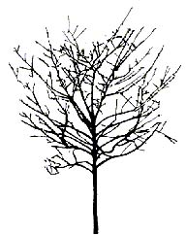

Scientific Name: Crataegus phaenopyrum

Common Name: Washington Hawthorn

Environmental Conditions:

Hardiness Zone: 4a

Soil Moisture:

occasionally  saturated or  very wet soil |  |  | consistently  moist, well  drained soil |  |  | occasional  periods of  dry soil |  |  | prolonged  periods of  dry soil
1 | 2 | 3 | 4 | 5 | 6 | 7 | 8 | 9 | 10 | 11 | 12

Sun/Shade: full sun

Salt: some observed tolerance
pH: < 8.2
Insect/Disease Factors: Crataegus species are susceptible to many foliage diseases and various insects (fireblight, leaf blight, mildews, and rusts are some of the common problems), reportedly resistant to cedar-hawthorn rust and less susceptible than other Crataegus to disease, susceptible to lacebug

Growth Characteristics:

Height: 20’-30’
Width: 20’- 25’
Form/Habit: round, densely branched, multi-stem forms available, must specify single-stem tree form
Rate: slow to medium

Ornamental Characteristics:

Flower: white clusters, early summer, a later flowering Crataegus

Fruit: showy clusters, bright and glossy red, berry-like, persist through winter
Seasonal Foliage Color: glossy dark green in summer, reddish-purple in fall
Bark: not ornamentally important, silver-gray, scaly with age

Other: thorny
Transplant Issues: difficult to transplant B&B or bare root, somewhat slow to establish
Management Issues: thorns should be considered in relation to clearance requirements
Suggested Uses: narrow or wide street tree lawns/pits, parks, suitable for CU-Structural Soil™
Cultivars: Princeton Sentry™ (faster growing, almost thornless, more upright branching, relatively pest-free), ‘Manbeck Select’ (selected for improved tree form), ‘Lustre’ (faster growing, oval shape, fewer thorns), ‘Fastigiata’ (glossy dark green in summer, orange to purplish fall color), ‘Vaughn’
(C. crusgalli x C. phaenopyrum, not recommended due to increased rust susceptibility and particularly thorny quality)
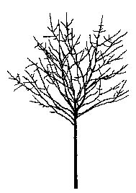

Scientific Name: Crataegus punctata var. inermis ‘Ohio Pioneer’
Common Name: Ohio Pioneer Dotted Hawthorn

Environmental Conditions:
Hardiness Zone: 5a (4)

Soil Moisture:

occasionally  saturated or  very wet soil |  |  | consistently  moist, well  drained soil |  |  | occasional  periods of  dry soil |  |  | prolonged  periods of  dry soil
1 | 2 | 3 | 4 | 5 | 6 | 7 | 8 | 9 | 10 | 11 | 12

Sun/Shade: full sun

Salt: some observed tolerance
pH: < 8.2
Insect/Disease Factors: Crataegus species are susceptible to many foliage diseases and various insects (fireblight, leaf blight, mildews, and rusts are some of the common problems), resistant to fireblight, susceptible to cedar-hawthorn rust and mildew

Growth Characteristics:

Height: 20’-25’
Width: 30’-35’
Form/Habit: round, strongly horizontal branching structure, multi-stem forms may be available, should specify single-stem tree form
Rate: medium, possibly fast

Ornamental Characteristics:

Flower: abundant, large white clusters, spring

Fruit: showy, dark red, often dotted white, drop in fall
Seasonal Foliage Color: gray-green in summer, purplish-red in fall

Bark: not ornamentally important, silver-gray
Other: essentially thornless

Transplant Issues: difficult to transplant B&B, somewhat slow to establish
Management Issues: none of significance
Suggested Uses: narrow or wide street tree lawns/pits, parks, suitable for CU-Structural Soil™
Cultivars: above info is cultivar specific, f. aurea (sometimes listed as ‘Aurea’, yellow fruiting form of Crataegus puncata) is very difficult to find
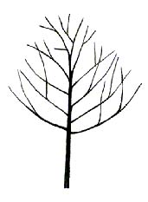

Scientific Name: Crataegus viridis ‘Winter King’
Common Name: Winter King Hawthorn

Environmental Conditions:
Hardiness Zone: 5a (4)

Soil Moisture:

occasionally  saturated or  very wet soil |  |  | consistently  moist, well  drained soil |  |  | occasional  periods of  dry soil |  |  | prolonged  periods of  dry soil
1 | 2 | 3 | 4 | 5 | 6 | 7 | 8 | 9 | 10 | 11 | 12

Sun/Shade: full sun

Salt: some observed tolerance
pH: < 8.2
Insect/Disease Factors: Crataegus species are susceptible to many foliage diseases and various insects (fireblight, leaf blight, mildews, and rusts are some of the common problems), species is very susceptible to cedar-hawthorn rust, ‘Winter King’ cultivar resistant to cedar-hawthorn rust (leaves only, fruits may still be susceptible), reportedly less susceptible than most other Crataegus to disease and insects

Growth Characteristics:

Height: 20’- 25’
Width: 25’
Form/Habit: rounded to broad-vase shaped, multi-stem forms may be available, should specify single-stem tree form
Rate: slow to medium

Ornamental Characteristics:

Flower: white clusters, spring
Fruit: very showy, bright red, larger than species, persist through winter
Seasonal Foliage Color: glossy green in summer, color variable in fall (often purple to scarlet, sometimes gold to bronze)
Bark: silver-gray in youth, exfoliates with age exposing orange-brown inner bark

Other: thorny
Transplant Issues: difficult to transplant B&B, moderately difficult to transplant bare root, better success in transplanting bare root in fall, do not attempt to transplant > 2” caliper trees bare root, somewhat slow to establish
Management Issues: thorns should be considered in relation to clearance requirements, suckering of

C. phaenopyrum – the common rootstock
Suggested Uses: narrow or wide street tree lawns/pits, parks, suitable for CU-Structural Soil™
Cultivars: above info is cultivar specific, ‘Winter King’ is only C. viridis cultivar available

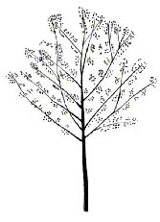

Scientific Name: Fraxinus excelsior ‘Aureafolia’
Common Name: Golden Desert™ European Ash

Environmental Conditions:
Hardiness Zone: 5a (4b)

Soil Moisture:

occasionally  saturated or  very wet soil |  |  | consistently  moist, well  drained soil |  |  | occasional  periods of  dry soil |  |  | prolonged  periods of  dry soil
1 | 2 | 3 | 4 | 5 | 6 | 7 | 8 | 9 | 10 | 11 | 12

Sun/Shade: full sun

Salt: some observed tolerance
pH: < 8.2
Insect/Disease Factors: Ashes are susceptible to a number of insect and disease problems, borer problems can be serious and limiting for the species in some areas (hot dry environments), borer resistance for ‘Aureafolia’ unknown

Growth Characteristics:

Height: 20’-30’
Width: 15’-20’

Form/Habit: rounded

Rate: slow

Ornamental Characteristics:

Flower: not ornamentally important
Fruit: not ornamentally important, samara
Seasonal Foliage Color: emerges yellow, becomes yellow-green in early summer, turns a more golden yellow in late summer and fall
Bark: not ornamentally important
Other: twigs and young stems are bright golden yellow
Transplant Issues: easy to transplant B&B or < 2” caliper bare root

Management Issues: none of significance
Suggested Uses: narrow or wide street tree lawns/pits, parks, suitable for CU-Structural Soil™
Cultivars: above info is cultivar specific, ‘Aureafolia’ sometimes called ‘Handles,’ other F. excelsior cultivars are large trees
Scientific Name: Fraxinus pennsylvanica ‘Johnson’
Common Name: Leprechaun™ Green Ash

Environmental Conditions:

Hardiness Zone: 3

Soil Moisture:

occasionally  saturated or  very wet soil |  |  | consistently  moist, well  drained soil |  |  | occasional  periods of  dry soil |  |  | prolonged  periods of  dry soil
1 | 2 | 3 | 4 | 5 | 6 | 7 | 8 | 9 | 10 | 11 | 12

Sun/Shade: full sun

Salt: some observed tolerance
pH: < 8.2
Insect/Disease Factors: Ashes are susceptible to a number of insect and disease problems, borers can be a problem in hot, dry environments for the species, resistant to anthracnose

Growth Characteristics:

Height: 15’-20’
Width: 15’-20’
Form/Habit: dense, round, top-grafted on 4’ or 6’ stems

Rate: medium

Ornamental Characteristics:

Flower: not ornamentally important

Fruit: seedless

Seasonal Foliage Color: yellow in fall
Bark: not ornamentally important, gray to gray-brown, narrow interlacing ridges create diamond shaped furrows

Other: leaves smaller than straight species
Transplant Issues: easy to transplant B&B or < 2” caliper bare root

Management Issues: none of significance
Suggested Uses: narrow or wide street tree lawns/pits, parks, suitable for CU-Structural Soil™
Cultivars: above info is cultivar specific, other F. pennsylvanica cultivars are large trees

Scientific Name: Koelreuteria paniculata

Common Name: Goldenraintree

Environmental Conditions:

Hardiness Zone: 5b

Soil Moisture:

occasionally  saturated or  very wet soil |  |  | consistently  moist, well  drained soil |  |  | occasional  periods of  dry soil |  |  | prolonged  periods of  dry soil
1 | 2 | 3 | 4 | 5 | 6 | 7 | 8 | 9 | 10 | 11 | 12

Sun/Shade: full sun

Salt: some observed tolerance
pH: < 8.2
Other: tolerates heat

Insect/Disease Factors: relatively pest free

Growth Characteristics:
Height: 30’ (can reach 40’)
Width: 30’
Form/Habit: irregular rounded, open, spreading and ascending branching
Rate: medium to fast

Ornamental Characteristics:

Flower: yellow, 12” long pyramidal clusters, mid-summer
Fruit: papery, 1”-2”, 3-valved capsules, green changing to yellow then to brown, persistent throughout winter
Seasonal Foliage Color: purple-red when emerging, bright green to blue-green in summer, yellow in fall

Bark: light gray-brown, ridged and furrowed
Transplant Issues: easy to transplant B&B or < 2” caliper bare root

Management Issues: none of significance
Suggested Uses: narrow or wide street tree lawns/pits, parks, suitable for CU-Structural Soil™
Cultivars: ‘September’ (zone 6 (5b), late summer to fall flowering), ‘Rose Lantern’ (zone 6 (5b), pinkish fruit capsules), selections are currently being made to develop reliably cold hardy (5a) cultivars
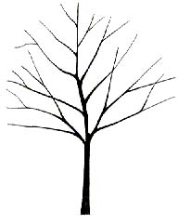

Scientific Name: Liquidambar stryaciflua ‘Clydesform’
Common Name: Emerald Sentinel® Sweetgum

Environmental Conditions:

Hardiness Zone: 5

Soil Moisture:

occasionally  saturated or  very wet soil |  |  | consistently  moist, well  drained soil |  |  | occasional  periods of  dry soil |  |  | prolonged  periods of  dry soil
1 | 2 | 3 | 4 | 5 | 6 | 7 | 8 | 9 | 10 | 11 | 12

Sun/Shade: full sun

Salt: unknown
pH: < 7.5

Insect/Disease Factors: relatively pest free

Growth Characteristics:

Height: 30’
Width: 10’-15’
Form/Habit: narrowly pyramidal to columnar
Rate: slower than straight species (medium to fast)

Ornamental Characteristics:

Flower: not ornamentally important, present as leaves are emerging and expanding

Fruit: 1”-1 ½” ball of dehiscent capsules, persist into winter
Seasonal Foliage Color: dark green in summer, yellow-orange in fall
Bark: not ornamentally important, grayish-brown, somewhat rounded ridges and deep furrows

Transplant Issues: transplant B&B, not bare root
Management Issues: fruit litter may be objectionable in some situations

Suggested Uses: narrow or wide street tree lawns/pits, parks
Cultivars: above info is cultivar specific, other L. stryaciflua cultivars are large trees
Scientific Name: Malus spp.

Common Name: Flowering Crabapple

Environmental Conditions:

Hardiness Zone: 4, some cultivars hardy to zone 3

Soil Moisture:

occasionally  saturated or  very wet soil |  |  | consistently  moist, well  drained soil |  |  | occasional  periods of  dry soil |  |  | prolonged  periods of  dry soil
1 | 2 | 3 | 4 | 5 | 6 | 7 | 8 | 9 | 10 | 11 | 12

Sun/Shade: full sun

Salt: some observed tolerance
pH: < 8.2
Insect/Disease Factors: many crabapples cultivars are highly disease susceptible, limiting their usefulness in the landscape, all cultivars selected here have ‘good’ to ‘excellent’ resistance to cedar-apple rust, mildew, and scab, as well as at least ‘fair’ resistance to fireblight (‘fair’ resistance is tolerated as it is not as serious a problem in Northern areas as it is in the Southern areas)
Growth Characteristics: varies with cultivar, see chart on following page for cultivar characteristics, along with cultivar silhouettes on page 34
Ornamental Characteristics: varies with cultivar, see chart on following page for cultivar characteristics

Transplant Issues: easy to transplant B&B or < 2” caliper bare root
Management Issues: fruit litter on streets may be objectionable in some situations
Suggested Uses: narrow or wide street tree lawns/pits, parks, suitable for CU-Structural Soil™

Cultivars: see chart on following page
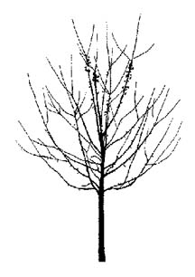

ORNAMENTAL CHARACTERISTICS OF SELECTED DISEASE RESISTANT CRABAPPLES
Species and/or Cultivar | Zone | Ht | Wd | Form/Habit | Bud | Flower | Fruit | Foliage
‘Adams’ | 4a | 20’ | 20’ | round | deep pink | deep pink, profuse | red, persistent, 5/8” | green with red tint
‘Adirondack’ | 4 | 18’ | 12’ | vase | carmine | white, textured | bright red, ½” | dark green, leathery
American  Spirit™  (‘Amerspirzam’) | 4 | 18’ | 18’ | round | white-pink | deep rose | persistent,  red, ½” | green
baccata ‘Jackii’ | 3a | 20’ | 20’ | round | white-pink | white, fragrant, early | deep red-purple, 3/8” | glossy green
‘Cardinal’ | 4 | 16’ | 22’ | broad spreading | pink | bright pink to red | deep red, ½”, often sparse | dark purple-red, glossy
Centurion®  (‘Centsam’) | 4 | 20’ | 15’ | narrow oval | dark red | rose red | bright red, persistent, 5/8” | reddish changing to green
‘Dolgo’ | 3b | 30’ | 25’ | oval | white | white | bright red, edible, 1 ½” | glossy green
‘Donald Wyman’ | 4 | 20’ | 22’ | round | pink | white, abundant | bright red, persistent, 3/8” | dark green
‘Doubloons’ | 4 | 18’ | 16’ | dense oval | carmine | white, double | yellow, persistent, 3/8” | deep green
floribunda | 4b | 20’ | 25’ | round | carmine | pink-white, large | yellow/red, 3/8” | green, small
Harvest Gold®  (‘Hargozam’) | 4 | 20’ | 15’ | oval | rose red | white | gold, persistent, ¾” | green
‘Henry Kohankie’ | 4 | 20’ | 20’ | round | pink | pink-white | red, persistent,  1 ¼” | dark green, large, lobed
‘Indian Summer’ | 4a | 18’ | 20’ | round | purple | rose red | bright red, persistent, 5/8” | bronze green
‘Liset’ | 4a | 15’ | 15’ | columnar | crimson | pink-red, large | dark red, ½” | reddish aging to bronze green
‘Ormiston Roy’ | 4a | 20’ | 25’ | oval, round with age | rose to pink | white | yellow, persistent, 3/8” | green
‘Prairiefire’ | 4 | 20’ | 18’ | oval, round with age | crimson | pink-red | orange-red, persistent, ½” | reddish aging to red-green
‘Professor  Sprenger’ | 4 | 20’ | 20’ | oval, round with age | pink | white, fragrant | orange-red, persistent, ½” | green
‘Purple Prince’ | 4 | 20’ | 20’ | round | carmine | rose red | maroon, persistent, 3/8” | purple aging to bronze-green
Red Jewel™  (‘Jewelcole’) | 4 | 15’ | 12’ | oval | pink to white | white | bright red, persistent, ½” | green
‘Robinson’ | 4 | 25’ | 25’ | oval | crimson | deep pink | dark glossy red, 3/8” | reddish aging to bronze green
Royal Raindrops™  (‘JFS-KW5’) | 4 | 20’ | 15’ | upright spreading | pink | bright pinkish-red | persistent,  red, ¼” | purple, cut-leaf, orange-red in fall
‘Sentinel’ | 4 | 18’ | 12’ | narrow oval | red | pink to white | bright red, persistent, ½” | dark glossy green
‘Strawberry Parfait’ | 4 | 18’ | 22’ | vase | red | pink, large | yellow, 3/8” | reddish aging to green
Sugartyme®  (‘Sutyzam’) | 4 | 18’ | 15’ | oval | pink | white, fragrant | red, persistent, ½” | green
x zumi ‘Calocarpa’ | 4a | 20’ | 22’ | round | deep red | white | bright red, persistent, 3/8” | green
* This list does not include recent selections that have reportedly shown good disease resistance, yet have not been around long enough to reliably prove their disease resistance. This list is a work in progress and will be updated periodically as information regarding disease resistance becomes available. ©Urban Horticulture Institute, 2003

Malus Cultivar Silhouettes

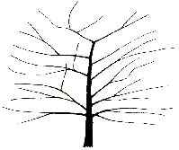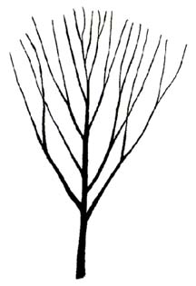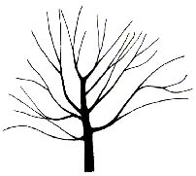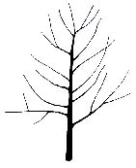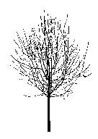
'Adams' 'Adirondack' baccata 'Jackii' 'Centurion' 'Dolgo' 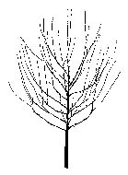 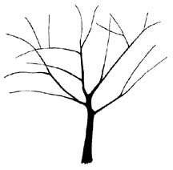 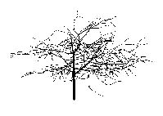 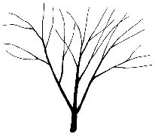
'Donald Wyman' 'Doubloons' floribunda ‘Harvest Gold'

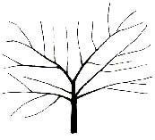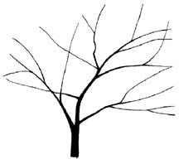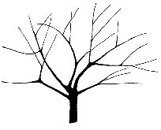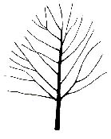
'Henry Kohankie' 'Indian Summer' 'Ormiston Roy' 'Prairiefire'

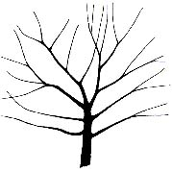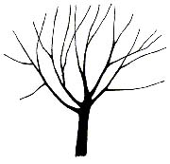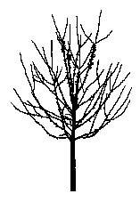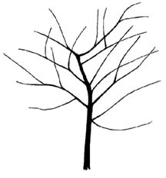
'Professor Sprenger' 'Purple Prince' 'Red Jewel' ‘Robinson’

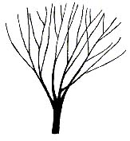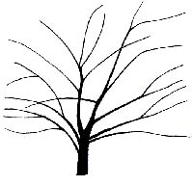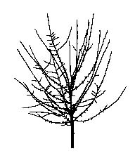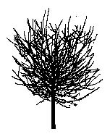
'Sentinel' 'Strawberry Parfait' 'Sugartyme' x zumi 'Calocarpa'
Scientific Name: Parrotia persica

Common Name: Persian Parrotia

Environmental Conditions:

Hardiness Zone: 5

Soil Moisture:

occasionally  saturated or  very wet soil |  |  | consistently  moist, well  drained soil |  |  | occasional  periods of  dry soil |  |  | prolonged  periods of  dry soil
1 | 2 | 3 | 4 | 5 | 6 | 7 | 8 | 9 | 10 | 11 | 12

Sun/Shade: prefers full sun, tolerates partial shade, fall color best in full sun

Salt: unknown
pH: < 8.2

Insect/Disease Factors: relatively pest free

Growth Characteristics:

Height: 20’-30’
Width: 15’-25’
Form/Habit: broadly pyramidal to rounded, irregular, low branching, branching ranges from horizontal (sometimes semi-pendent) to upright-ascending, occasionally specifying for upright or horizontal branching is possible
Rate: slow to medium

Ornamental Characteristics:

Flower: showy red stamens, late winter/early spring before leaves emerge

Fruit: not ornamentally important, 2-valved brown capsule
Seasonal Foliage Color: reddish-purple when unfolding changing to green in summer, often a mix of yellow, orange, and red in fall
Bark: very ornamental, exfoliating to expose gray/green/white/brown mottled pattern on trunk as well as on older branches

Transplant Issues: easy to transplant B&B or < 2” caliper bare root
Management Issues: prune in spring
Suggested Uses: wide street tree lawns/pits, narrow tree lawns/pits with pruning, parks, suitable for

CU-Structural Soil™
Cultivars: ‘Ruby Vase’ (listed as zone 4, narrower than species, 20’ high by 10’ wide, upright to vase shaped, foliage emerges ruby red in spring and color persists into fall)
Scientific Name: Prunus ‘Accolade’ (P. sargentii x P. subhirtella)
Common Name: Accolade Flowering Cherry

Environmental Conditions:

Hardiness Zone: 5a

Soil Moisture:

occasionally  saturated or  very wet soil |  |  | consistently  moist, well  drained soil |  |  | occasional  periods of  dry soil |  |  | prolonged  periods of  dry soil
1 | 2 | 3 | 4 | 5 | 6 | 7 | 8 | 9 | 10 | 11 | 12

Sun/Shade: full sun

Salt: some observed tolerance
pH: < 7.5
Insect/Disease Factors: Prunus have many potential problems, ‘Accolade’ is reportedly more resistant than most

Growth Characteristics:

Height: 20’-25’
Width: 15’- 25’
Form/Habit: rounded to vase shaped, spreading
Rate: fast for Prunus

Ornamental Characteristics:
Flower: deep rose-pink buds, semi-double pink pendulous clusters, early spring

Fruit: not showy, small purple-black drupe
Seasonal Foliage Color: green in spring through fall

Bark: attractive, smooth reddish-brown, marked with horizontal lenticels
Transplant Issues: easy to transplant B&B or < 2” caliper bare root
Management Issues: cherries are short-lived trees (only 50 years in a good site)
Suggested Uses: narrow or wide street tree lawns/pits, parks
Cultivars: above info is cultivar specific

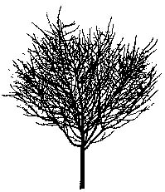

Scientific Name: Prunus ‘Snow Goose’
Common Name: Snow Goose Cherry

Environmental Conditions:

Hardiness Zone: 5

Soil Moisture:

occasionally  saturated or  very wet soil |  |  | consistently  moist, well  drained soil |  |  | occasional  periods of  dry soil |  |  | prolonged  periods of  dry soil
1 | 2 | 3 | 4 | 5 | 6 | 7 | 8 | 9 | 10 | 11 | 12

Sun/Shade: full sun

Salt: unknown
pH: < 7.5
Insect/Disease Factors: Prunus have many potential problems, ‘Snow Goose’ is reportedly more resistant than most

Growth Characteristics:

Height: 20’-25’
Width: 20’-25’
Form/Habit: upright in youth becoming much wider with age, top grafted, typically good central leader and well spaced branches

Rate: medium

Ornamental Characteristics:

Flower: white, single, early spring before leaves unfold

Fruit: not showy, ¼” blue-black cherries, inconspicuous
Seasonal Foliage Color: bright green in summer, yellow to red in fall
Bark: attractive, smooth gray-brown to reddish brown, marked with horizontal lenticels

Transplant Issues: probably easy to transplant B&B
Management Issues: cherries are short-lived trees (only 50 years in a good site)
Suggested Uses: narrow or wide street tree lawns/pits, parks
Cultivars: above info is cultivar specific
Scientific Name: Prunus virginiana ‘Canada Red Select’
Common Name: Canada Red Chokecherry

Environmental Conditions:

Hardiness Zone: 2b

Soil Moisture:

occasionally  saturated or  very wet soil |  |  | consistently  moist, well  drained soil |  |  | occasional  periods of  dry soil |  |  | prolonged  periods of  dry soil
1 | 2 | 3 | 4 | 5 | 6 | 7 | 8 | 9 | 10 | 11 | 12

Sun/Shade: full sun

Salt: unknown
pH: < 7.5
Insect/Disease Factors: Prunus have many potential problems, ‘Canada Red Select’ is reportedly more resistant than most and resistant to Japanese Beetle, Black knot may be a problem but can be pruned out

Growth Characteristics:

Height: 25’
Width: 20’
Form/Habit: oval to upright spreading, good branching habit

Rate: fast

Ornamental Characteristics:

Flower: showy, white 3”-6” long clusters in spring

Fruit: round, red-dark purple drupe, edible
Seasonal Foliage Color: emerges green, matures to dark maroon in summer
Bark: more red-brown than the typical gray of P. virginiana, obvious lenticels do not extend very far horizontally like many other Prunus species, remains fairly smooth with age
Transplant Issues: easy to transplant B&B or < 2” caliper bare root, quick to establish
Management Issues: suckering can be a problem, cherries are short-lived trees (only 50 years in a good site)

Suggested Uses: narrow or wide street tree lawns/pits, parks
Cultivars: ‘Canada Red Select’ was selected from P. virginiana ‘Schubert’ for its faster growth rate, straighter trunk, well distributed branches, fuller/rounder crown and brighter red leaves
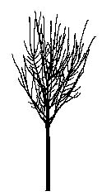
'Canada Red Select' in youth
Scientific Name: Pyrus betulaefolia ‘Southworth’ and P. calleryana x P. betulaefolia ‘Edgedell’
Common Name: Dancer™ Ornamental Birchleaf Pear and Edgewood™ Callery Pear

Environmental Conditions:

Hardiness Zone: Dancer™ 4, Edgewood™ 5

Soil Moisture:

occasionally  saturated or  very wet soil |  |  | consistently  moist, well  drained soil |  |  | occasional  periods of  dry soil |  |  | prolonged  periods of  dry soil
1 | 2 | 3 | 4 | 5 | 6 | 7 | 8 | 9 | 10 | 11 | 12

Sun/Shade: full sun

Salt: unknown
pH: < 8.2
Insect/Disease Factors: fireblight is a common and potentially serious problem for Pryus, reportedly no fireblight observed on Dancer™

Growth Characteristics:

Height: 30’
Width: 20’-25’
Form/Habit: wider branching angles than P. calleryana, Dancer™ is oval to rounded, Edgewood™ is rounded
Rate: medium to fast

Ornamental Characteristics:
Flower: showy, white clusters, spring, Dancer™ flowers heavier and 3 weeks later (so after leaves emerge) than most P. calleryana cultivars, Edgewood™ flowering time unknown

Fruit: 1/3”- 1/4”, tan, clustered
Seasonal Foliage Color: Dancer™ emerges silvery-gray in spring, turns glossy light green in summer (fall color unknown), Edgewood™ emerges with purple tint in spring, turns silvery-green in summer and reddish-purple in fall
Bark: similar to P. calleryana, brown to gray, lightly ridged and furrowed with age

Transplant Issues: easy to transplant B&B or < 2” caliper bare root
Management Issues: none of significance
Suggested Uses: narrow or wide street tree lawns/pits, parks, suitable for CU-Structural Soil™

Cultivars: above info is specific to cultivars
Scientific Name: Pyrus calleryana ‘Jaczam’, ‘Jilzam’, ‘Valzam’, and ‘Cleprizam’
Common Name: Jack™, Jill™, Valiant®, and Cleveland Pride® Callery Pears

Environmental Conditions:

Hardiness Zone: 4

Soil Moisture:

occasionally  saturated or  very wet soil |  |  | consistently  moist, well  drained soil |  |  | occasional  periods of  dry soil |  |  | prolonged  periods of  dry soil
1 | 2 | 3 | 4 | 5 | 6 | 7 | 8 | 9 | 10 | 11 | 12

Sun/Shade: full sun

Salt: some observed tolerance
pH: < 8.2
Insect/Disease Factors: Jack™ and Jill™ are fireblight resistant (fireblight is a common and potentially serious problem for Pryus), Valiant® and Cleveland Pride® have unknown fireblight resistance

Growth Characteristics:

Height: Jack™ and Jill™ 15’-20’, Valiant® and Cleveland Pride® 25’-30’

Width: Jack™ 10’-12’, Jill™ 15-20’, Valiant® and Cleveland Pride® 15’-20’
Form/Habit: Jack™ oval and denser than Jill™, Jill™ round, Valiant® and Cleveland Pride® pyramidal, Valiant® is more upright pyramidal than Cleveland Pride®
Rate: medium to fast

Ornamental Characteristics:

Flower: showy, white clusters, spring before or as leaves emerge
Fruit: Jack™ and Jill™ ½”, yellow-green and clustered, Valiant® and Cleveland Pride® ¼”, tan and clustered
Seasonal Foliage Color: Jack™ is glossy dark green in summer and turns gold (possibly red) in fall, Jill™ is olive green in summer and turns gold in fall, Valiant® is glossy hunter-green in summer and turns crimson red in fall, Cleveland Pride® is olive green in summer and turns burgundy in fall with salmon-pink juvenile foliage
Bark: not ornamentally important, brown to gray, lightly ridged and furrowed with age, sometimes grayish and blocky with age as well

Other: Jill™ foliage is smaller in size and more rounded than Jack™ foliage
Transplant Issues: easy to transplant B&B or < 2” caliper bare root
Management Issues: branching angles and branch density combined with late holding leaves may make P. calleryana prone to early winter ice/snow storm damage
Suggested Uses: narrow or wide street tree lawns/pits, parks, suitable for CU-Structural Soil™
Cultivars: above info is specific to cultivars, other P. calleryana cultivars are larger trees

Scientific Name: Pyrus fauriei ‘Westwood’
Common Name: Korean Sun™ Pear

Environmental Conditions:

Hardiness Zone: 4

Soil Moisture:

occasionally  saturated or  very wet soil |  |  | consistently  moist, well  drained soil |  |  | occasional  periods of  dry soil |  |  | prolonged  periods of  dry soil
1 | 2 | 3 | 4 | 5 | 6 | 7 | 8 | 9 | 10 | 11 | 12

Sun/Shade: full sun

Salt: unknown
pH: < 8.2
Insect/Disease Factors: fireblight tolerant (a common and potentially serious problem for Pryus)

Growth Characteristics:

Height: 15’-20’
Width: 15’-20’

Form/Habit: rounded

Rate: unknown

Ornamental Characteristics:
Flower: showy, white clusters, spring during or after leaves emerge, smaller and fewer per cluster than P. calleryana

Fruit: small and clustered
Seasonal Foliage Color: excellent reddish-orange in fall
Bark: not ornamentally important, similar to P. calleryana, brown to gray, lightly ridged and furrowed with age

Other: drops leaves sooner than P. calleryana
Transplant Issues: easy to transplant B&B or < 2” caliper bare root

Management Issues: none of significance
Suggested Uses: narrow or wide street tree lawns/pits, parks, suitable for CU-Structural Soil™

Cultivars: above info is cultivar specific
Scientific Name: Pyrus ussuriensis ‘Mountain Frost’ and ‘MorDak’
Common Name: ‘Mountain Frost’ and Prairie Gem™ Ussurian Pears

Environmental Conditions:

Hardiness Zone: 3

Soil Moisture:

occasionally  saturated or  very wet soil |  |  | consistently  moist, well  drained soil |  |  | occasional  periods of  dry soil |  |  | prolonged  periods of  dry soil
1 | 2 | 3 | 4 | 5 | 6 | 7 | 8 | 9 | 10 | 11 | 12

Sun/Shade: full sun

Salt: unknown
pH: < 8.2
Insect/Disease Factors: P. ussuriensis shows good fireblight tolerance (a common and potentially serious problem for Pryus)

Growth Characteristics:

Height: 20’-25’
Width: 20’-25’
Form/Habit: upright-oval when young, rounded with age

Rate: unknown

Ornamental Characteristics:
Flower: showy, white clusters, spring before or as leaves emerge, individual flowers larger than P. calleryana
Fruit: 1”-1 ½”, greenish-yellow, in clusters, Prairie Gem™ (and likely ‘Mountain Frost’) will only fruit if cross pollinated

Seasonal Foliage Color: leathery, dark green in summer, yellow in fall
Bark: similar to P. calleryana, brown to gray, lightly ridged and furrowed with age

Transplant Issues: easy to transplant B&B or < 2” caliper bare root
Management Issues: none of significance
Suggested Uses: narrow or wide street tree lawns/pits, parks, suitable for CU-Structural Soil™

Cultivars: above info is specific to cultivars
Scientific Name: Robinia pseudoacacia ‘Globe’ (or ‘Inermis’) and ‘Bessoniana’
Common Name: Globe and Bessoniana Black Locust

Environmental Conditions:

Hardiness Zone: 4

Soil Moisture:

occasionally  saturated or  very wet soil |  |  | consistently  moist, well  drained soil |  |  | occasional  periods of  dry soil |  |  | prolonged  periods of  dry soil
1 | 2 | 3 | 4 | 5 | 6 | 7 | 8 | 9 | 10 | 11 | 12

Sun/Shade: prefers full sun, tolerates full shade
Salt: some observed tolerance
pH: < 8.2
Other: species appropriate for very difficult reclamation sites, fixes own nitrogen
Insect/Disease Factors: borers can be a serious problem for species, leaf miners can be problematic for species, ‘Globe’ appears to be less borer susceptible

Growth Characteristics:

Height: ‘Globe’ 20’, ‘Bessoniana’ 30’
Width: 20’
Form/Habit: ‘Globe’ very dense and round, ‘Bessoniana’ oval with typically good central leader and good branching habit
Rate: species is fast

Ornamental Characteristics:
Flower: white, fragrant, late spring, both cultivars flower less than straight species, ‘Globe’ is sometimes completely non-flowering
Fruit: flat 2”-4” long pod, both cultivars produce less fruit than straight species, ‘Globe’ is sometimes completely non-fruiting

Seasonal Foliage Color: medium green to blue-green, yellowish in fall
Bark: dark gray, with interlacing ridges, ropy appearance

Other: ‘Globe’ is spineless, ‘Bessoniana’ is essentially spineless
Transplant Issues: easy to transplant B&B or < 2” caliper bare root

Management Issues: best to prune in late summer or fall due to “bleeding” in spring
Suggested Uses: narrow or wide street tree lawns/pits, parks, suitable for CU-Structural Soil™
Cultivars: above info is specific to cultivars, other R. pseudoacacia cultivars are larger trees or smaller unique trees not suited for urban use

Scientific Name: Sorbus intermedia

Common Name: Swedish Mountainash

Environmental Conditions:

Hardiness Zone: 5b or 6a

Soil Moisture:

occasionally  saturated or  very wet soil |  |  | consistently  moist, well  drained soil |  |  | occasional  periods of  dry soil |  |  | prolonged  periods of  dry soil
1 | 2 | 3 | 4 | 5 | 6 | 7 | 8 | 9 | 10 | 11 | 12

Sun/Shade: full sun

Salt: unknown
pH: < 8.2
Insect/Disease Factors: reportedly less susceptible to pests than European Mountainash (Sorbus aucuparia), which has many pest problems

Growth Characteristics:

Height: 25’-35’
Width: 30’

Form/Habit: round

Rate: medium

Ornamental Characteristics:

Flower: showy, white clusters, spring
Fruit: showy, orange-red clusters, berry-like, late summer/early fall
Seasonal Foliage Color: green on upper surface with a gray-white pubescence on undersides in summer, color varies from pale green to golden brown to orange-reddish in fall
Bark: not ornamentally important, gray-brown, often smooth, becoming slightly rough with age

Transplant Issues: easy to transplant B&B or < 2” caliper bare root
Management Issues: none of significance
Suggested Uses: narrow or wide street tree lawns/pits, parks, suitable for CU-Structural Soil™

Cultivars: none available commercially
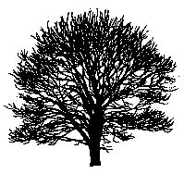
S. intermedia with age
Scientific Name: Sorbus x hybrida and Sorbus x thuringiaca, these hybids (S. aria x S. aucuparia) are virtually the same plant and therefore readily confused in the trade
Common Name: Oak-Leaf Mountainash

Environmental Conditions:

Hardiness Zone: 3b

Soil Moisture:

occasionally  saturated or  very wet soil |  |  | consistently  moist, well  drained soil |  |  | occasional  periods of  dry soil |  |  | prolonged  periods of  dry soil
1 | 2 | 3 | 4 | 5 | 6 | 7 | 8 | 9 | 10 | 11 | 12

Sun/Shade: prefers full sun, tolerates partial shade

Salt: unknown
pH: < 8.2
Insect/Disease Factors: reportedly less susceptible to pests than European Mountainash (Sorbus aucuparia), which has many pest problems

Growth Characteristics:

Height: 25‘-35’
Width: 30’
Form/Habit: upright oval to pyramidal (true S. x thuringiaca is sometimes more dense and rounded with age)

Rate: medium

Ornamental Characteristics:

Flower: white clusters, spring
Fruit: showy reddish-orange clusters, berry-like
Seasonal Foliage Color: dark green on upper surface with a white pubescence on undersides in summer, rusty orange-yellow in fall
Bark: not ornamentally important, gray-brown, often smooth, becoming slightly rough with age

Other: true S. x thuringiaca has longer leaves than S. x hybrida
Transplant Issues: easy to transplant B&B or < 2” caliper bare root

Management Issues: none of significance
Suggested Uses: narrow or wide street tree lawns/pits, parks, suitable for CU-Structural Soil™
Cultivars: ‘Fastigiata’ (narrowly pyramidal form, 10’-20’ wide, usually twice as tall as wide at maturity)

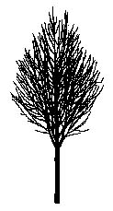

Scientific Name: Syringa reticulata

Common Name: Japanese Tree Lilac

Environmental Conditions:

Hardiness Zone: 3a

Soil Moisture:

occasionally  saturated or  very wet soil |  |  | consistently  moist, well  drained soil |  |  | occasional  periods of  dry soil |  |  | prolonged  periods of  dry soil
1 | 2 | 3 | 4 | 5 | 6 | 7 | 8 | 9 | 10 | 11 | 12

Sun/Shade: prefers full sun, tolerates partial shade, flowers best in full sun
Salt: some observed tolerance
pH: < 8.2
Insect/Disease Factors: resistant to powdery mildew (the most common Lilac problem), susceptible to a number of lilac problems that are rarely serious or limiting in Northern regions, although in warmer regions borers and scale may be serious problems

Growth Characteristics:

Height: 20’-25’
Width: 15’-20’

Form/Habit: oval

Rate: slow

Ornamental Characteristics:
Flower: showy, cream colored, 6”-12” long pyramidal-shaped cluster, summer (late June in central NY)
Fruit: ¾” long capsules, persistent clusters, obvious but not necessarily attractive
Seasonal Foliage Color: dark green in summer, fall color often nonexistent, occasionally turns dull yellow in fall

Bark: attractive, cherry-like, smooth reddish-brown with horizontal lenticels
Transplant Issues: easy to transplant B&B or < 2” caliper bare root

Management Issues: none of significance
Suggested Uses: narrow or wide street tree lawns/pits, parks, suitable for CU-Structural Soil™
Cultivars: ‘Ivory Silk’ (upright habit, dense, compact, heavy flowering, flowers at young age, grows faster than ‘Summer Snow’), ‘Summer Snow’ (round, compact, 16’-20’, glossy leaves, heavy flowering), Regent™ (‘PNI 5723’, upright form, pure white flowers, glossy foliage)
* var. mandshurica not recommended due to shrubby tendencies and extremely slow growth rate (also may not be as hardy as the species)
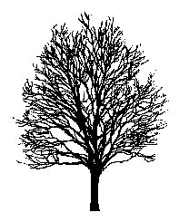

Scientific Name: Tilia cordata ‘Halka’
Common Name: Summer Sprite® Littleaf Linden

Environmental Conditions:

Hardiness Zone: 4

Soil Moisture:

occasionally  saturated or  very wet soil |  |  | consistently  moist, well  drained soil |  |  | occasional  periods of  dry soil |  |  | prolonged  periods of  dry soil
1 | 2 | 3 | 4 | 5 | 6 | 7 | 8 | 9 | 10 | 11 | 12
*prolonged drought will lead to leaf scorch

Sun/Shade: full sun

Salt: sensitive
pH: < 8.2
Insect/Disease Factors: species is highly susceptible to aphids and Japanese Beetles, cultivar’s resistance unknown

Growth Characteristics:

Height: 15’-20’
Width: 8’-10’
Form/Habit: narrow pyramidal, dense
Rate: species is medium, cultivar may be slower

Ornamental Characteristics:
Flower: yellowish, drooping clusters attached to pale greenish-yellow leaf-like bracts, mid-summer, very fragrant, attracts bees, flowers after T. americana but before T. tomentosa
Fruit: not ornamentally important, small nutlets, globose, attached to bracts, late summer

Seasonal Foliage Color: yellow in fall

Bark: not ornamentally important, gray-brown, ridged and furrowed on older trunks

Transplant Issues: easy to transplant B&B or < 2” caliper bare root
Management Issues: none of significance
Suggested Uses: narrow or wide street tree lawns/pits, parks, suitable for CU-Structural Soil™
Cultivars: above info is cultivar specific, other T. cordata cultivars are large trees

Scientific Name: Viburnum sieboldii

Common Name: Siebold Viburnum

Environmental Conditions:
Hardiness Zone: 5 (4)

Soil Moisture:

occasionally  saturated or  very wet soil |  |  | consistently  moist, well  drained soil |  |  | occasional  periods of  dry soil |  |  | prolonged  periods of  dry soil
1 | 2 | 3 | 4 | 5 | 6 | 7 | 8 | 9 | 10 | 11 | 12

Sun/Shade: prefers full sun, tolerates partial shade

Salt: unknown
pH: < 8.2

Insect/Disease Factors: none serious or limiting

Growth Characteristics:

Height: 15’-20’
Width: 10’-15’
Form/Habit: open, multi-stemmed, often considered large shrub, can easily be small tree with pruning
Rate: medium to fast

Ornamental Characteristics:

Flower: creamy white, 3”-6” flat-topped clusters, late spring
Fruit: showy, red drupes in clusters, turn blue-black in late summer, fruit display typically short as birds eat fruit quickly, red stalks persist into fall
Seasonal Foliage Color: lustrous, leathery, dark green in summer, fall color usually nonexistent, although red-purple potential observed

Bark: not ornamentally important, gray-brown
Other: holds leaves late into fall

Transplant Issues: easy to transplant B&B or < 2” caliper bare root
Management Issues: low branches may require pruning for street tree use
Suggested Uses: wide street tree lawns/pits, narrow tree lawns/pits with pruning, parks
Cultivars: ‘Seneca’ (heavy flowering/fruiting form, fruits have long-lasting red color stage – up to 3 months, very firm fruit not preferred by birds, reportedly good red fall color)

Scientific Name: Zelkova serrata ‘Schmidtlow’
Common Name: Wireless® Japanese Zelkova

Environmental Conditions:

Hardiness Zone: 5

Soil Moisture:

occasionally  saturated or  very wet soil |  |  | consistently  moist, well  drained soil |  |  | occasional  periods of  dry soil |  |  | prolonged  periods of  dry soil
1 | 2 | 3 | 4 | 5 | 6 | 7 | 8 | 9 | 10 | 11 | 12

Sun/Shade: full sun

Salt: some observed tolerance
pH: < 8.2

Insect/Disease Factors: none serious or limiting

Growth Characteristics:

Height: 25’
Width: 35’
Form/Habit: broadly spreading vase, flattened top at maturity
Rate: species is medium, possibly fast in youth

Ornamental Characteristics:

Flower: not ornamentally important, usually present as leaves are emerging

Fruit: not ornamentally important, ripens in fall
Seasonal Foliage Color: medium green in summer, red in fall

Bark: exfoliates and mottles with oranges, grays and browns with age
Transplant Issues: easy to transplant B&B or < 2” caliper bare root
Management Issues: species has narrow crotch angles and poor branch attachments which may give rise to splitting and form damage when older, this problem may be less likely to develop in this smaller cultivar
Suggested Uses: narrow or wide street tree lawns/pits, parks, suitable for CU-Structural Soil™
Cultivars: above info is cultivar specific, other Z. serrata cultivars are large trees

RECOMMENDED URBAN TREES FOR

USDA PLANT HARDINESS ZONE 6 AND COLDER

II. MEDIUM TO LARGE TREES (> 30’) SUITABLE FOR

CITY ENVIRONMENT PLANTINGS

Scientific Name: Acer x freemanii (A. rubrum x A. saccharinum)

Common Name: Freeman Maple

Environmental Conditions:

Hardiness Zone: 4

Soil Moisture:

occasionally  saturated or  very wet soil |  |  | consistently  moist, well  drained soil |  |  | occasional  periods of  dry soil |  |  | prolonged  periods of  dry soil
1 | 2 | 3 | 4 | 5 | 6 | 7 | 8 | 9 | 10 | 11 | 12

Sun/Shade: full sun

Salt:
pH: < 7.5
Insect/Disease Factors: none serious or limiting, Autumn Blaze® shows more tolerance to leafhoppers than A. rubrum

Growth Characteristics:

Height: 45’-70’

Width: varies with cultivar, see cultivar chart on following page
Form/Habit: varies with cultivar, see cultivar chart on following page
Rate: medium to fast

Ornamental Characteristics:

Flower: greenish-yellow to red clusters, early spring, some showy red
Fruit: samara, sometimes reddish maturing to brown, seedless forms available
Seasonal Foliage Color: fall color varies with cultivar (yellow/orange/red), see cultivar chart on following page

Bark: typically attractive silver-gray
Transplant Issues: easy to transplant B&B or < 2” caliper bare root
Management Issues: can develop graft incompatibility depending on understock used, specify own roots to avoid this delayed graft incompatibility problem
Suggested Uses: narrow or wide street tree lawns/pits, parks
Cultivars: see chart on following page
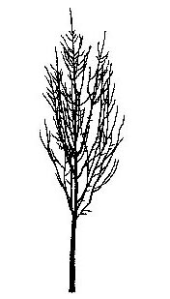

'Armstrong'

Acer x freemanii (Freeman Maple) Cultivars:

Cultivar | Width | Form/Habit | Foliage | Fall Color | Other
‘Armstong’  occasionally listed under  A. rubrum | 15’-20’ | columnar/fastigiated,  upright branching | resembles  A. saccharinum,  5-lobed, silvery undersides | yellow to orange | fast grower, flowers not showy
‘Armstong Two’ | 15’-20’ | more dense, more tightly ascending branches than ‘Armstrong’ | resemble  A. saccharinum,  5-lobed, silvery undersides | better red than  ‘Armstrong’, still not reliable red | fast grower, flowers not showy
Autumn Blaze® (‘Jeffersred’) | 40’ | broad oval, improved branch structure over A. saccharinum, dense, multi-stem form available | resemble  A. saccharinum,  deeply 5-lobed | excellent orange-red, long-lasting | fast grower, sparse  flowering, nearly seedless
Autumn Fantasy™ (‘DTR102’) | 40’ | broadly oval to upright-oval | more closely resembling  A. saccharinum,  5-lobed | consistently bright red | fast growing
Celebration™ (‘Celzam’) | 20’-25’ maybe 40’ | upright-pyramidal,  strong branch angles | similar to  A. saccharinum, dense | golden-yellow to red, reportedly turning from red to gold | red flower, seedless,  fast growing in youth
‘Marmo’ | 35’-45’ | broad columnar, strong central leader | 5-lobed, intermediate between parents | excellent, often mottled red & green, at times varying burgundy to orange or gold, colors early | good growth rate, seedless
‘Morgan’ Canadian, can be known as ‘Indian Summer’ in U.S, sometimes listed under A. rubrum | 40’ | broadly oval, open habit |  | orange-red to red | very fast growing
Scarlet Sentinel™  occasionally still listed as  A. rubrum | 25’-35’ | broad columnar to oval-rounded, ascending branches, improved branch structure over  A. saccharinum | closely resembling A. saccharinum,  5-lobed | yellow to red | fast growing, bright red flowers, no fruit observed, reportedly shiny bark
* ‘Armstong’, ‘Armstong Two’, Autumn Blaze®, ‘Marmo’, and ‘Morgan’ sometimes listed as Zone 3
Scientific Name: Acer miyabei

Common Name: Miyabei Maple

Environmental Conditions:
Hardiness Zone: 5a (4b)

Soil Moisture:

occasionally  saturated or  very wet soil |  |  | consistently  moist, well  drained soil |  |  | occasional  periods of  dry soil |  |  | prolonged  periods of  dry soil
1 | 2 | 3 | 4 | 5 | 6 | 7 | 8 | 9 | 10 | 11 | 12

Sun/Shade: prefers full sun, tolerates partial shade

Salt: unknown
pH: < 8.2
Other: State Street™ has reportedly good heat tolerance

Insect/Disease Factors: relatively pest free

Growth Characteristics:

Height: 35’-45’
Width: 30’
Form/Habit: upright oval to rounded, can have open or dense branching, low branching tendency often creates short trunk

Rate: medium

Ornamental Characteristics:

Flower: greenish-yellow, in pyramidal clusters, spring

Fruit: samara
Seasonal Foliage Color: flat to semi-glossy, medium to dark green in summer, yellow in fall, often holds green late so fall color is short-lived before leaves fall

Bark: dark gray, typically rough and corky
Transplant Issues: easy to transplant B&B or < 2” caliper bare root

Management Issues: none of significance
Suggested Uses: narrow or wide street tree lawns/pits, parks, suitable for CU-Structural Soil™
Cultivars: State Street™ (‘Morton’, zone 4, upright oval form, good uniform branching, dark green foliage, good golden yellow fall color, possibly fast growing)

Scientific Name: Acer platanoides

Common Name: Norway Maple

Environmental Conditions:

Hardiness Zone: 4a

Soil Moisture:

occasionally  saturated or  very wet soil |  |  | Consistently  Moist, well  Drained soil |  |  | occasional  periods of  dry soil |  |  | prolonged  periods of  dry soil
1 | 2 | 3 | 4 | 5 | 6 | 7 | 8 | 9 | 10 | 11 | 12

Sun/Shade: prefers full sun, tolerates full shade
Salt: some observed tolerance
pH: < 8.2

Other: ‘Summershade’ considered more heat tolerant
Insect/Disease Factors: tar/black spot is a common serious aesthetic problem that can defoliate species in certain areas, susceptible to Verticillium Wilt (reportedly ‘Schwerdleri’, Parkway™, ‘Jade Glen’ are tolerant, ‘Summershade’ is moderately tolerant, ‘Crimson King’ is the most susceptible) which can be a serious problem in some areas, susceptible to leafhoppers (reportedly ‘Summer Shade’ is tolerant), ‘Crimson King’ and reportedly ‘Royal Red’ are more susceptible to pest problems than species, ‘Deborah’ foliage more resistant to leaf scorch

Growth Characteristics:
Height: 40’-50’ (can reach 90’)
Width: 30’-50’
Form/Habit: oval to upright-oval or rounded to broadly oval

Rate: medium

Ornamental Characteristics:

Flower: yellow to greenish yellow clusters, early spring before leave emerge
Fruit: 1 ½”-2” samara, mature in fall, abundant
Seasonal Foliage Color: dark green in summer, dark maroon color on some cultivars, yellow to brown in fall
Bark: not ornamentally important, gray-black with narrow ridges and shallow furrows

Other: foliage is typically very dense, foliage often held late
Transplant Issues: easy to transplant B&B or < 2” caliper bare root
Management Issues: very likely to naturalize when planted next to open areas, tends to heave sidewalks unless adequate rooting space is provided, tendency to develop girdling roots, very dense foliage and shallow root system makes successful turf growth beneath difficult, bark split may be common in zone 4 conditions
Suggested Uses: narrow or wide street tree lawns/pits, parks, suitable for CU-Structural Soil™

Cultivars: see chart on following page
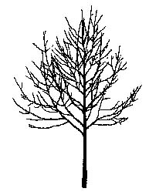

'Superform'
(one of the rounded to broadly oval forms)

Acer platanoides (Norway Maple) cultivars:

Cultivar and Size | Noteworthy Foliage Characteristics | Other Noteworthy Characteristics
Rounded to Broadly Oval
Champ Tree™  (‘National 2000’)  55’high x 40’wide | yellow in fall
‘Crimson King’  40’high x 30’wide | dark maroon in summer, turn darker or brown-out in fall | maroon-yellow flowers, slower growing
‘Deborah’  50’high x 45’wide | thick, new growth emerges red-purple matures dark green in summer, yellow (orangey) in fall | straight central leader
‘Drummondii’  35’high x 30’wide | variegated, light green edged with white in summer, yellowish in fall
Emerald Lustre™ (‘Pond’)  50’high x 45’wide | glossy, wavy margin, new leaves have reddish tint | sometimes listed as zone 3, good branching at early age, faster growing
‘Emerald Queen’  50’high x 40’wide | leathery, reddish tint in spring, bright yellow in fall | sometimes listed as zone 3, uniform growth, straight trunk, faster growing
‘Jade Glen’  45’high x 45’wide | yellow in fall | open habit, faster growing
‘Princeton Gold’  35’high x 30’wide | emerges bright yellow in spring, may fade in summer, darker yellow in fall
Medallion™ (‘Medzam’)  45’high x 35’-40’wide | thick glossy, red and gold in fall | dense branching
‘Royal Red’  40’high x 30’wide | glossy, dark maroon in summer, turn darker or browns out in fall | reportedly slightly hardier & slower growing than ‘Crimson King’
‘Schwedleri’  50’high x 50’wide | emerges purplish-red in spring, matures to dark green in summer, orange to yellow in fall | flowers brownish
‘Summershade’  50’high x 40’wide | leathery, leafs out late in spring and holds late in fall, yellow in fall | zone 4b, faster growing
‘Superform’  50’high x 45’wide | yellow in fall | symmetrical, uniform branching angles, straight trunk
Oval to Upright Oval
‘Cleveland’  45’high x 25’-30’wide | good golden-yellow in fall | good branching habit
‘Columnare’  50’high x 15’-20’wide | darker green in summer, golden-yellow in fall | sometimes listed as zone 3, moderate growth rate
Conquest™ (‘Conzam’)  30’-35’high x 8’-10’wide | dark maroon changes to deep green in summer, bright red in fall | dense branching
‘Crimson Sentry’  25’high x 15’wide | dark maroon to purple in summer | sometimes listed as zone 4b, dense branching, almost pyramidal, slower growing than ‘CrimsonKing’
Easy Street™ (‘Ezeste’)  40’high x 20’wide | yellow in fall | almost pyramidal, faster growing
‘Fairview’  45’high x 35’wide | reddish purple new growth, matures to bronze-green in summer
‘Olmstead’  40’high x 20’-25’wide |  | slower growing
Parkway™ (‘Columnarbroad’)  40’high x 25’wide | yellow in fall | sometimes listed as zone 3, strong central leader, good branching, faster growing

Scientific Name: Acer pseudoplatanus

Common Name: Sycamore Maple

Environmental Conditions:

Hardiness Zone: 5b

Soil Moisture:

occasionally  saturated or  very wet soil |  |  | consistently  moist, well  drained soil |  |  | occasional  periods of  dry soil |  |  | prolonged  periods of  dry soil
1 | 2 | 3 | 4 | 5 | 6 | 7 | 8 | 9 | 10 | 11 | 12

Sun/Shade: prefers full sun, tolerates partial shade
Salt: tolerant of both soil and air-borne salts
pH: < 8.2
Insect/Disease Factors: none serious or limiting, the more common cultivar ‘Atropurpureum’ (also known as ‘Spaethii’ or ‘Purpureum’) is likely not as tolerant as straight species (aphids favor, may have problems with leaf scorch, sunscald, and/or borer infestations)

Growth Characteristics:

Height: 40’-60’
Width: 30’-50’
Form/Habit: oval to rounded crown, upright spreading branching

Rate: medium

Ornamental Characteristics:

Flower: yellow-green clusters, spring after leaves

Fruit: 1 ¼”-2” long samara
Seasonal Foliage Color: dark green in summer, brown to poor yellow in fall
Bark: gray and reddish brown, flaking into scales and exposing orange-brown inner bark

Other: more leathery foliage that A. platanoides
Transplant Issues: easy to transplant B&B or < 2” caliper bare root

Management Issues: species naturalizes freely when planted next to open areas
Suggested Uses: narrow or wide street tree lawns/pits (popular street tree in Europe), parks, suitable for CU-Structural Soil™
Cultivars: many common in Europe, few rarely available in the United States, ‘Atropurpureum’ (also known as ‘Spaethii’ or ‘Purpureum’) is not highly recommended due to above mentioned potential insect and disease problems
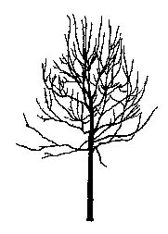

Scientific Name: Acer rubrum

Common Name: Red Maple

Environmental Conditions:
Hardiness Zone: 3b, choose zone appropriate seed source if cultivar not selected

Soil Moisture:

Cultivar | occasionally  saturated or  very wet soil |  |  | consistently  moist, well  drained soil |  |  | occasional  periods of  dry soil |  |  | prolonged  periods of  dry soil
Red Sunset®  ‘Bowhall’ | 1 | 2 | 3 | 4 | 5 | 6 | 7 | 8 | 9 | 10 | 11 | 12
‘Autumn Flame’  October Glory® | 1 | 2 | 3 | 4 | 5 | 6 | 7 | 8 | 9 | 10 | 11 | 12
Northwood®  ‘Karpick’ | 1 | 2 | 3 | 4 | 5 | 6 | 7 | 8 | 9 | 10 | 11 | 12
*flood tolerance of above cultivars is listed on cultivar chart on following page

Sun/Shade: full sun

Salt: sensitive
pH: < 7.0
Insect/Disease Factors: susceptible to Verticillium Wilt and leaf hoppers, ‘Brandywine’, ‘Red Rocket’, ‘Somerset’ and ‘Sun Valley’ show good potato leafhopper (which can cause leaves to scorch) resistance, occasionally borers attack young terminals

Growth Characteristics:

Height: 35’-60’
Width: 30’-70’
Form/Habit: pyramidal in youth, narrow upright to rounded with age, greatly varies, see cultivar chart on following page
Rate: medium to fast

Ornamental Characteristics:

Flower: showy, red, sometimes yellow to orange, small clusters in spring before leaves

Fruit: samara, often red, late spring to early summer
Seasonal Foliage Color: leaves emerge reddish in spring, green in summer, color varies in fall (yellow, orange, red), see cultivar chart on following page

Bark: attractive silver-gray in youth
Transplant Issues: easy to transplant B&B or < 2” caliper bare root
Management Issues: thin bark can be easily damaged, delayed graft incompatibility can be a problem, should specify as ‘own-rooted’ when possible
Suggested Uses: narrow or wide street tree lawns/pits, parks
Cultivars: see chart on following page
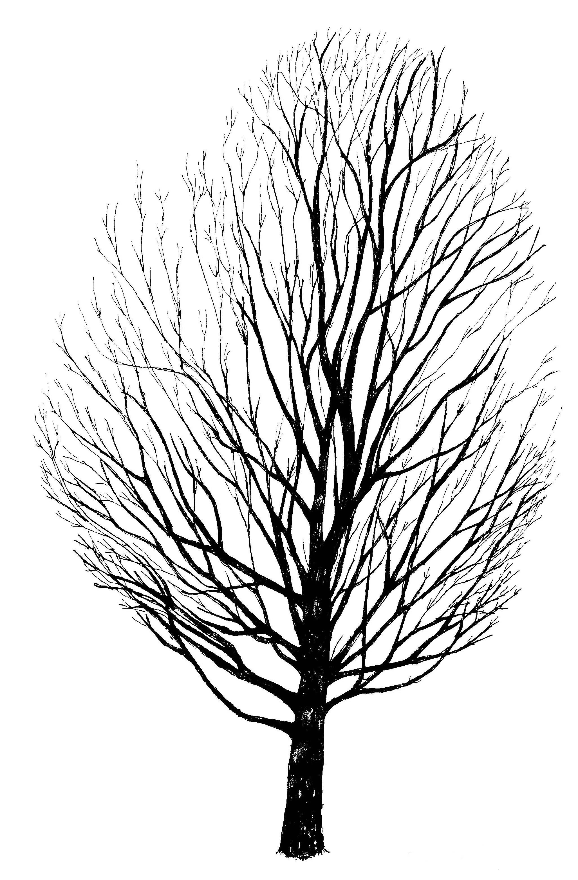

Acer rubrum (Red Maple) cultivars:

Cultivar | Zone | Width | Form/Habit | Fall Color | Flood Tolerance | Other
‘Autumn Flame’ | 3b | 35’-55’ | round, dense, good branch structure, symmetrical | red, early, long-lasting | medium | fruitless, red-brown 1 year old twigs, smaller leaves
‘Autumn Radiance’ | 4 | 40’ | oval to rounded | red, early
‘Autumn Spire’ | 3 | 20’-25’ | broad columnar, upright branching | red, early
‘Bowhall’ | 4 | 15’-25’ | narrow columnar, upright, symmetrical | orange, variable | high | pale orange flowers, slower growing
‘Brandywine’ | 4 | 35’ | oval to round | red to purple-red, late turning
Fairview Flame® | 4 | 30’ | oval to round | scarlet red
Fireball™ (‘Firzam’) | 4 | 25’-30’ | narrow pyramidal, dense, symmetrical | red and gold
‘Karpick’ | 4 | 15’-25’ | narrow columnar, upright, dense | yellow or red, variable | low | red twigs, red fruit, fast growing
Northfire™  (‘Olson’) | 3 | 35’ | oval, good branch structure | red, early
Northwood® | 3b (3a) | 35’ | round, somewhat irregular, straight trunk, good branch structure | orange-red | low | orange-red flowers, seedless
October Glory® (‘PNI 0268’) | 5a | 35’-45’ | round | red, late turning, holds leaves late | medium | bright red flowers, glossy leaves
‘Red Rocket’ | 3 | 10’-15’ | columnar | red
‘Red Skin’ | 4 | 40’ | round | reddish maroon, early |  | large thick leaves
Red Sunset® (‘Franksred’) | 4b (4a) | 35’-45’ | oval to round, upright branching, good branch structure, symmetrical, clump form available | orange-red, leaves hold late | high | bright red fruit, thick glossy leaves
‘Schlesingeri’ | 4 (3) | 45’ | broad vase-shaped to rounded, dense | orange to red, often paler tones, early, often long-lasting color
‘Somerset’ | 4 | 30’ | oval to round | red
‘Sun Valley’ | 4 | 35’ | oval, dense, symmetrical | red |  | seedless

Scientific Name: Acer saccharum

Common Name: Sugar Maple

Environmental Conditions:
Hardiness Zone: 4 (3b with selection of appropriate genetic material)

Soil Moisture:

occasionally  saturated or  very wet soil |  |  | consistently  moist, well  drained soil |  |  | occasional  periods of  dry soil |  |  | prolonged  periods of  dry soil
1 | 2 | 3 | 4 | 5 | 6 | 7 | 8 | 9 | 10 | 11 | 12
* Adirondak®, Crescendo™, Fiddler’s Creek™, ‘Legacy’, and Steeple™ reportedly better
drought tolerance than species, ‘Caddo’ (a western ecotype) is extremely drought tolerant
* Acer nigrum, Black Maple, is closely related to A. saccarhum, although it has a higher drought-tolerance, the A. nigrum selection ‘Greencolumn’ is included on cultivar chart on following page

Sun/Shade: full sun

Salt: sensitive
pH: < 7.5
Other: heat sensitive, Apollo™, Bonfire™, Commemoration’, Crescendo™, ‘Legacy’, and Steeple™ reportedly more heat tolerant than species, ‘Caddo’ (a western ecotype) is extremely heat tolerant
Insect/Disease Factors: Verticillium wilt can be a serious problem in some areas, leaf scorch can be serious (reportedly ‘Goldspire’ is moderately resistant, ‘Endowment’ and ‘Wright Brothers’ are resistant, and ‘Goldspire’ is highly resistant), Bonfire™ shows good leafhopper resistance

Growth Characteristics:
Height: 45’-50’ typical, 60’-75’ possible (can grow 100’+ in wild)
Width: 35’-40’ typical, 55’-70’ possible

Form/Habit: oval to round

Rate: slow to medium

Ornamental Characteristics:

Flower: pale yellow pendulous clusters, early spring before leaves emerge
Fruit: 1” samara
Seasonal Foliage Color: medium to dark green in summer, varies from yellow, orange, to bright red in fall, typically excellent fall color
Bark: smooth gray bark in youth becomes furrowed with long scaly plates with age

Transplant Issues: easy to transplant B&B or < 2” caliper bare root
Management Issues: none of significance

Suggested Uses: wide street tree lawns/pits due to drought sensitivity, parks
Cultivars: see chart on following page
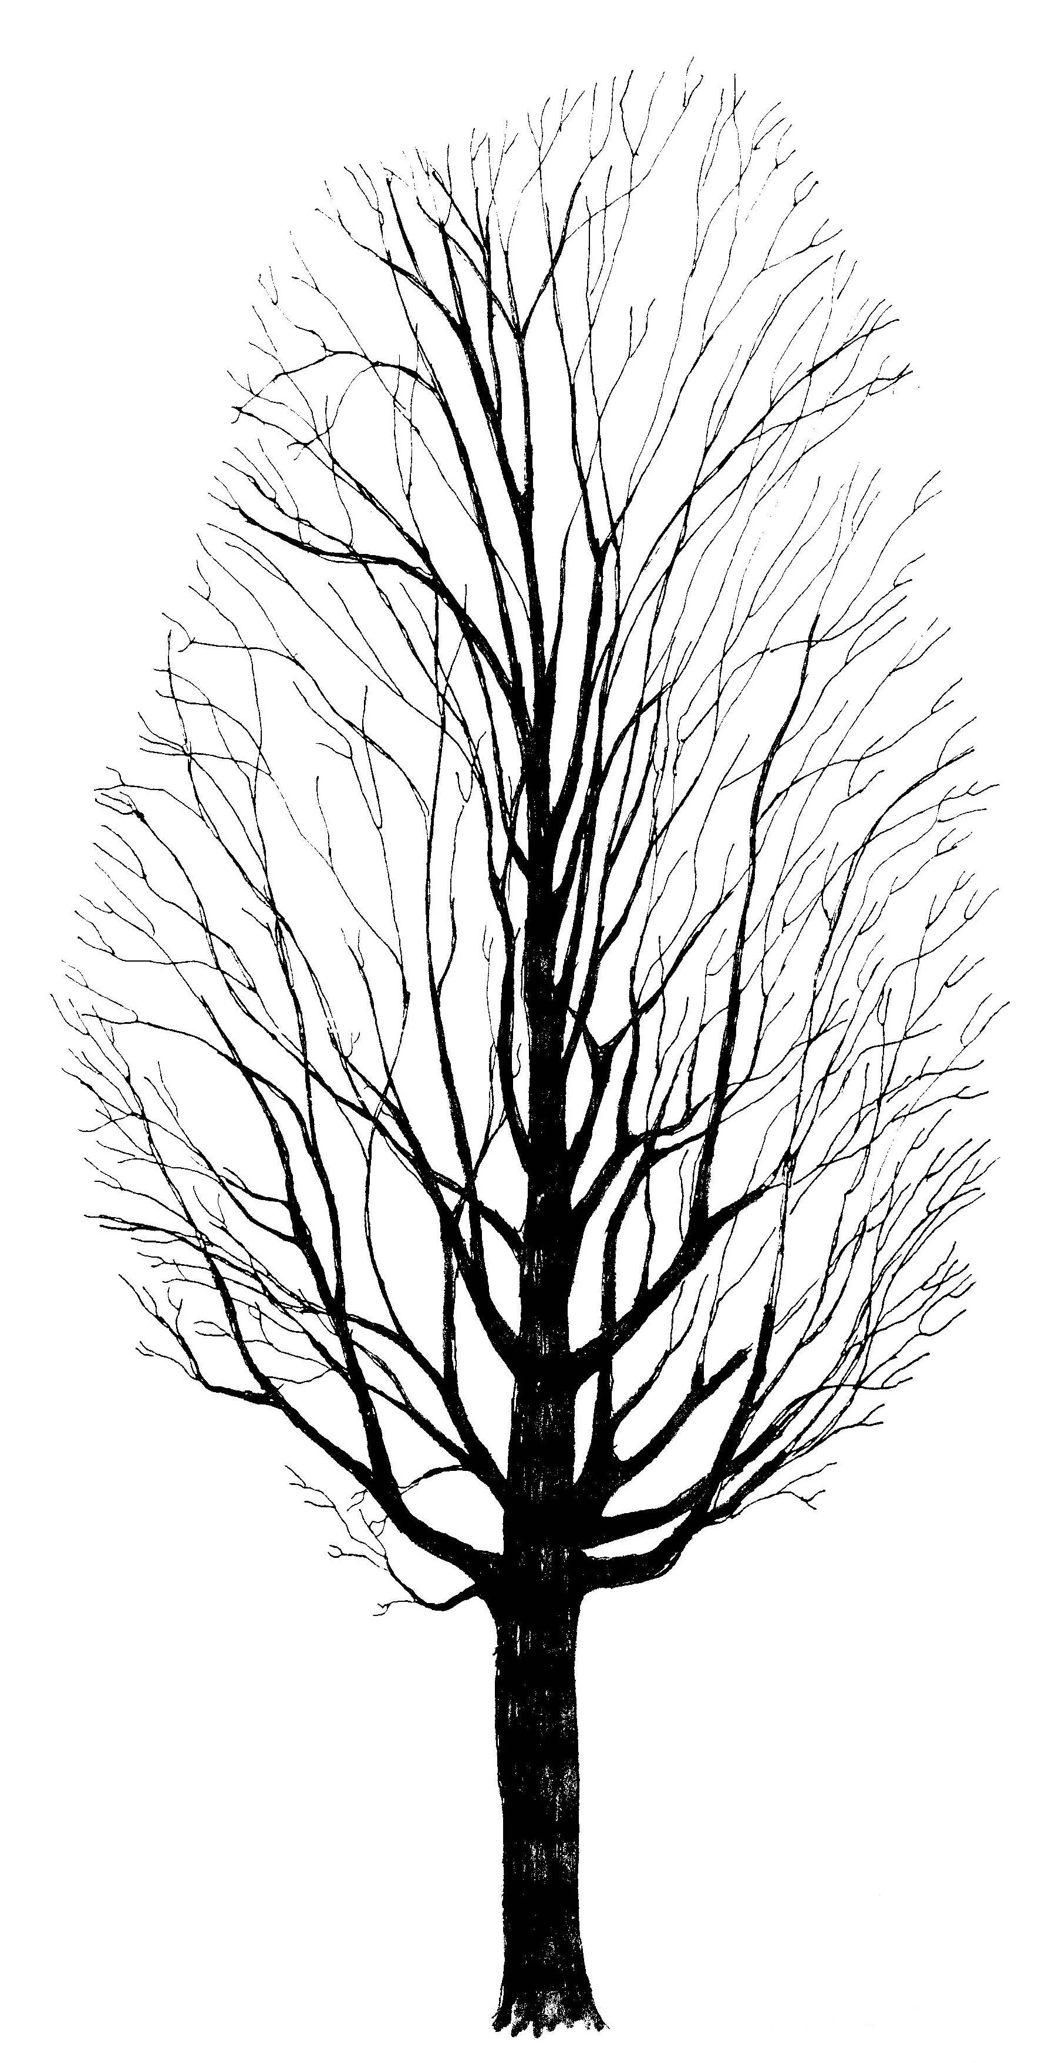

Acer saccharum (Sugar Maple) cultivars:

Culitvar | Height | Width | Foliage | Fall Foliage | Growth Rate and Form/Habit  variations from species
Adirondak®  (‘Adirzam’) | 60’-75’ | 25’-30’ | glossy, dark green | golden-orange, turns  and holds color late | pyramidal habit, dense
Apollo®  (‘Barrett Cole’) | 25’ | 10’ | dark green | variable | dense branching,  symmetrical
‘Arrowhead’ | 60’ | 30’-40’ | large, dark green | yellow to orange | pyramidal, strong central leader, dense branching
Bonfire™ | 50’-65’ | 40’-50’ | medium green | bright orange to red | faster growing
‘Caddo’ (describes a western ecotype) | 30’-50’ | variable | leathery, deeply lobed,dark green | variable, can be very showy | variable form/habit
‘Commemoration’ | 50’-60’ | 30’-35’ | thick, glossy, dark green, tatter resistant | variable, turns early, drops foliage late | faster growing, dense branching, develops heavy caliper earlier
Crescendo™ (‘Morton’) | 45’ or 30’ | 40’ | dark green | orange-red to red
‘Endowment’ | 50’ | 20’ | dark green | bright yellow,  sometimes orange-red | slower growing
Fall Fiesta™ | 50’-75’ | 50’ | glossy, thick, leathery, tatter resistant | variable | faster growing
Fiddler’s Creek™  (‘Fidcezam’) | 40’-50’ | 20’-25’ | large, deeply cut, thick, leathery, glossy | variable | faster growing, dense
‘Goldspire’ | 40’-45’ | 12’-20’ | leathery, dark green | bright yellow-orange | slower growing, dense
A. nigrum ‘Greencolumn’ | 50’ | 20’-25’ | medium green | yellow to apricot-orange | upright, narrow, maintains central leader, columnar in youth
Green Mountain® | 70’ (45’) | 45’  (35’) | thick, leathery, dark green, tatter resistant | variable | faster growing, uniform growth, upright habit
‘Legacy’ | 50’ | 35’ | glossy, thick, leathery, dark green, tatter resistant | variable | faster growing, dense, symmetrical at early age
Majesty®  (‘Flax Mill Majesty’) | 50’-80’ | 40’-50’ | dark green | orange to red | faster growing, develops heavy caliper and full branching earlier, symmetrical
‘Seneca Chief’ | 50’ | 30’ | dark green, larger | golden-orange | faster growing, muscle-like bark, dense branching
Steeple® (‘Astis’) *cold hardy only to  zone 5 | 45’ | 20’ | dark green | yellow-orange | narrow, symmetrical
‘Wright Brothers’  (formerly‘Moraine’) | 50’-75’ | 35’ |  | variable | faster growing, develops heavy caliper earlier
* ‘Arrowhead’, Adirondak®, Green Mountain®, Majesty®, ‘Seneca Chief’, ‘Wright Brothers’ sometimes listed as Zone 3

Scientific Name: Aesculus x carnea (A. hippocastanum x A. pavia)

Common Name: Red Horsechesnut

Environmental Conditions:

Hardiness Zone: 5a

Soil Moisture:

occasionally  saturated or  very wet soil |  |  | consistently  moist, well  drained soil |  |  | occasional  periods of  dry soil |  |  | prolonged  periods of  dry soil
1 | 2 | 3 | 4 | 5 | 6 | 7 | 8 | 9 | 10 | 11 | 12

Sun/Shade: full sun

Salt: unknown
pH: < 8.2
Insect/Disease Factors: less susceptible (but not immune) to leaf scorch, leaf blotch and reportedly mildew than Common Horsechestnuts (A. hippocastanum), potential fungal disease problems, sun-scald on trunks can be a problem in Zone 5a, ‘Fort McNair’ is reportedly more resistant to leaf scorch and leaf blotch

Growth Characteristics:

Height: 35’-50’
Width: 30’
Form/Habit: oval to round, typically dense

Rate: slow

Ornamental Characteristics:

Flower: 6”-8” tall, pink to red, upright pyramidal clusters, late spring

Fruit: glossy brown nuts in 1 ½” slightly prickly capsules
Seasonal Foliage Color: dark green in summer, no notable fall color
Bark: typically not ornamentally important, dark gray to brown, potentially becoming platy and exfoliating

Transplant Issues: easy to transplant B&B or < 2” caliper bare root
Management Issues: flower, fruit, leaf and twig litter may be a problem in some areas

Suggested Uses: narrow or wide street tree lawns/pits, parks
Cultivars: ‘Briotii’ (sometimes listed as Zone 4, bright red flowers in longer (10”) clusters, deep green foliage, reportedly nearly fruitless), ‘O’Neill’ (red flowers in longer, (10-12”) clusters, lighter green foliage), ‘Fort McNair’ (pink flowers with yellow throats)

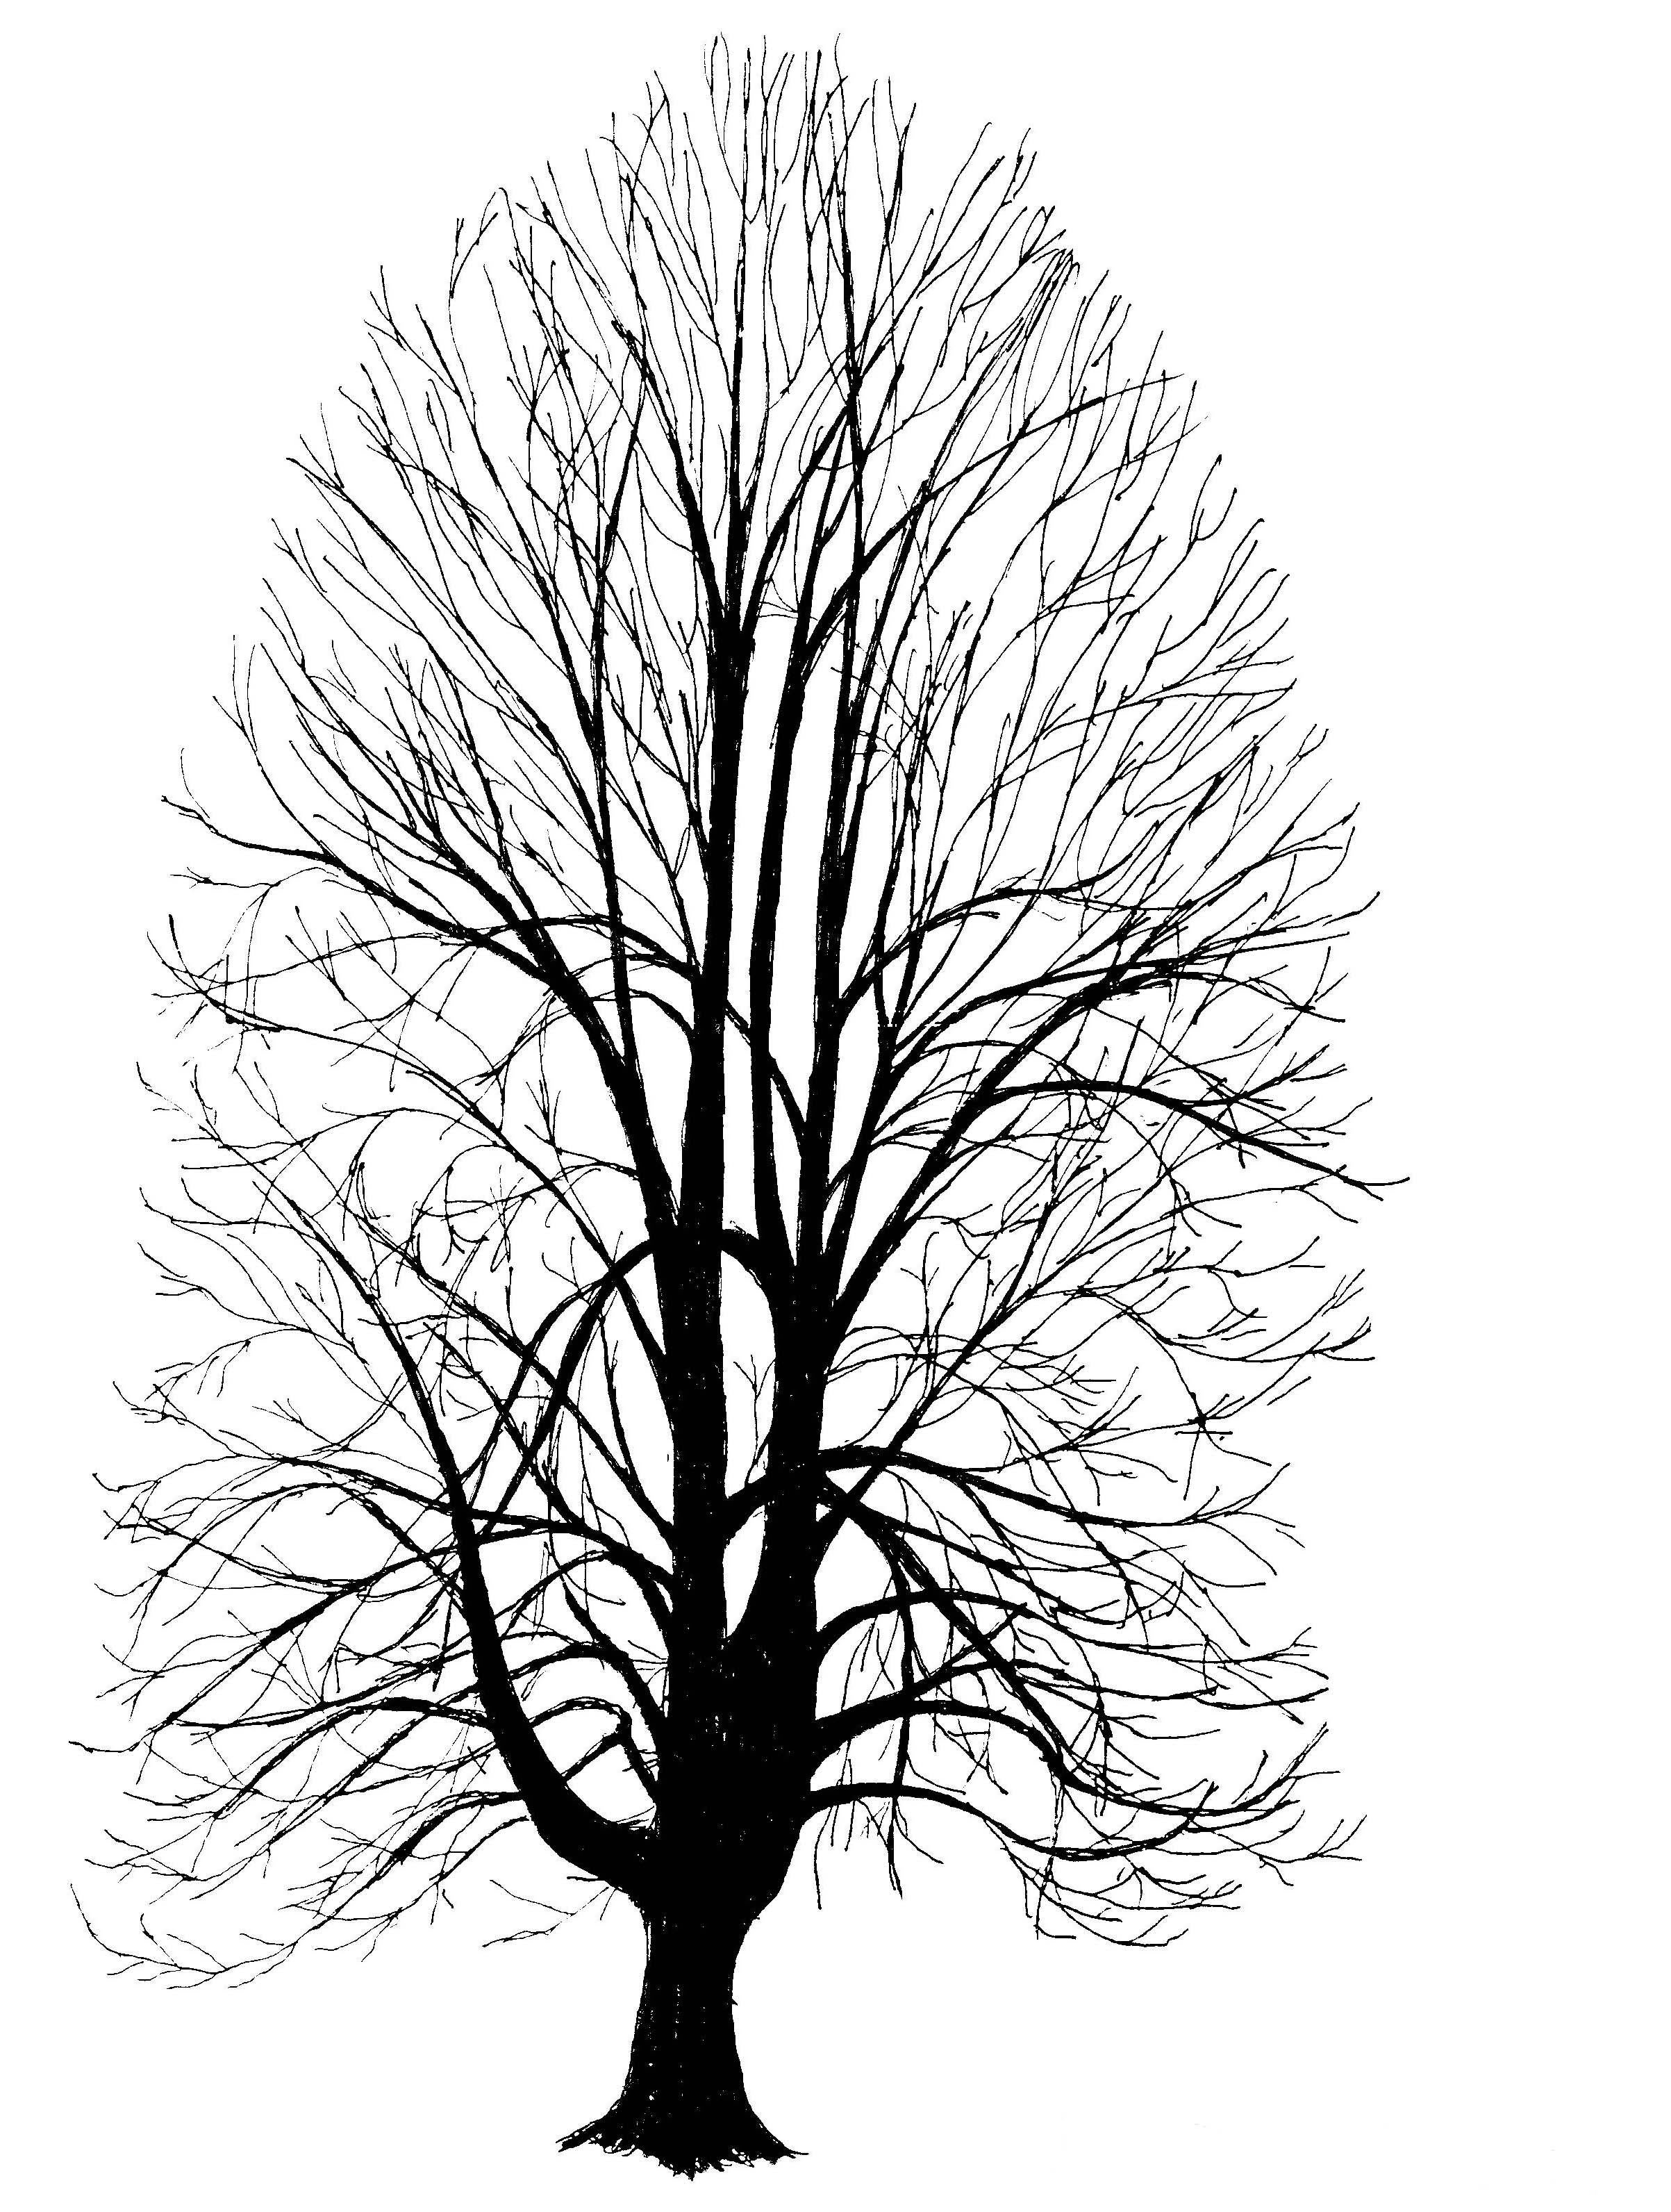

Scientific Name: Alnus glutinosa

Common Name: European Alder or Black Alder

Environmental Conditions:

Hardiness Zone: 4a

Soil Moisture:

occasionally  saturated or  very wet soil |  |  | consistently  moist, well  drained soil |  |  | occasional  periods of  dry soil |  |  | prolonged  periods of  dry soil
1 | 2 | 3 | 4 | 5 | 6 | 7 | 8 | 9 | 10 | 11 | 12

Sun/Shade: prefers full sun, tolerates partial shade
Salt: some observed tolerance
pH: < 8.2
Insect/Disease Factors: numerous insects and diseases are potentially problematic (including leaf miners, tent caterpillars, woody alder aphids, and cankers)

Growth Characteristics:

Height: 40’-60’
Width: 20’-40’
Form/Habit: pyramidal to oval, multi-stem form available, should specify single-stem form
Rate: fast in youth, slows down with age

Ornamental Characteristics:
Flower: not typically considered ornamental, yet attractive, male - reddish-brown, 2”-4” long catkins open yellow, female - purple, in an upright egg-shaped strobile, both spring
Fruit: small winged nutlets inside ½” long, egg-shaped pine cone-like fruit, persists through winter
Seasonal Foliage Color: dark glossy green in summer, typically no fall color, yellow possible

Bark: attractive, lustrous gray-green to green-brown in youth, polished brown with age
Transplant Issues: easy to transplant B&B, moderately difficult to transplant bare root, better success in transplanting bare root in fall, do not attempt to transplant > 2” caliper trees bare root
Management Issues: relatively short lived, may naturalize when planted next to open areas
Suggested Uses: narrow or wide street tree lawns/pits, parks, good for reclamation sites (fixes own nitrogen), often used for windbreaks
Cultivars: ‘Pyramidalis’ or ‘Fastigiata’ (upright columnar habit, 10’-15’ wide, somewhat denser and lower branched)
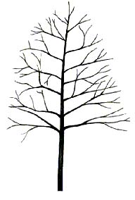

Scientific Name: Betula nigra ‘Cully’ and ‘BNMTF’
Common Name: Heritage® and Dura-Heat™ River Birch

Environmental Conditions:
Hardiness Zone: 4b (4a)

Soil Moisture:

occasionally  saturated or  very wet soil |  |  | consistently  moist, well  drained soil |  |  | occasional  periods of  dry soil |  |  | prolonged  periods of  dry soil
1 | 2 | 3 | 4 | 5 | 6 | 7 | 8 | 9 | 10 | 11 | 12

Sun/Shade: prefers full sun, tolerates partial shade

Salt: unknown
pH: < 7.0
Other: Dura-Heat™ is reportedly heat tolerant
Insect/Disease Factors: resistant to bronze birch borer, less prone to leaf-spot than species, Dura-Heat™ is aphid resistant

Growth Characteristics:

Height: 40’-50’
Width: 30’-40’
Form/Habit: broadly pyramidal to oval, vigorous grower, multi-stem or single-stem forms available, Dura-Heat™ has dense compact appearance
Rate: medium to fast

Ornamental Characteristics:

Flower: 2”-3” slender dark brown catkins
Fruit: not ornamentally important, inconspicuous, small nutlets inside catkins
Seasonal Foliage Color: glossy, Heritage® is light green in summer, Dura-Heat™ is dark green, both turn yellow in fall

Bark: strongly exfoliating, cream and tan, Heritage® exfoliates pinkish-orange as well
Other: Heritage® has larger leaves than straight species, Dura-Heat™ has smaller leaves than straight species
Transplant Issues: moderately difficult to transplant bare root, better success in transplanting bare root in fall, do not attempt to transplant > 2” caliper tress bare root, best planted B&B
Management Issues: can be low branched, may require pruning to be used as street tree
Suggested Uses: narrow or wide street tree lawns/pits (preferably wide lawns/pits for multi-stem form), parks
Cultivars: above information is specific to cultivars

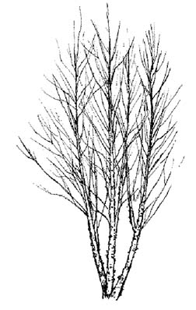
Clump Form
Scientific Name: Betula populifolia ‘Whitespire Sr.’ (cultivar formerly listed as Betula platyphylla var. japonica, Asian White Birch)
Common Name: Whitespire Sr. Gray Birch

Environmental Conditions:

Hardiness Zone: 4a

Soil Moisture:

occasionally  saturated or  very wet soil |  |  | consistently  moist, well  drained soil |  |  | occasional  periods of  dry soil |  |  | prolonged  periods of  dry soil
1 | 2 | 3 | 4 | 5 | 6 | 7 | 8 | 9 | 10 | 11 | 12

Sun/Shade: full sun

Salt: unknown
pH: < 7.5
Other: reportedly better heat tolerance than most Birch but not as good as previously listed River Birch cultivars Heritage® and Dura-Heat™
Insect/Disease Factors: shows some resistance to bronze birch borer, reportedly leafhopper resistant

Growth Characteristics:

Height: 40’
Width: 25’
Form/Habit: pyramidal to oval, available in multi-stem or single-stem forms, specify desirable form
Rate: medium (possibly fast)

Ornamental Characteristics:

Flower: catkins
Fruit: not ornamentally important, inconspicuous, small nutlets inside catkins

Seasonal Foliage Color: glossy, dark green in summer, yellow in fall
Bark: attractive, grayish-white, with black markings, doesn’t exfoliate
Transplant Issues: moderately difficult to transplant bare root, better success in transplanting bare root in fall, do not attempt to transplant > 2” caliper trees bare root, best planted B&B
Management Issues: none of significance
Suggested Uses: narrow or wide street tree lawns/pits(preferably wide lawns/pits for multi-stem form), parks
Cultivars: above information is cultivar specific, ‘Whitespire Jr.’ not recommended because of genetic variability due to seed propagation

Scientific Name: Carpinus betulus

Common Name: European Hornbeam

Environmental Conditions:
Hardiness Zone: 5a (4)

Soil Moisture:

occasionally  saturated or  very wet soil |  |  | consistently  moist, well  drained soil |  |  | occasional  periods of  dry soil |  |  | prolonged  periods of  dry soil
1 | 2 | 3 | 4 | 5 | 6 | 7 | 8 | 9 | 10 | 11 | 12

Sun/Shade: full sun

Salt: sensitive
pH: < 8.2
Insect/Disease Factors: none serious or limiting, leaf minor possible, two-lined chestnut borer sometimes attacks ‘Fastigiata’

Growth Characteristics:

Height: 40’-60’
Width: 30’-40’
Form/Habit: pyramidal to rounded in youth, oval to rounded at maturity, fine textured branches, low branching tendency typically creates short trunk
Rate: slow to medium

Ornamental Characteristics:

Flower: catkins with light-green bracts, spring
Fruit: small green-brown nutlets at base of leafy flower bracts in pendulous clusters, mature in fall
Seasonal Foliage Color: dark green in summer, yellow to yellow-green in fall, fall color is often late

Bark: attractive, smooth slate-gray
Transplant Issues: difficult to transplant B&B or bare root, somewhat slow to establish
Management Issues: typically low branched, may require pruning to be used as street tree, tolerates heavy pruning, dieback can be a minor problem, narrow branch angles on columnar forms may be problem with heavy snow/ice loads
Suggested Uses: wide street tree lawns/pits, narrow tree lawns/pits with pruning, parks, suitable for CU-Structural Soil™, columnar forms useful for screening or hedging
Cultivars: ‘Fastigiata’ (35’-40’ high, 20’-30’ wide, narrowly conical becoming broadly oval-vase shaped with age, very dense branching), ‘Columnaris’ (another upward branching and compact crown form commonly confused with ‘Fastigiata’ in the nursery trade, theoretically ‘Columnaris’ develops a central leader and ‘Fastigata’ does not), ‘Pyramidalis’ (just another name given to ‘Fastigiata’ and ‘Columnaris’ forms), ‘Franz Fontaine’ (35’-40’ high, 15’ wide, narrowest form available, maintains narrow-columnar form with age as currant season’s growth curves inward toward central leader)
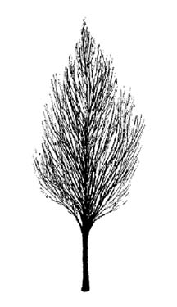

‘Fastigiata’

Scientific Name: Catalpa speciosa

Common Name: Northern Catalpa

Environmental Conditions:

Hardiness Zone: 4a

Soil Moisture:

occasionally  saturated or  very wet soil |  |  | consistently  moist, well  drained soil |  |  | occasional  periods of  dry soil |  |  | prolonged  periods of  dry soil
1 | 2 | 3 | 4 | 5 | 6 | 7 | 8 | 9 | 10 | 11 | 12

Sun/Shade: full sun

Salt: unknown
pH: < 8.2

Insect/Disease Factors: none serious or limiting

Growth Characteristics:

Height: 50’-60’ typical, can reach over 100’
Width: 20’-40’
Form/Habit: narrow, open, irregular-oval
Rate: medium to fast

Ornamental Characteristics:
Flower: showy, white, orchid-like with yellow and/or purplish spots inside, large 6” upright clusters, early to mid summer
Fruit: 8”-20” long, thin, pendulous pods, green changing to brown, persistent throughout winter
Seasonal Foliage Color: bright to medium green in summer, poor yellow-green to brownish in fall

Bark: dark grayish brown, old trunks are ridged and furrowed or thick and scaly
Transplant Issues: easy to transplant B&B or < 2” caliper bare root

Management Issues: fruit litter could be a nuisance in some areas
Suggested Uses: narrow or wide street tree lawns/pits, parks, suitable for CU-Structural Soil™
Cultivars: none known

Scientific Name: Celtis laevigata

Common Name: Sugar Hackberry, Southern or Mississippi Hackberry

Environmental Conditions:
Hardiness Zone: 6a (culitvars reportedly zone 5)

Soil Moisture:

occasionally  saturated or  very wet soil |  |  | consistently  moist, well  drained soil |  |  | occasional  periods of  dry soil |  |  | prolonged  periods of  dry soil
1 | 2 | 3 | 4 | 5 | 6 | 7 | 8 | 9 | 10 | 11 | 12

Sun/Shade: prefers full sun, tolerates partial shade

Salt: unknown
pH: < 7.5
Other: good heat and wind tolerance
Insect/Disease Factors: resistant to witches’ broom and nipple gall, ‘Magnifica’ resistant leafhoppers

Growth Characteristics:

Height: 60’-80’
Width: similar to height, 60’+
Form/Habit: rounded with spreading, often pendulous branches
Rate: medium to fast

Ornamental Characteristics:

Flower: not ornamentally important, inconspicuous clusters

Fruit: small orange-red to blue-black drupes in fall
Seasonal Foliage Color: light green in summer, dull yellow in fall
Bark: smooth light gray with corky/warty ridges
Other: foliage is smaller than C. occidentalis
Transplant Issues: moderately difficult to transplant bare root, better success in transplanting bare root in fall, do not attempt to transplant > 2” caliper trees bare root, best planted B&B, somewhat slow to establish
Management Issues: ‘All Seasons’ twigs are heavier than average for species and less likely to shed
Suggested Uses: wide street tree lawns/pits due to size, ‘All Seasons’ can be used in narrow street tree lawns/pits, parks
Cultivars: ‘All seasons’ (reportedly zone 5, 40’-50’ high, 30’-40’ wide, fast growing, well balanced crown with ascending branches, fine textured foliage, good yellow fall color, red fruit, American Beech-like bark is smooth silver-gray with few corky ridges), ‘Magnifica’ (C. occidentalis and C. laevigata hybrid, reportedly zone 5, broadly oval to vase-shaped, fast growing, nearly sterile – little to no fruit)

Scientific Name: Celtis occidentalis

Common Name: Common Hackberry

Environmental Conditions:
Hardiness Zone: 3b (3a, 2b)

Soil Moisture:

occasionally  saturated or  very wet soil |  |  | consistently  moist, well  drained soil |  |  | occasional  periods of  dry soil |  |  | prolonged  periods of  dry soil
1 | 2 | 3 | 4 | 5 | 6 | 7 | 8 | 9 | 10 | 11 | 12

Sun/Shade: prefers full sun, tolerates partial shade

Salt: unknown
pH: < 8.2
Other: good heat and wind tolerance
Insect/Disease Factors: susceptible to various problems, although most rarely serious or limiting, except witches’ broom, which can disfigure form with abnormal branch growth (broom-like clusters)

Growth Characteristics:

Height: 40’-60’
Width: similar to height, 40’+
Form/Habit: pyramidal when young, irregular-rounded when mature, open branching, somewhat elm-like with ascending then arching branches
Rate: medium to fast

Ornamental Characteristics:
Flower: not ornamentally important, inconspicuous clusters, spring as leaves are emerging

Fruit: yellow or orange-red to dark purple drupe, fall
Seasonal Foliage Color: light to medium green in summer, yellow in fall

Bark: gray with rough and corky ridges
Transplant Issues: moderately difficult to transplant bare root, better success in transplanting bare root in fall, do not attempt to transplant > 2” caliper trees bare root, best planted B&B, somewhat slow to establish

Management Issues: none of significance
Suggested Uses: narrow or wide street tree lawns/pits, parks, suitable for CU-Structural Soil™
Cultivars: ‘Prairie Pride’ (zone 3b or 4, rapid grower, compact uniform crown, thick leathery lustrous foliage, dark red-purple fruit, lighter fruit crop than species)
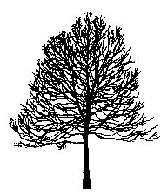

Scientific Name: Cercidiphyllum japonicum

Common Name: Katsura Tree

Environmental Conditions:

Hardiness Zone: 5a

Soil Moisture:

occasionally  saturated or  very wet soil |  |  | consistently  moist, well  drained soil |  |  | occasional  periods of  dry soil |  |  | prolonged  periods of  dry soil
1 | 2 | 3 | 4 | 5 | 6 | 7 | 8 | 9 | 10 | 11 | 12

Sun/Shade: prefers full sun, tolerates partial shade

Salt: unknown
pH: < 8.2
Other: protected site best
Insect/Disease Factors: relatively pest free, resistant to Verticillium Wilt

Growth Characteristics:
Height: 40’-60’ (can reach 100’ in the wild)
Width: quite variable, 25’-60’
Form/Habit: upright pyramidal when young, round with age, multi-stem or single-stem forms available
Rate: medium to fast

Ornamental Characteristics:

Flower: early spring before leaves emerge
Fruit: small ½”- ¾” pods in clusters (resemble tiny banana bunches)
Seasonal Foliage Color: new leaves emerge bright red-purple, becoming bluish-green in summer, good yellow to apricot-orange in fall
Bark: attractive, shaggy brown
Other: yellow leaves in fall have a cotton-candy scent
Transplant Issues: easy to transplant B&B or < 2” caliper bare root

Management Issues: trunk sunscalds easily when young
Suggested Uses: wide street tree lawns/pits and parks due to size and drought sensitivity
Cultivars: weeping forms (f. pendula and f. pendula ‘Morioka Weeping’) available but not suitable for street tree use
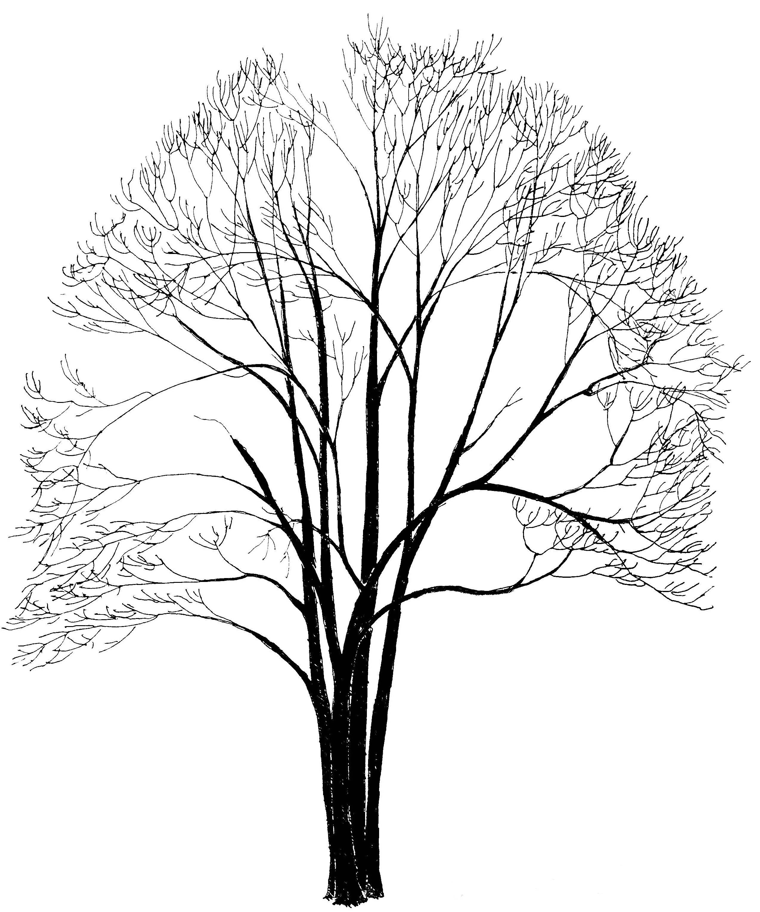

Scientific Name: Cladrastis kentukea

Common Name: Yellowwood

Environmental Conditions:

Hardiness Zone: 4b

Soil Moisture:

occasionally  saturated or  very wet soil |  |  | consistently  moist, well  drained soil |  |  | occasional  periods of  dry soil |  |  | prolonged  periods of  dry soil
1 | 2 | 3 | 4 | 5 | 6 | 7 | 8 | 9 | 10 | 11 | 12

Sun/Shade: full sun

Salt: unknown
pH: < 8.2

Insect/Disease Factors: relatively pest free

Growth Characteristics:

Height: 30’-50’
Width: 40’-55’
Form/Habit: broadly rounded, graceful arching habit, branches low and typically looses central leader, may need to specify single-stem for street tree use due to multi-stemmed potential
Rate: medium-fast

Ornamental Characteristics:
Flower: showy, fragrant, white, 8”-14” long pendulous clusters, late spring (bi-annually)

Fruit: brown, 3” long seed pods, ripening in fall
Seasonal Foliage Color: bright green in summer, yellow in fall
Bark: attractive smooth gray
Other: yellow leaf axis (rachises) persist after leaflets fall off in fall, prolonging seasonal interest

Transplant Issues: easy to transplant B&B or < 2” caliper bare root
Management Issues: prune only in summer as profuse bleeding will occur other times of the year, can be weak wooded with poor crotch angles that split out as the tree grows older, pruning may be needed in youth to develop desired trunk form or for use as a street tree, thin bark sensitive to mechanical damage
Suggested Uses: wide street tree lawns/pits, narrow tree lawns/pits with pruning, parks
Cultivars: ‘Rosea’ (sometimes called ‘Perkins Pink’) a pink flowering form, may be difficult to find

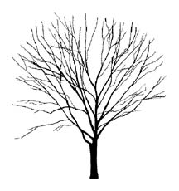

Scientific Name: Corylus colurna

Common Name: Turkish Filbert

Environmental Conditions:
Hardiness Zone: 5a (4b)

Soil Moisture:

occasionally  saturated or  very wet soil |  |  | consistently  moist, well  drained soil |  |  | occasional  periods of  dry soil |  |  | prolonged  periods of  dry soil
1 | 2 | 3 | 4 | 5 | 6 | 7 | 8 | 9 | 10 | 11 | 12

Sun/Shade: full sun

Salt: unknown
pH: < 8.2
Other: heat tolerant once established
Insect/Disease Factors: occasionally eastern filbert blight can be a serious problem in some areas, leaves fairly resistant to leaf scorch

Growth Characteristics:

Height: 40’-60’
Width: 20’-40’
Form/Habit: broadly pyramidal, conical

Rate: medium

Ornamental Characteristics:
Flower: 2”-3” long, pendulous male catkins, late winter to early spring, female flowers inconspicuous

Fruit: edible nuts inside textured and fringed 2” husks
Seasonal Foliage Color: dark green and leathery in summer (although species variable), potentially yellow to purple in fall, often leaves drop yellow-green
Bark: gray-brown, flakes and scales with age on trunk and older branches, exposing orange-brown inner bark

Transplant Issues: difficult to transplant bare root, best planted B&B
Management Issues: fruit may be a litter problem
Suggested Uses: narrow or wide street tree lawns/pits, parks, suitable for CU-Structural Soil™

Cultivars: none available
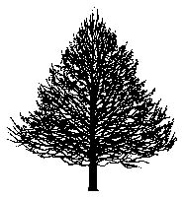

Scientific Name: Eucommia ulmoides

Common Name: Hardy Rubber Tree

Environmental Conditions:

Hardiness Zone: 5b

Soil Moisture:

occasionally  saturated or  very wet soil |  |  | consistently  moist, well  drained soil |  |  | occasional  periods of  dry soil |  |  | prolonged  periods of  dry soil
1 | 2 | 3 | 4 | 5 | 6 | 7 | 8 | 9 | 10 | 11 | 12

Sun/Shade: full sun

Salt: unknown
pH: < 8.2
Other: heat tolerant

Insect/Disease Factors: relatively pest free

Growth Characteristics:

Height: 40’-60’
Width: 40’-60’
Form/Habit: very sparsely branched in youth, rounded to broad-spreading at maturity

Rate: medium

Ornamental Characteristics:

Flower: not ornamentally important
Fruit: 1 ½” winged capsule on female trees
Seasonal Foliage Color: attractive glossy dark green in summer, fall color often nonexistent or poor yellow-green
Bark: gray-brown, becomes ridged and furrowed with age
Transplant Issues: easy to transplant B&B
Management Issues: none of significance
Suggested Uses: narrow or wide street tree lawns/pits, parks, suitable for CU-Structural Soil™
Cultivars: none available

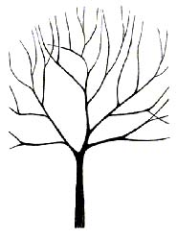

Scientific Name: Fraxinus americana

Common Name: White Ash

Environmental Conditions:
Hardiness Zone: 4a (some cultivars to 3)

Soil Moisture:

occasionally  saturated or  very wet soil |  |  | consistently  moist, well  drained soil |  |  | occasional  periods of  dry soil |  |  | prolonged  periods of  dry soil
1 | 2 | 3 | 4 | 5 | 6 | 7 | 8 | 9 | 10 | 11 | 12

Sun/Shade: full sun

Salt: some observed tolerance
pH: < 8.2
Insect/Disease Factors: Ashes are susceptible to a number of insect and disease problems, ash borer (in hot dry environments) and ash yellows (in the Eastern and Midwestern United States) may be the most serious

Growth Characteristics:

Height: 50’-70’
Width: 40’-60’
Form/Habit: oval to rounded and open with age, maintains good central leader in youth

Rate: medium

Ornamental Characteristics:

Flower: not ornamentally important, inconspicuous
Fruit: not ornamentally important, 1”-2” long samara, male seedless cultivars available
Seasonal Foliage Color: dark green in summer, color variable in fall (yellow to purple), certain cultivars selected for good reddish to purple color in fall

Bark: gray to gray-brown, narrow interlacing ridges create diamond shaped furrows
Transplant Issues: easy to transplant B&B or < 2” caliper bare root
Management Issues: fruit litter can be a problem in some areas, non-fruiting cultivars available, graft incompatibility problems have been observed on some cultivars
Suggested Uses: narrow or wide street tree lawns/pits, wide street tree lawns/pits preferred for straight species due to tree size, parks, suitable for CU-Structural Soil™
Cultivars: see chart on following page

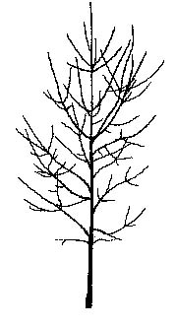

Fraxinus americana (White Ash) Cultivars:

Cultivar | Zone | Form/Habit | Fall Color | Fruiting/  Non-fruiting | Other
‘Autumn Applause’ | 5a | oval, dense branching | maroon, early turning and long lasting | non-fruiting | young trees subject to bark splitting at ground level
‘Autumn Blaze’ | 3 | oval | purple | light fruit set
Autumn Purple®  (‘Junginger’) | 5a | round | reddish-purple to deep red | non-fruiting | fast growing, glossy leaves
‘Champaign County’ | 4a (5a) | dense, strong central leader, heavy trunk | not much, yellow to purple possible | little to no fruiting observed | lustrous dark green leaves
‘Chicago Regal’ | 4a | oval to rounded, symmetrical branching | orange to purple, mixed with earth tones | non-fruiting | fast growing, larger foliage, bark resistant to frost cracking
‘Empire’ | 3 | narrow oval (25’wide), strong central leader | rusty orange to purple | non-fruiting
‘Rose Hill’ | 5b | upright oval to pyramidal, sturdy branching | bronze-red to purple | non-fruiting
‘Royal Purple’ | 4a | oval, upright habit | purple | fruiting | vigorous grower in youth, bark resistant to frost cracking
Skyline®  (‘Skycole’) | 4b | oval, strong central leader, symmetrical branching, good branch angles | orange-red | non-fruiting | glossy leaves
Sparzam™ (‘Sparticus’) | 4a | pyramidal form | burgundy with bronze highlights | non-fruiting | glossy dark green foliage, silvery-white undersides, wavy leaf margins, longer foliage retention
Windy City™ (‘Tures’) | 4a | oval to rounded, good central leader, may have smaller width, possibly only 30’-35’ wide | burgundy to reddish-orange with orange and yellow highlights | fruiting | semi-glossy foliage, bark resistant to frost cracking

Scientific Name: Fraxinus excelsior ‘Hessei’
Common Name: Hessei European Ash

Environmental Conditions:

Hardiness Zone: 4b

Soil Moisture:

occasionally  saturated or  very wet soil |  |  | consistently  moist, well  drained soil |  |  | occasional  periods of  dry soil |  |  | prolonged  periods of  dry soil
1 | 2 | 3 | 4 | 5 | 6 | 7 | 8 | 9 | 10 | 11 | 12

Sun/Shade: full sun

Salt: some observed tolerance
pH: < 8.2
Insect/Disease Factors: Ashes are susceptible to a number of insect and disease problems, F. excelsior is particularly susceptible to borers, ‘Hessei’ has shown good pest resistance compared to species and other Ashes, although almost as susceptible to borers as species if planted in a hot dry site

Growth Characteristics:

Height: 60’
Width: 45’
Form/Habit: typically upright oval to rounded, occasionally almost flat-topped at maturity, very vigorous, typically dense

Rate: medium

Ornamental Characteristics:

Flower: not ornamentally important

Fruit: seedless
Seasonal Foliage Color: lustrous dark green in summer, potentially yellow in fall, although leaves typically remain green late into fall and drop when still green

Bark: not ornamentally important, gray to gray-brown
Transplant Issues: easy to transplant B&B or < 2” caliper bare root

Management Issues: none of significance
Suggested Uses: narrow or wide street tree lawns/pits, parks, suitable for CU-Structural Soil™
Cultivars: above info is cultivar specific

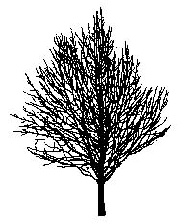
Scientific Name: Fraxinus ‘Northen Gem’ and ‘Northern Treasure’ (F. nigra x F. mandshurica)
Common Name: Northern Gem and Northern Treasure Ash

Environmental Conditions:

Hardiness Zone: 3

Soil Moisture:

occasionally  saturated or  very wet soil |  |  | consistently  moist, well  drained soil |  |  | occasional  periods of  dry soil |  |  | prolonged  periods of  dry soil
1 | 2 | 3 | 4 | 5 | 6 | 7 | 8 | 9 | 10 | 11 | 12

Sun/Shade: full sun

Salt: unknown
pH: > 8.2

Insect/Disease Factors: ash yellows susceptibility unknown

Growth Characteristics:

Height: 50’
Width: ‘Northern Gem’ 50’, ‘Northern Treasure’ 30’
Form/Habit: ‘Northern Gem’ is broadly oval, ‘Northern Treasure’ is upright oval
Rate: moderate to fast

Ornamental Characteristics:

Flower: not ornamentally important, inconspicuous

Fruit: nearly seedless
Seasonal Foliage Color: thick, glossy green in summer, pale orangish-yellow in fall

Bark: not ornamentally important, likely scaly and flaky as F. nigra
Other: leaves arch downward
Transplant Issues: available bare root
Management Issues: none of significance
Suggested Uses: narrow or wide street tree lawns/pits, parks, suitable for CU-Structural Soil™
Cultivars: above info is specific to cultivars
Scientific Name: Fraxinus pennsylvanica

Common Name: Green Ash

Environmental Conditions:

Hardiness Zone: 2a

Soil Moisture:

occasionally  saturated or  very wet soil |  |  | consistently  moist, well  drained soil |  |  | occasional  periods of  dry soil |  |  | prolonged  periods of  dry soil
1 | 2 | 3 | 4 | 5 | 6 | 7 | 8 | 9 | 10 | 11 | 12

Sun/Shade: full sun

Salt: some observed tolerance
pH: < 8.2
Insect/Disease Factors: Ashes are susceptible to a number of insect and disease problems, ash borer (in hot dry environments) may be serious, F. pennsylvanica is fairly resistant to ash yellows (a problem for F. americana in the Eastern and Midwestern United States)

Growth Characteristics:

Height: 40’-60’
Width: 30’-50’
Form/Habit: pyramidal in youth, variable with age, oval to rounded and often irregular

Rate: fast

Ornamental Characteristics:

Flower: not ornamentally important
Fruit: not ornamentally important, samara on female trees
Seasonal Foliage Color: glossy medium to dark green in summer, typically inconsistent yellow in fall, some of available cultivars turn bronze-red, burgundy, or purple in fall

Bark: gray to gray-brown, narrow interlacing ridges create diamond shaped furrows
Transplant Issues: easy to transplant B&B or < 2” caliper bare root
Management Issues: may require frequent pruning as storm damage prone, fruit litter can be a problem, non-fruiting cultivars available
Suggested Uses: narrow or wide street tree lawns/pits, parks, suitable for CU-Structural Soil™
Cultivars: see chart on following page, selections made for growth form/habit, seedless character of male trees, and foliage characteristics (specifically dark green and shiny leaves in summer and attractive fall color)

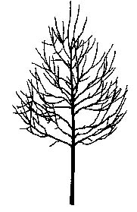

'Patmore'

Fraxinus pennsylvanica (Green Ash) cultivars:

Common:
Cultivar | Zone |  | Form/Habit |  | Foliage |  | Fruit | Other
Cimmaron®  (‘Cimmzam’) | 4 |  | upright-oval, 30’wide, straight central leader, good branch structure |  | thick, glossy, dark green in summer, burgundy changing to orange in fall, leafs-out late, holds leaves late |  | non-fruiting
‘Marshall’ | 3a |  | broadly oval, irregular at times |  | glossy dark green in summer, bright yellow in fall |  | usually but not always non-fruiting | fewer insect and disease problems then species
‘Patmore’ | 3a (2b) |  | oval to broadly pyramidal, straight trunk, good branch structure, symmetrical |  | glossy, dark green in summer, long-lasting yellow in fall |  | non-fruiting | relatively pest free
‘Summit’ | 3b |  | upright, oval to pyramidal, 25’-35’ wide straight trunk, good central leader, symmetrical |  | semi-glossy, excellent golden yellow in fall |  | light and infrequent crops | thicker bark, more resistant to mechanical damage
Urbanite® | 5b |  | broadly pyramidal to oval |  | thick, leathery, lustrous dark green in summer, bronze-red in fall |  | none observed | thicker bark appears more sun -scald resistant
Available
Cultivar |  | Zone |  | Form/Habit |  | Foliage |  |  | Fruit
‘Bergeson’ |  | 3 (2) |  | upright, oval, dense, rapid grower |  | lustrous dark green in summer, yellow in fall |  |  | non-fruiting
Centerpoint™ |  | 4 |  | broadly oval to rounded, symmetrical |  | very glossy, yellowish in fall |  |  | non-fruiting
ChampTree™ (‘National 1999’) |  | 4 |  | rounded, upright spreading branches |  | glossy, yellow in fall |  |  | non-fruiting
DakotaCentennial™ (‘Wahpeton’) |  | 3 |  | oval to broadly pyramidal, tends to maintain central leader, good branch structure |  | glossy, bright green changes to dark green in summer, deep yellow in fall |  |  | non-fruiting
Georgia Gem™  (‘Oconee’) |  | 6 |  | upright-oval |  | larger leaves, glossy, dark green in summer, yellowish in fall |  |  | non-fruiting
Newport™  (‘Bailey’) |  | 3b |  | oval, straight trunk, good branching |  | glossy dark green in summer, yellow in fall |  |  | non-fruiting
Prairie Spire™ (‘Rugby’) |  | 3 |  | upright-oval to narrow pyramidal, 20’ wide, dense branching |  | glossy, bright green changes to dark green in summer, golden yellow in fall |  |  | non-fruiting
Skyward™  (‘Wandell’) |  | 5b |  | narrowly pyramidal, 20’ wide, dense |  | thick, semi-lustrous, bronze-red to purple in fall |  |  | non-fruiting
var. lanceolata |  | 3 |  | oval to rounded |  | lanceolate, golden yellow in fall

Scientific Name: Ginkgo biloba

Common Name: Ginkgo, sometimes called Maidenhair Tree

Environmental Conditions:

Hardiness Zone: 4b

Soil Moisture:

occasionally  saturated or  very wet soil |  |  | consistently  moist, well  drained soil |  |  | occasional  periods of  dry soil |  |  | prolonged  periods of  dry soil
1 | 2 | 3 | 4 | 5 | 6 | 7 | 8 | 9 | 10 | 11 | 12

Sun/Shade: full sun

Salt: some observed tolerance
pH: < 8.2

Insect/Disease Factors: relatively pest free

Growth Characteristics:
Height: 50’-80’ (can reach over 100’)
Width: greatly variable, 30’-40’ is common, potentially wider than high at maturity
Form/Habit: variable, irregular when young, pyramidal with age, open, often large wide-spreading branches

Rate: slow

Ornamental Characteristics:

Flower: not ornamentally important, inconspicuous

Fruit: noxious smelling on female trees, specify male trees
Seasonal Foliage Color: bright green in summer, yellow in fall
Bark: light gray-brown, ridged and furrowed
Transplant Issues: difficult to transplant bare root, best planted B&B
Management Issues: specify male trees to avoid fruit litter and noxious fruit smell, easy fall clean-up as all leaves drop within just a couple days of each other
Suggested Uses: narrow or wide street tree lawns/pits, parks, suitable for CU-Structural Soil™
Cultivars: all the following cultivars are male (non-fruiting)
Common: ‘Autumn Gold’ (50’ high, 35’ wide – perhaps broader later, symmetrical when young, broad, excellent golden yellow fall color), ‘Lakeview’ (45’ high, 25’ wide, narrowly conical, upright, frequently irregular), ‘Magyar’ (60’ high, 30’ wide, narrowly-pyramidal, uniform, upright branching), Princeton Sentry® (‘PNI 2720’, 60’ high, 25’ wide, narrowly conical, upright, uniform branching)
Available: ‘Golden Globe’ (zone 6, 80’ wide, 30’-40’ wide, denser branching habit), Emperor™ (‘Woodstock’, uniform oval form, strong central leader, good branching habit, good yellow fall color), ‘Saratoga’ (40’ high, 30’ wide, distinct central leader, somewhat oval, good yellow fall color),
Shangri-la® (45’ high, 30’ wide, uniform, compact pyramidal, good dense branching habit, good yellow fall color, faster growing)
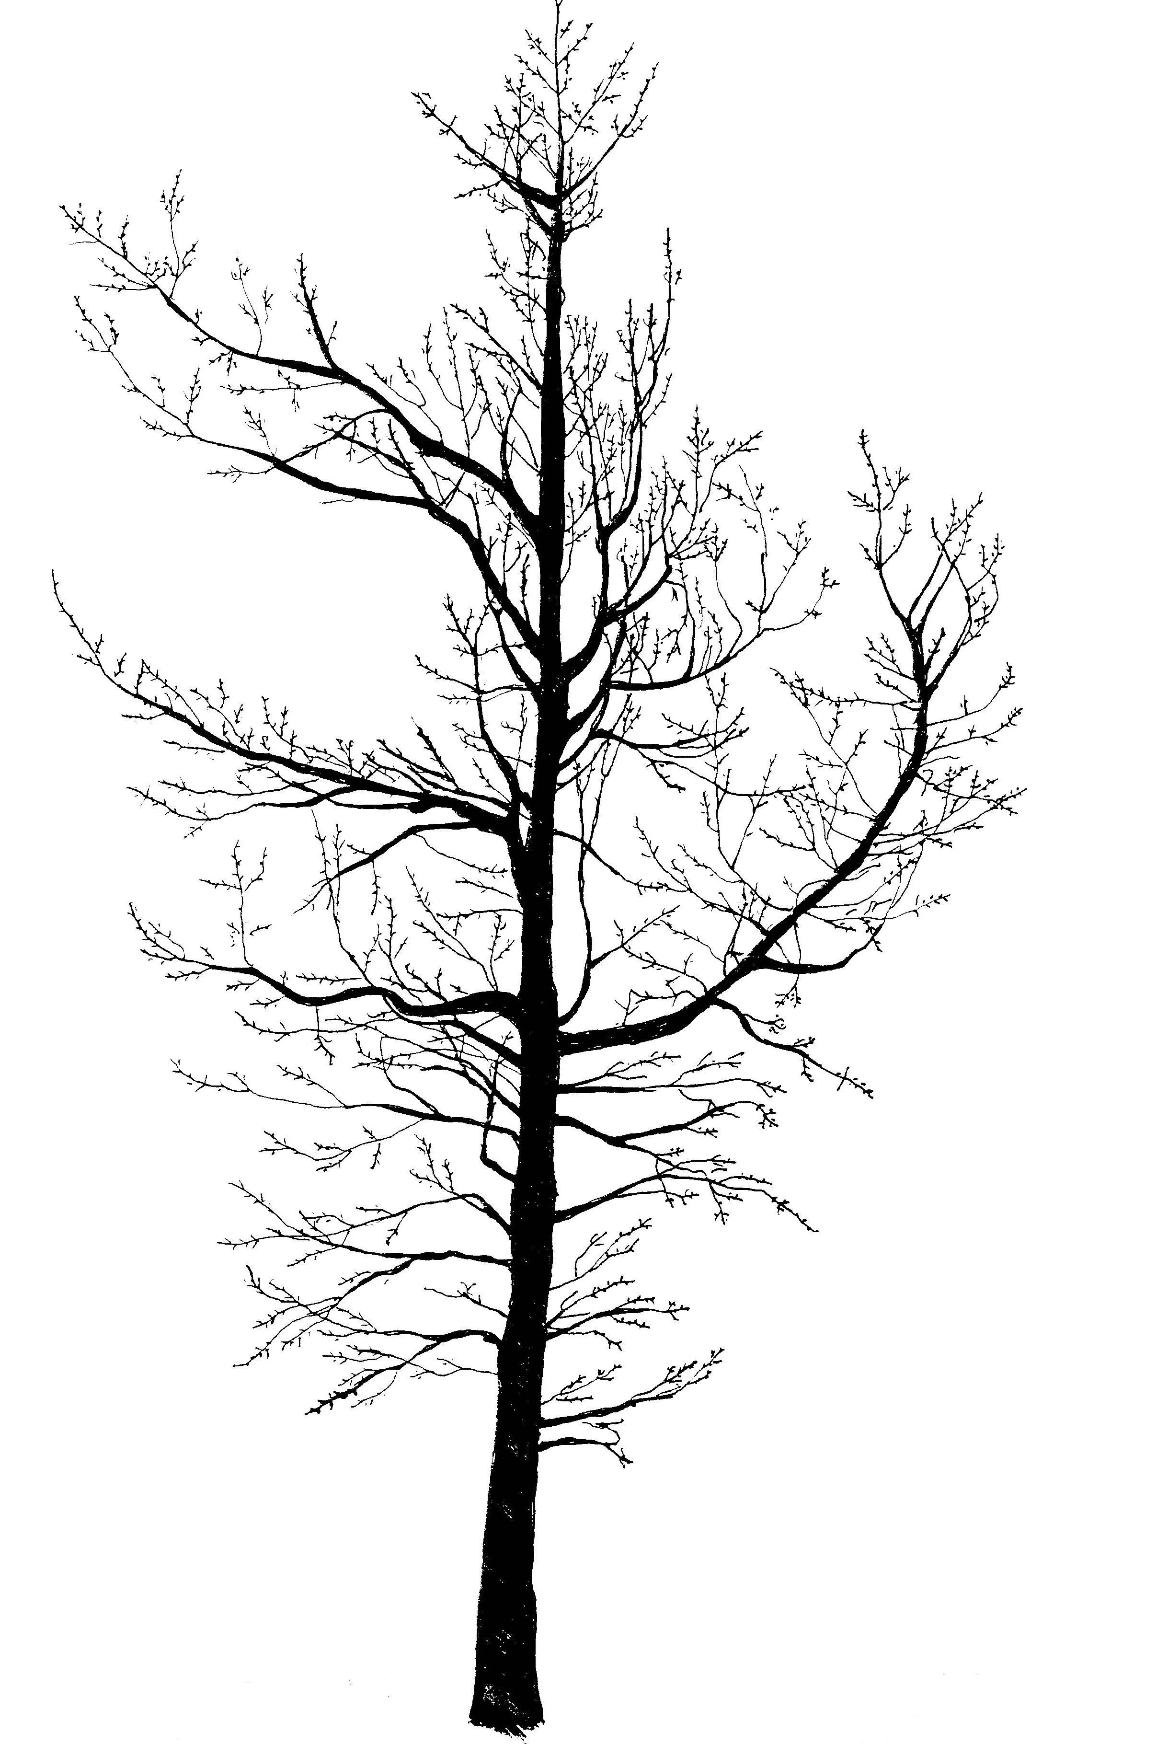

Scientific Name: Gleditsia triacanthos var. inermis
Common Name: Thornless Common Honeylocust

Environmental Conditions:
Hardiness Zone: 4b (selected cultivars into 4a and 3b)

Soil Moisture:

occasionally  saturated or  very wet soil |  |  | consistently  moist, well  drained soil |  |  | occasional  periods of  dry soil |  |  | prolonged  periods of  dry soil
1 | 2 | 3 | 4 | 5 | 6 | 7 | 8 | 9 | 10 | 11 | 12

Sun/Shade: full sun

Salt: some observed tolerance
pH: < 8.2
Insect/Disease Factors: over-planting has encouraged severe insect problems in many areas, including spider mite borers, leaf spot, cankers, powdery mildew, wiches’ broom, Honeylocust plant bug (‘Moraine’ and Skyline® have shown some resistance, green-leaved strains more tolerant such as Shademaster®, yellow-leaved strains very susceptible such as Sunburst®), mimosa webworm (‘Moraine’ resistant, ‘Green Glory’ moderately resistant, Imperial® very susceptible), Thyronectria canker (Halka™ resistant, Imperial®, Shademaster®, Skyline®, and Trueshade® partially resistant, ‘Morraine’, Skyline® and Sunburst® susceptible), and Nectria canker (Sunburst® susceptible)

Growth Characteristics:

Height: 40’-80’
Width: 30’-70’
Form/Habit: oval to rounded, open, spreading

Rate: fast

Ornamental Characteristics:

Flower: inconspicuous, not ornamentally important

Fruit: long brown pods, most cultivars have little to no fruit
Seasonal Foliage Color: light green in summer (dark green cultivars available), yellow in fall
Bark: attractive, dark gray-brown, develops scaly platy ridges and deep furrows with age

Other: drops leaves early
Transplant Issues: easy to transplant B&B or < 2” caliper bare root

Management Issues: small leaves easy for fall clean-up
Suggested Uses: narrow or wide street tree lawns/pits, parks, suitable for CU-Structural Soil™
Cultivars: all typically less than 50’ high except ‘Green Glory’, ‘Fairview’ (zone 3b, fast growing, essentially fruitless), ‘Green Glory’ (zone 3b, similar to ‘Moraine’ pyramidal, strong central leader, fast growing, holds foliage late, essentially fruitless), Halka™ (‘Christie’, zone 4a (3b), full branching, develops heavier caliper at an early age, essentially fruitless), Imperial® (‘Impcole’, zone 4a (3b), shorter, 30’-35’ high, broadly rounded, good horizontal branching angles, essentially fruitless), ‘Moraine’ (zone 3b, denser than species, upper branches ascending, lower branches more pendulous, dark green summer foliage, golden yellow fall color, fruitless form, reportedly susceptible to storm damage), Shademaster® (‘PNI 2835’, zone 3b, high vase shaped canopy, dark green summer foliage, late to turn yellow-green in fall, essentially fruitless), Skyline® (‘Skycole’, zone 3b, upright, broadly pyramidal, strong central leader, tight upright branching, dark green summer foliage, good yellow fall color), True Shade® (fast growing, shiny dark bark, essentially fruitless)
*Avoid ‘Rubylace’ and Sunburst® (‘Suncole’)
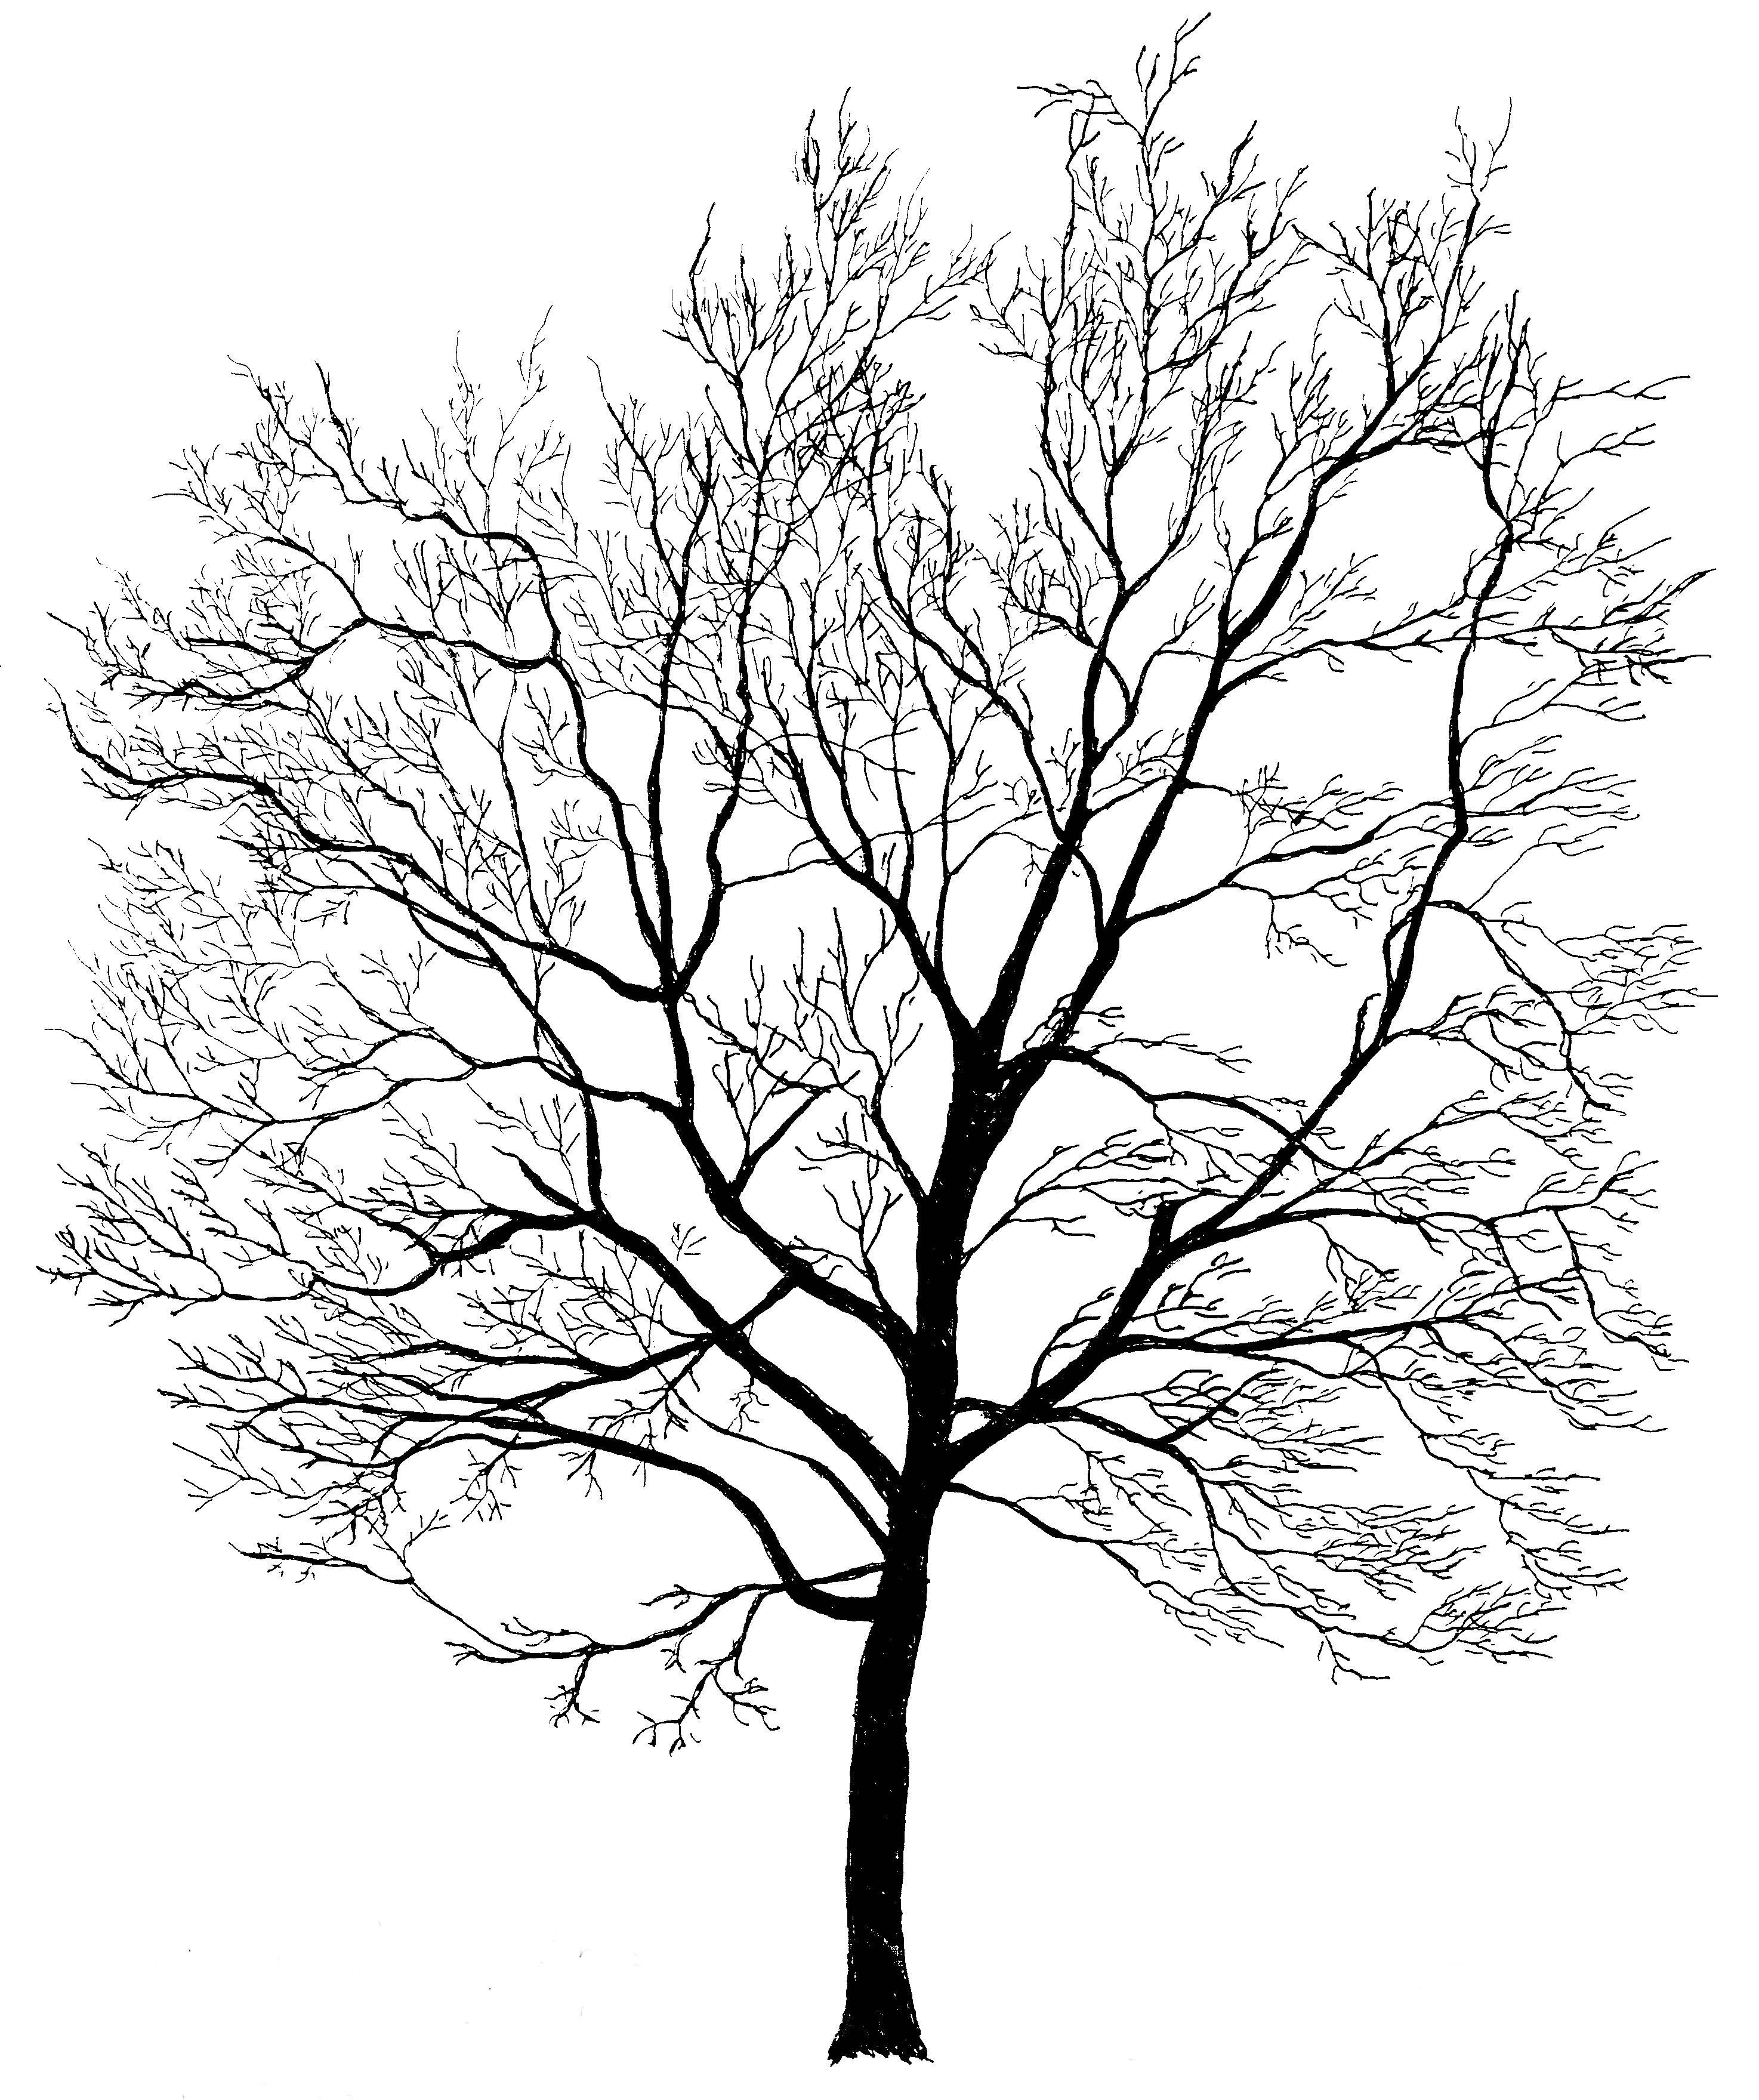

Scientific Name: Gymnocladus dioicus

Common Name: Kentucky Coffeetree

Environmental Conditions:

Hardiness Zone: 4a

Soil Moisture:

occasionally  saturated or  very wet soil |  |  | consistently  moist, well  drained soil |  |  | occasional  periods of  dry soil |  |  | prolonged  periods of  dry soil
1 | 2 | 3 | 4 | 5 | 6 | 7 | 8 | 9 | 10 | 11 | 12

Sun/Shade: full sun

Salt: unknown
pH: < 8.2

Insect/Disease Factors: relatively pest free

Growth Characteristics:

Height: 50’-70’
Width: 40’-50’
Form/Habit: very sparse branching when young, oval to vase shaped, upward arching branches, open, unique and irregular, coarse yet particularly interesting and picturesque in winter, provides filtered shade in summer, male trees often more upright

Rate: medium

Ornamental Characteristics:
Flower: greenish-white or yellowish-white pyramidal clusters, late spring, 8”-12” on female trees, 3”-4” on male trees, female has rose fragrance
Fruit: leathery, reddish-brown to black, 4”-10” long pods in fall, persist throughout winter
Seasonal Foliage Color: emerges late spring with pinkish-purplish tinge, changing to blue-green in summer, potentially good yellow in fall
Bark: attractive, gray-brown to dark brown, rough, with hard thin and scaly ridges curling outward exposing an orange-brown color

Transplant Issues: easy to transplant B&B or < 2” caliper bare root
Management Issues: use of male tree eliminates fruit litter problem
Suggested Uses: narrow or wide street tree lawns/pits, parks, suitable for CU-Structural Soil™
Cultivars: ‘Espresso’ (male non-fruiting form)

Scientific Name: Liquidambar stryraciflua

Common Name: American Sweetgum

Environmental Conditions:
Hardiness Zone: 5b, northern seed source recommended or reliably cold hardy cultivar

Soil Moisture:

occasionally  saturated or  very wet soil |  |  | consistently  moist, well  drained soil |  |  | occasional  periods of  dry soil |  |  | prolonged  periods of  dry soil
1 | 2 | 3 | 4 | 5 | 6 | 7 | 8 | 9 | 10 | 11 | 12

Sun/Shade: full sun

Salt: unknown
pH: < 7.5

Insect/Disease Factors: none serious or limiting

Growth Characteristics:
Height: 50’-75’ (80’-120’ in the wild)
Width: 40’-65’
Form/Habit: pyramidal when young, oval to round with age, straight trunk
Rate: medium to fast

Ornamental Characteristics:

Flower: not ornamentally important, present as leaves are emerging and expanding

Fruit: 1”-1 ½” ball of dehiscent capsules, persist into winter
Seasonal Foliage Color: glossy deep green in summer, great variability in fall, yellow/orange/red/purple tones, typically excellent fall color

Bark: grayish-brown, somewhat rounded ridges and deep furrows
Transplant Issues: transplant B&B, not bare root
Management Issues: fruit litter may be objectionable
Suggested Uses: narrow or wide street tree lawns/pits, parks
Cultivars: Gold Dust® (‘Goduzam’, reliably cold hardy in zone 5, gold and green variegated, strongly star-shaped leaves, fall color adds pink and burgundy tones), Grandmaster™ (‘Grazam’, reliably cold hardy in zone 5, retains pyramidal form with age, star-shaped leaves, orange to reddish-purple fall color), ‘Moraine’ (most cold hardy cultivar, reportedly to zone 4b, uniform, upright-oval habit, fast growing, bright red to burgundy fall color), ‘Rotundaloba’ (not as hardy, zone 6 (5b), rounded leaf lobes, fruitless), ‘Worplesdon’ (mixed reports on hardiness, possibly not as hardy, only zone 6, uniquely lobed leaves, apricot-orange or purple fall color)
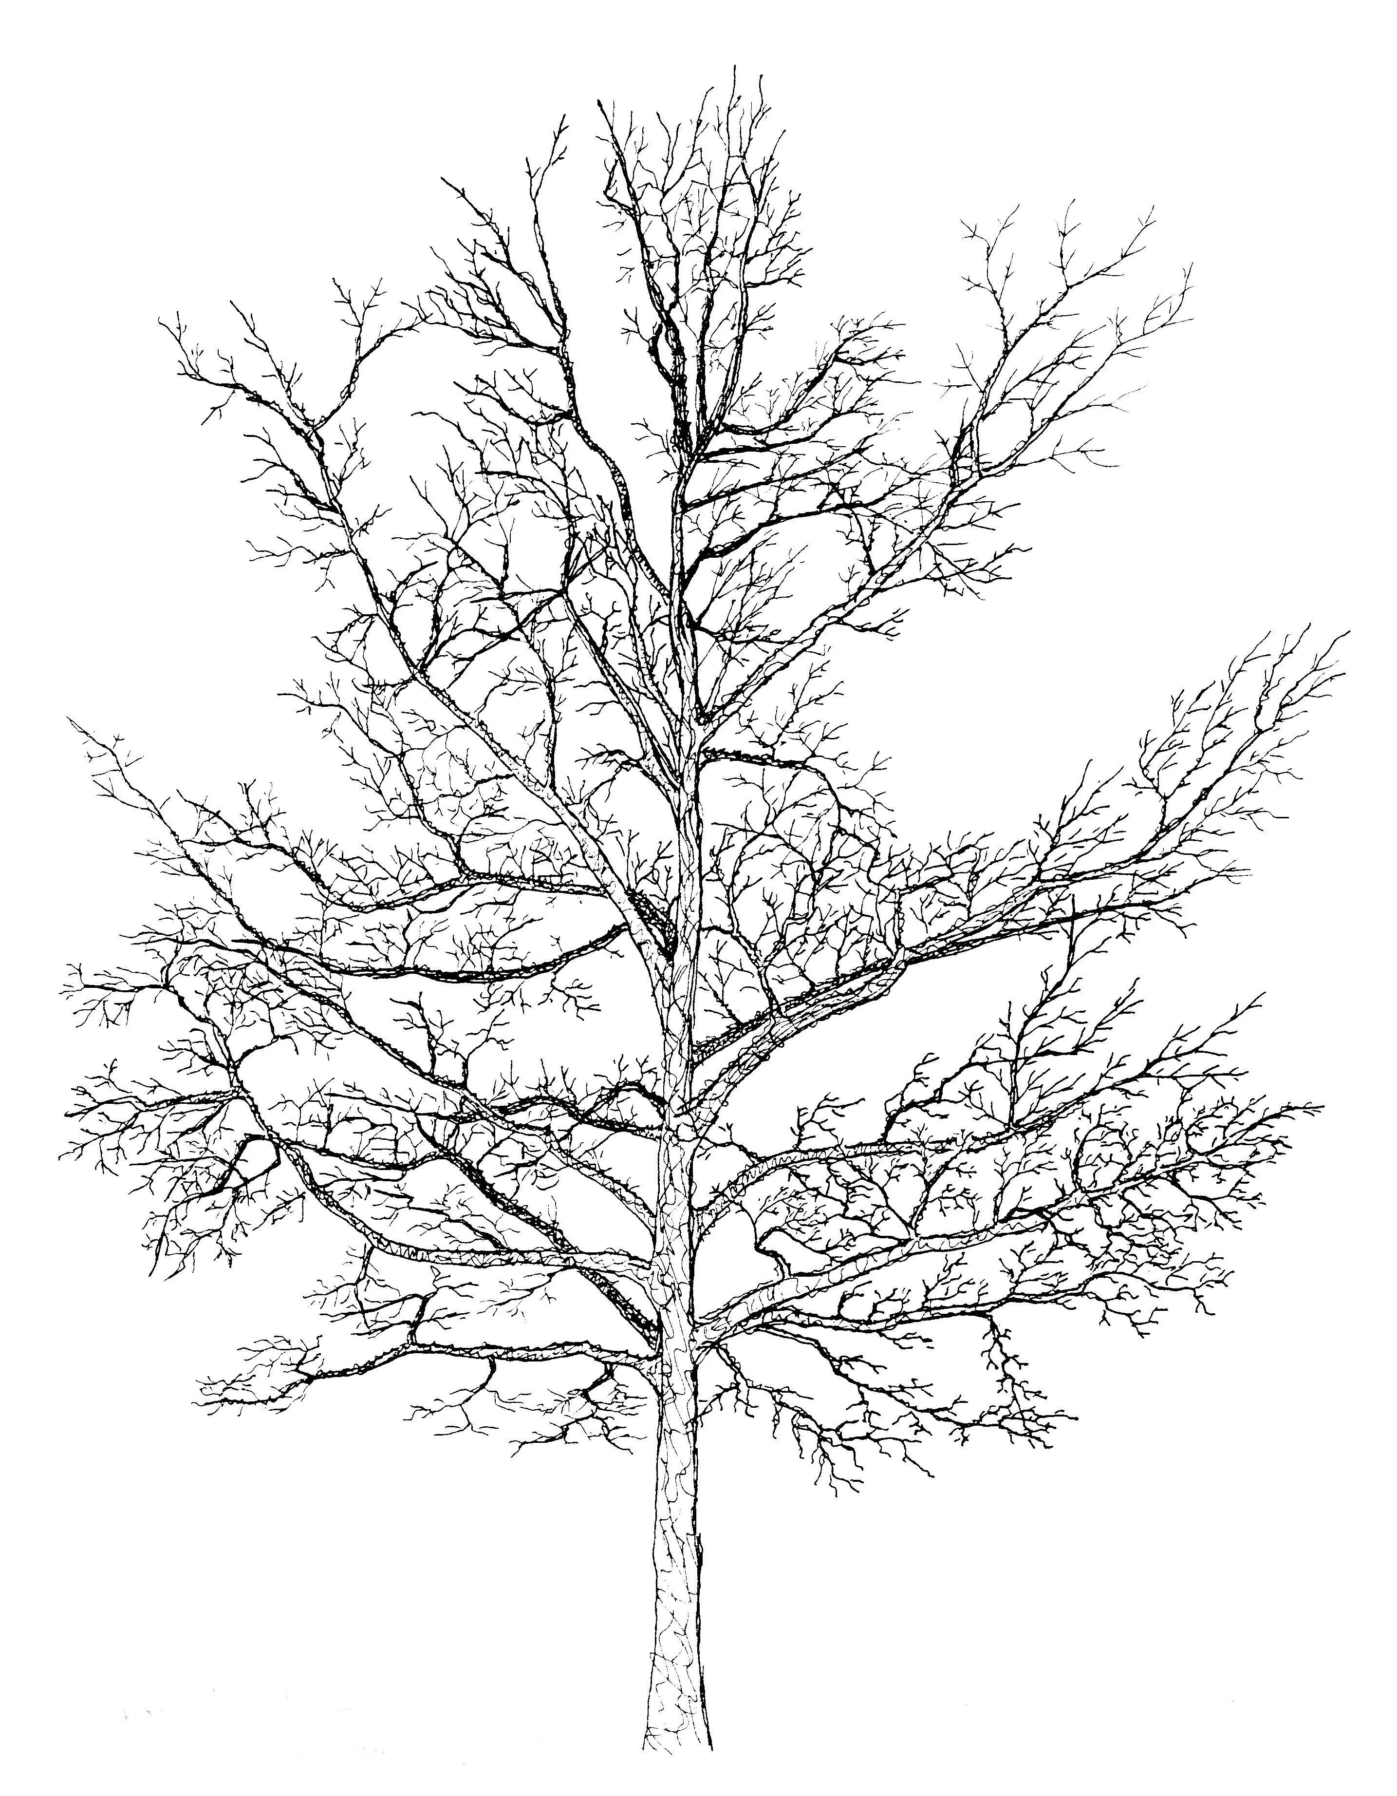

Scientific Name: Liriodendron tulipifera

Common Name: Tuliptree or Tulip Poplar

Environmental Conditions:

Hardiness Zone: 5a (4b), northern seed source recommended

Soil Moisture:

occasionally  saturated or  very wet soil |  |  | consistently  moist, well  drained soil |  |  | occasional  periods of  dry soil |  |  | prolonged  periods of  dry soil
1 | 2 | 3 | 4 | 5 | 6 | 7 | 8 | 9 | 10 | 11 | 12

Sun/Shade: full sun

Salt: sensitive
pH: < 8.2

Insect/Disease Factors: none serious or limiting

Growth Characteristics:
Height: 70’-90’ (can grow 150’+ in wild)
Width: 35’-50’
Form/Habit: somewhat pyramidal in youth, oval with age
Rate: medium to fast

Ornamental Characteristics:
Flower: tulip shaped, 2” upright, pale green, deep orange at base, late spring to early summer

Fruit: cone like cluster of woody samaras
Seasonal Foliage Color: bright green in summer, yellow in fall
Bark: gray to gray-brown, furrowed with tight, lighter colored, interlacing, round to flat ridges
Transplant Issues: difficult to transplant B&B or bare root, B&B transplanting in small caliper is best
Management Issues: soft bark easily damaged by mechanical injury, leaf yellowing followed by leaf drop can be a real problem if trees do not receive adequate water
Suggested Uses: wide street tree lawns/pits or parks due to size and drought sensitivity
Cultivars: ‘Fastigiatum’ or ‘Arnold’ (narrow form, 50’-60’ high, 15’-25’ wide)

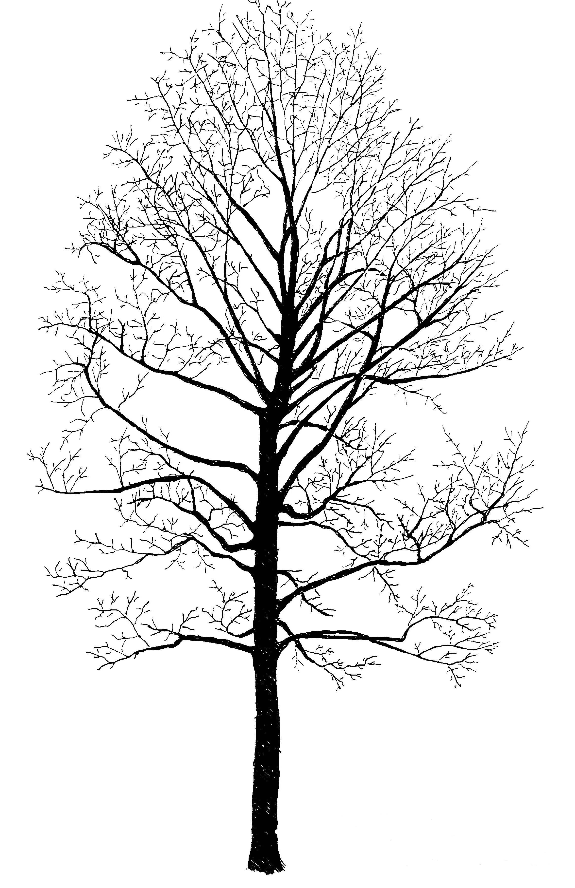

Scientific Name: Maclura pomifera var. inermis (male)

Common Name: Osage Orange

Environmental Conditions:

Hardiness Zone: 5b

Soil Moisture:

occasionally  saturated or  very wet soil |  |  | consistently  moist, well  drained soil |  |  | occasional  periods of  dry soil |  |  | prolonged  periods of  dry soil
1 | 2 | 3 | 4 | 5 | 6 | 7 | 8 | 9 | 10 | 11 | 12

Sun/Shade: full sun

Salt: some observed tolerance
pH: < 8.2

Insect/Disease Factors: relatively pest free

Growth Characteristics:

Height: 30’-50’
Width: 30’-50’
Form/Habit: irregular, rounded, typically low branching, stiff interlacing branches, sometimes branches show pendulous tendency

Rate: fast

Ornamental Characteristics:

Flower: not ornamentally important
Fruit: baseball size green-yellow fruit on female trees in fall
Seasonal Foliage Color: bright, glossy medium to dark green in summer, yellow-green to good yellow in fall
Bark: attractive, orange-brown inner bark seen though shredding gray-brown outer bark
Transplant Issues: easy to transplant B&B
Management Issues: use of male tree eliminates fruit litter problem, var. inermis is completey thornless (except for juvenile stems, which occasionally have thorns)
Suggested Uses: narrow or wide street tree lawns/pits, parks, suitable for CU-Structural Soil™, useful as a windbreak
Cultivars: ‘Double O’ (male, thornless except juvenile stems), ‘Park’ (thornless male), ‘Wichita’ (thornless male, upright-spreading habit), availability of any cultivar may be limited

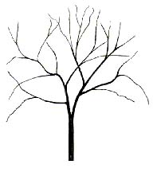

Scientific Name: Metasequoia glyptostroboides

Common Name: Dawn Redwood

Environmental Conditions:

Hardiness Zone: 5b

Soil Moisture:

occasionally  saturated or  very wet soil |  |  | consistently  moist, well  drained soil |  |  | occasional  periods of  dry soil |  |  | prolonged  periods of  dry soil
1 | 2 | 3 | 4 | 5 | 6 | 7 | 8 | 9 | 10 | 11 | 12

Sun/Shade: full sun

Salt: unknown
pH: < 8.2
Insect/Disease Factors: none serious or limiting, although mites can cause defoliation under drought stress

Growth Characteristics:

Height: 70’-100’
Width: 25’-50’
Form/Habit: pyramidal, single straight trunk, tapered with a buttressed base, develops an irregular fluted character and armpit-like depressions below the branch attachments to central leader

Rate: fast

Ornamental Characteristics:

Flower: not ornamentally important
Fruit: 1” pendulous cones
Seasonal Foliage Color: bright green in summer, brown in fall, often pinkish/orange-brown to red-brown
Bark: reddish brown, fissured, finely shredding and exfoliating

Transplant Issues: easy to transplant B&B
Management Issues: lower branch attachments would require removal for typical street tree use
Suggested Uses: exceptionally wide street tree lawns/pits with pruning or parks due to size, low branching, and drought sensitivity
Cultivars: very limited availability, ‘National’ and ‘Sheridan Spire’ were selected for narrow growth habits, ‘Sheridan Spire’ is likely more upright, compact and columnar growing than ‘National’, ‘National’ may be more susceptible to canker problems than species

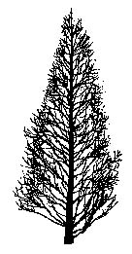

Scientific Name: Nyssa sylvatica

Common Name: Black Tupelo, also known as Sour Gum or Black Gum

Environmental Conditions:

Hardiness Zone: 5a

Soil Moisture:

occasionally  saturated or  very wet soil |  |  | consistently  moist, well  drained soil |  |  | occasional  periods of  dry soil |  |  | prolonged  periods of  dry soil
1 | 2 | 3 | 4 | 5 | 6 | 7 | 8 | 9 | 10 | 11 | 12

Sun/Shade: full sun

Salt: some observed tolerance
pH: < 7.5

Insect/Disease Factors: none serious or limiting

Growth Characteristics:
Height: 30’- 60’ (although rare, can grow to 100’+)
Width: 20’- 40’
Form/Habit: pyramidal when young, dense, horizontal branching, sometimes pendulous lower branches, varies with age between two distinct forms, either an irregular-rounded and often flat-topped form or an oval to pyramidal form
Rate: slow to medium

Ornamental Characteristics:

Flower: not ornamentally important
Fruit: not ornamentally important, fairly inconspicuous, ½” long blue-black drupes in pairs or clusters, eaten by birds and mammals
Seasonal Foliage Color: glossy green in summer, great variability in fall (yellow/orange/red/purple tones), typically excellent fall color
Bark: color variable, dark gray to brown, often silvery or almost black, texture variable, at times irregular ridges broken into short segments, other times almost scaly
Transplant Issues: difficult to transplant, use small caliper B&B only, slow to recover from transplanting
Management Issues: fruits (found on older trees) can stain sidewalk and may cause litter problem

Suggested Uses: narrow or wide street tree lawns/pits, parks
Cultivars: strongly weeping form ‘Autumn Cascades’ is available but not suitable for street tree use
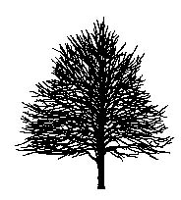

Scientific Name: Ostrya virginiana
Common Name: American Hophornbeam (also known as Ironwood, but should not be confused with Carpinus caroliniana, which is more commonly called Ironwood)

Environmental Conditions:

Hardiness Zone: 3b

Soil Moisture:

occasionally  saturated or  very wet soil |  |  | consistently  moist, well  drained soil |  |  | occasional  periods of  dry soil |  |  | prolonged  periods of  dry soil
1 | 2 | 3 | 4 | 5 | 6 | 7 | 8 | 9 | 10 | 11 | 12

Sun/Shade: prefers full sun, tolerates partial shade
Salt: very sensitive
pH: < 8.2
Insect/Disease Factors: none serious or limiting if healthy, two-lined chestnut borer can destroy stressed trees

Growth Characteristics:

Height: 30’-50’
Width: 20’-30’
Form/Habit: oval to pyramidal in youth, oval to rounded with age, horizontal and drooping branching, should specify single-stem form as multi-stem form is available

Rate: slow

Ornamental Characteristics:
Flower: female visible in spring, but not showy, male visible in winter, 1” long catkins in clusters
Fruit: small, greenish-white, inflated pods in tight hanging clusters (hop-like, hence the common name)
Seasonal Foliage Color: dark green in summer, yellow in fall
Bark: attractive, light grayish brown, shredded look
Transplant Issues: difficult to transplant B&B or bare root, slow to recover from transplanting
Management Issues: none of significance
Suggested Uses: narrow or wide street tree lawns/pits, parks
Cultivars: none known
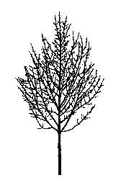

Scientific Name: Phellodendron amurense

Common Name: Amur Corktree

Environmental Conditions:
Hardiness Zone: 4b (3b)

Soil Moisture:

occasionally  saturated or  very wet soil |  |  | consistently  moist, well  drained soil |  |  | occasional  periods of  dry soil |  |  | prolonged  periods of  dry soil
1 | 2 | 3 | 4 | 5 | 6 | 7 | 8 | 9 | 10 | 11 | 12

Sun/Shade: full sun

Salt: unknown
pH: < 8.2

Insect/Disease Factors: relatively pest free

Growth Characteristics:

Height: 30’-45’
Width: 30’-40’
Form/Habit: broadly vase-shaped to rounded, open with massive branches, often horizontally arranged, shorter trunk common

Rate: slow

Ornamental Characteristics:

Flower: not ornamentally important, inconspicuous

Fruit: not ornamentally important, small, black
Seasonal Foliage Color: often glossy dark green in summer, yellow to bronzy-yellow in fall

Bark: attractive, light gray-brown, corky, furrowed
Transplant Issues: easy to transplant B&B or < 2” caliper bare root
Management Issues: fruit on female trees may be a litter problem and can stain sidewalks, may naturalize when planted next to open areas, use male cultivar to avoid both potential problems
Suggested Uses: narrow or wide street tree lawns/pits, parks, suitable for CU-Structural Soil™
Cultivars: ‘His Majesty’ (P. sachalinense x P. amuerense, zone 3, male, fruitless, broadly vase-shaped, fast growing, yellow fall color), Eye Stopper ™ (‘Long Necker’, actually P. lavallei cultivar selected for bright yellow fall color, P. lavallei has a higher height at maturity, more upright branching, duller green leaves, and slightly less corky bark than P. amuerense), Macho® (vigorous male, fruitless, broadly vase-shaped, thick leathery leaves, yellow fall color), Shademaster® (‘PNI 4551’, sometimes listed as zone 3, male, fruitless, good branching structure, glossy foliage, yellow fall color)

Scientific Name: Platanus x aceriflolia

Common Name: London Planetree

Environmental Conditions:

Hardiness Zone: 5b

Soil Moisture:

occasionally  saturated or  very wet soil |  |  | consistently  moist, well  drained soil |  |  | occasional  periods of  dry soil |  |  | prolonged  periods of  dry soil
1 | 2 | 3 | 4 | 5 | 6 | 7 | 8 | 9 | 10 | 11 | 12

Sun/Shade: full sun

Salt: some observed tolerance
pH: < 8.2
Insect/Disease Factors: over planting has encouraged disease and insect problems, of those cankerstain, anthracnose (hybrid shows considerable variation in resistance, ‘Columbia’ & ‘Liberty’ resistant to eastern strains, ‘Bloodgood’ moderately resistant to eastern strains, Metroshade™ reportedly resistant to eastern strains, and ‘Yardwood’ is likely resistant to eastern strains) and powdery mildew (‘Yardwood’ resistant, Metroshade™ reportedly resistant, conflicting reports on ‘Columbia’, ‘Liberty’, and ‘Bloodgood’) are common

Growth Characteristics:

Height: 70’-100’
Width: 65’-80’
Form/Habit: pyramidal when young, open and spreading with age, develops massive branches

Rate: medium

Ornamental Characteristics:

Flower: not ornamentally important
Fruit: 1” globe-shaped (syncarp), pendulous, on long stalks, mostly in pairs, persist into winter

Seasonal Foliage Color: medium to dark green in summer, yellow-brown in fall
Bark: extremely showy, mottled with cream, olive, and light brown colors

Transplant Issues: easy to transplant B&B or < 2” caliper bare root
Management Issues: frost cracking is common, roots will heave sidewalks, bark/leaf/fruit litter may be a nuisance
Suggested Uses: wide street tree lawns/pits or parks due to size, suitable for CU-Structural Soil™
Cultivars: ‘Bloodgood’ (tolerates severe pruning, fast growing), ‘Columbia’ (zone 6, more deeply lobed leaves), ‘Liberty’, Metroshade™ (‘Metzam’, cinnamon colored new growth), ‘Yarwood’ (possibly not as hardy, reportedly only into zone 6, fast growing, bark exfoliates at younger age)

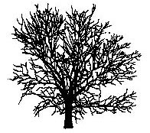

'Bloodgood'

Scientific Name: Prunus sargentii

Common Name: Sargent Cherry

Environmental Conditions:
Hardiness Zone: 4b (5a for reliable flowering)

Soil Moisture:

occasionally  saturated or  very wet soil |  |  | consistently  moist, well  drained soil |  |  | occasional  periods of  dry soil |  |  | prolonged  periods of  dry soil
1 | 2 | 3 | 4 | 5 | 6 | 7 | 8 | 9 | 10 | 11 | 12

Sun/Shade: full sun

Salt: some observed tolerance
pH: < 7.5

Insect/Disease Factors: none incapacitating

Growth Characteristics:

Height: 40’-50’
Width: 20’-30’, equal to height possible
Form/Habit: vase-shaped to rounded
Rate: medium to fast

Ornamental Characteristics:

Flower: showy, pink, early spring before leaves, hardy buds
Fruit: small, purple-black cherries, summer, not showy
Seasonal Foliage Color: emerges with reddish tinge in spring, glossy dark green in summer, yellow to bronze-red in fall
Bark: attractive, polished mahogany-red color

Transplant Issues: easy to transplant B&B or < 2” caliper bare root
Management Issues: cherries are short-lived trees (only 50 years in good site), fruit could stain sidewalk and be a nuisance in some situations

Suggested Uses: narrow or wide street tree lawns/pits, parks
Cultivars: ‘Columnaris’ (not true columnar, just narrower form with definite upright branching, 10’-20’ wide, likely shorter, 30’-40’ high, often flowers slightly later than species with emerging leaves instead of before leaves)
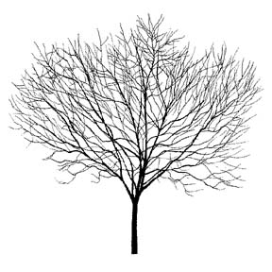

Scientific Name: Pyrus calleryana

Common Name: Callery Pear

Environmental Conditions:

Hardiness Zone: 5a

Soil Moisture:

occasionally  saturated or  very wet soil |  |  | consistently  moist, well  drained soil |  |  | occasional  periods of  dry soil |  |  | prolonged  periods of  dry soil
1 | 2 | 3 | 4 | 5 | 6 | 7 | 8 | 9 | 10 | 11 | 12

Sun/Shade: full sun

Salt: some observed tolerance
pH: < 8.2
Insect/Disease Factors: susceptible to fireblight, see cultivars for resistance

Growth Characteristics:

Height: 30’-50’
Width: 20’-40’
Form/Habit: pyramidal in youth, broadens with age to oval or rounded, dense branching and foliage

Rate: fast

Ornamental Characteristics:

Flower: showy, white clusters, spring before or as leaves emerge
Fruit: ½” greenish to tan, in clusters
Seasonal Foliage Color: glossy dark green in summer, fall color variable (yellow/orange/red/purple) but usually excellent
Bark: brown, lightly ridged and furrowed with age, sometimes grayish and blocky with age as well
Other: holds leaves late

Transplant Issues: easy to transplant B&B or < 2” caliper bare root
Management Issues: branching angles and branch density combined with late holding leaves may make species prone to early winter ice/snow storm damage, cultivar ‘Bradford’ is no longer recommended because of tendency for severe limb breakage, newer cultivars with improved branching habits are available, graft incompatibility can be a problem
Suggested Uses: narrow or wide street tree lawns/pits, parks, suitable for CU-Structural Soil™
Cultivars: see chart on following page, selections made for growth form, improved branching habit, flowering, fall color, and disease resistance, see small tree section for Pyrus under 30’

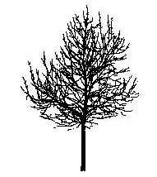

'Autumn Blaze'

Pyrus calleryana (Callery Pear) cultivars:

Cultivar | Zone | Form/Habit | Fall  Foliage | Disease  Resistance | Other
Aristocrat® | 5a | broadly pyramidal, wider branch angles, more open | variable, yellow to deep red | slightly  fireblight susceptible | later bloomer, sparser flowering, but still showy, wavy leaf margins
‘Autumn Blaze’ | 5a (4b) | rounded, can be irregular, more open, wider branch angles | early, reliable red | fireblight susceptible | leaves emerge with red tint in spring, drops leaves earlier
Burgundy Snow™  (‘Bursnozam’) | 4 | pyramidal |  |  | burgundy flower centers, heavy flowering, leaves are not dark green
‘Cambridge’ | 4 | upright, narrow-pyramidal, 15’ wide | bright orange
‘Capital’ | 5b (5a) | columnar, central leader, 15’ wide, more upright than ‘Whitehouse’ | copper-red to red-purple | slightly  fireblight  susceptible | very glossy leaves
Chanticleer® (‘Glens’ Form’) same as ‘Cleveland Select’ same as ‘Stonehill’ | 5a (4b) | upright, narrow-pyramidal, 15’-20’ wide, multiple leaders common, even branching | gold-red to plum | fireblight tolerant | heavier and later (a week) flowering, enters dormancy earlier
‘Fauriei’  sometimes listed as  P. calleryana var. fauriei or P. fauriei | 5a | pyramidal to rounded, wider branch angles, slower growing | early, variable | fireblight tolerant | heavy flowering, leaves leathery, drops leaves earlier
Frontier™ (‘Fronzam’) | 4 | narrow oval,  15-20’ wide | likely variable |  | very dark green leaves
Gladiator™ (‘Glazam’) | 4 | pyramidal, strong central leader, fast growing | likely variable
New Bradford® (‘Holmford’) | 5 | broadly oval to rounded | yellow to orange-red
‘Redspire’ | 5a | pyramidal to oval, dense, symmetrical, slower growing | often poor  in north, variable | fireblight tolerant | heavy flowering, enters dormancy earlier, thick leaves
‘Trinity | 5b (5a) | broadly oval to rounded | consistent,  orange-red |  | heavy flowering, light green leaves
‘Whitehouse’ | 5b (5a) | narrow pyramidal,  15’-20’ wide,  strong central leader | early, reddish purple | slightly fireblight  susceptible,  highly  leaf-spot  susceptible | leaves held late

Scientific Name: Quercus acutissima

Common Name: Sawtooth Oak

Environmental Conditions:

Hardiness Zone: 5b or 6a

Soil Moisture:

occasionally  saturated or  very wet soil |  |  | consistently  moist, well  drained soil |  |  | occasional  periods of  dry soil |  |  | prolonged  periods of  dry soil
1 | 2 | 3 | 4 | 5 | 6 | 7 | 8 | 9 | 10 | 11 | 12

Sun/Shade: full sun

Salt: some observed tolerance
pH: < 7.5

Insect/Disease Factors: none serious or limiting

Growth Characteristics:

Height: 40’-50’
Width: 35’-55’
Form/Habit: broadly pyramidal in youth, oval-rounded to broad-rounded with age, dense
Rate: medium (fast for an Oak)

Ornamental Characteristics:

Flower: attractive, pendent, golden, 3-4” male catkins, early spring as leaves emerge

Fruit: acorn, often heavy crops on older trees
Seasonal Foliage Color: leaves emerge yellow to light green in spring, lustrous green in summer, yellow to golden brown in fall, late to turn color in fall
Bark: attractive, gray-brown, deeply ridged and furrowed, almost corky on older trunks

Other: young trees hold leaves throughout winter
Transplant Issues: transplant B&B

Management Issues: acorns on older trees may be a litter problem certain years
Suggested Uses: wide street tree lawns/pits or parks preferred due to size
Cultivars: ‘Gobbler’ is the name given to seedlings that produce early and abundant acorns for wild turkey food, extremely limited availability

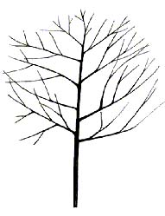

Scientific Name: Quercus bicolor

Common Name: Swamp White Oak

Environmental Conditions:

Hardiness Zone: 4a

Soil Moisture:

occasionally  saturated or  very wet soil |  |  | consistently  moist, well  drained soil |  |  | occasional  periods of  dry soil |  |  | prolonged  periods of  dry soil
1 | 2 | 3 | 4 | 5 | 6 | 7 | 8 | 9 | 10 | 11 | 12

Sun/Shade: full sun

Salt: unknown
pH: < 7.5 (variable susceptibility to iron chlorosis in high pH soils)

Insect/Disease Factors: none serious or limiting

Growth Characteristics:

Height: 50’-60’
Width: 50’-60’
Form/Habit: broad, rounded, open, typically has shorter trunk

Rate: slow

Ornamental Characteristics:

Flower: catkins, spring
Fruit: acorn, heavy crops at 3-5 year intervals
Seasonal Foliage Color: lustrous, leathery, dark green in summer (if soil has appropriate pH), yellowish in fall, sometimes red-purple in fall
Bark: attractive, grayish brown, flaky and divided into deep longitudinal fissures with flat ridges

Transplant Issues: easy to transplant B&B or < 2” caliper bare root
Management Issues: acorns may be a litter problem certain years

Suggested Uses: wide street tree lawns/pits or parks preferred due to size
Cultivars: none known
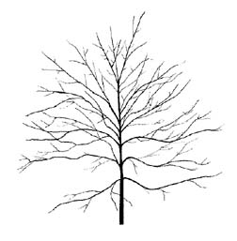

Scientific Name: Quercus coccinea

Common Name: Scarlet Oak

Environmental Conditions:

Hardiness Zone: 5a

Soil Moisture:

occasionally  saturated or  very wet soil |  |  | consistently  moist, well  drained soil |  |  | occasional  periods of  dry soil |  |  | prolonged  periods of  dry soil
1 | 2 | 3 | 4 | 5 | 6 | 7 | 8 | 9 | 10 | 11 | 12

Sun/Shade: full sun

Salt: unknown
pH: < 7.5

Insect/Disease Factors: none serious or limiting

Growth Characteristics:
Height: 60’-70’ (can reach 100’+ in wild)
Width: 40’-50’

Form/Habit: round, open

Rate: slow

Ornamental Characteristics:

Flower: catkins, spring as leaves emerge

Fruit: acorn
Seasonal Foliage Color: glossy dark green in summer, russet-red to brilliant scarlet in fall, late to turn color in fall

Bark: gray-brown
Other: leaves persist throughout winter, particularly on young trees

Transplant Issues: difficult to transplant B&B or bare root
Management Issues: acorns may be a litter problem certain years

Suggested Uses: wide street tree lawns/pits or parks preferred due to size
Cultivars: none available

Scientific Name: Quercus imbricaria

Common Name: Shingle Oak

Environmental Conditions:
Hardiness Zone: 5a (4b if hardy parent material selected)

Soil Moisture:

occasionally  saturated or  very wet soil |  |  | consistently  moist, well  drained soil |  |  | occasional  periods of  dry soil |  |  | prolonged  periods of  dry soil
1 | 2 | 3 | 4 | 5 | 6 | 7 | 8 | 9 | 10 | 11 | 12

Sun/Shade: full sun

Salt: unknown
pH: < 7.5

Insect/Disease Factors: none serious or limiting

Growth Characteristics:
Height: 40’-60’ (can grow 80’-100’)
Width: 40’-65’
Form/Habit: pyramidal to upright-oval in youth, broad-rounded outline with age, often lower lateral branches droop

Rate: slow

Ornamental Characteristics:

Flower: pale yellow-green catkins, spring as leaves emerge

Fruit: acorn
Seasonal Foliage Color: leaves unfold reddish in spring, lustrous dark green in summer, yellow-brown to russet-red in fall

Bark: gray-brown, shallow furrows, close low ridges that broaden with age
Other: leaves persist throughout winter
Transplant Issues: difficult to transplant B&B or bare root, slow to recover from transplanting
Management Issues: acorns may be a litter problem certain years although reportedly less of a litter problem than with other oaks, accepts pruning well

Suggested Uses: wide street tree lawns/pits or parks preferred due to size
Cultivars: none known
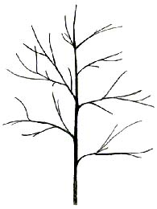

Scientific Name: Quercus macrocarpa

Common Name: Bur Oak or Mossycup Oak

Environmental Conditions:

Hardiness Zone: 3a

Soil Moisture:

occasionally  saturated or  very wet soil |  |  | consistently  moist, well  drained soil |  |  | occasional  periods of  dry soil |  |  | prolonged  periods of  dry soil
1 | 2 | 3 | 4 | 5 | 6 | 7 | 8 | 9 | 10 | 11 | 12

Sun/Shade: full sun

Salt: unknown
pH: < 8.2

Insect/Disease Factors: none serious or limiting

Growth Characteristics:
Height: 60’-80’ (can grow 100’+)

Width: 60’-90’, typically equal or slightly greater than height
Form/Habit: weakly pyramidal to oval in youth, broadly rounded and open with age

Rate: slow

Ornamental Characteristics:

Flower: pale yellowish catkins, spring as leaves emerge
Fruit: acorn, heavy crops at 3-5 year intervals
Seasonal Foliage Color: leathery, lustrous dark green in summer, yellow-green to yellow-brown in fall
Bark: dark gray to gray-brown, rough, corky, thick, developing deep ridges and furrows
Transplant Issues: difficult to transplant B&B or bare root, transplant small caliper trees

Management Issues: acorns may be a litter problem certain years
Suggested Uses: wide street tree lawns/pits or parks preferred due to size, suitable for CU-Structural Soil™

Cultivars: none known
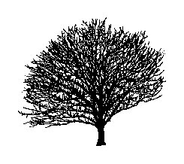
Scientific Name: Quercus muehlenbergii
Common Name: Chinkapin Oak, sometimes called Yellow Chestnut Oak

Environmental Conditions:

Hardiness Zone: 5a

Soil Moisture:

occasionally  saturated or  very wet soil |  |  | consistently  moist, well  drained soil |  |  | occasional  periods of  dry soil |  |  | prolonged  periods of  dry soil
1 | 2 | 3 | 4 | 5 | 6 | 7 | 8 | 9 | 10 | 11 | 12

Sun/Shade: full sun

Salt: unknown
pH: < 8.2

Insect/Disease Factors: none serious or limiting

Growth Characteristics:

Height: 30’-50’
Width: 30’-60’, usually greater than height at maturity

Form/Habit: round

Rate: medium in youth, slow with age

Ornamental Characteristics:

Flower: not ornamentally important, inconspicuous

Fruit: acorn
Seasonal Foliage Color: lustrous dark yellow-green in summer, yellow to orange-brown to brown in fall

Bark: gray, rough and flaky
Transplant Issues: difficult to transplant B&B or bare root, only transplant B&B

Management Issues: acorns may be a litter problem certain years
Suggested Uses: wide street tree lawns/pits or parks preferred due to size, suitable for CU-Structural Soil™
Cultivars: none known

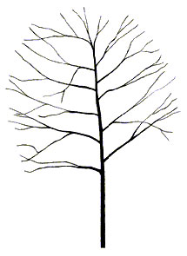

Scientific Name: Quercus palustris

Common Name: Pin Oak

Environmental Conditions:

Hardiness Zone: 5a

Soil Moisture:

occasionally  saturated or  very wet soil |  |  | consistently  moist, well  drained soil |  |  | occasional  periods of  dry soil |  |  | prolonged  periods of  dry soil
1 | 2 | 3 | 4 | 5 | 6 | 7 | 8 | 9 | 10 | 11 | 12

Sun/Shade: full sun

Salt: sensitive
pH: < 7.0 (iron chlorosis in high pH soils)
Insect/Disease Factors: over planting has encouraged problems, including gypsy moth, oak wilt, galls, and cankers, resistant to anthracnose

Growth Characteristics:
Height: 50’-70’ (can reach 100’+)
Width: 40’-50’
Form/Habit: pyramidal in youth, oval with age, strong central leader, distinct branching habit – upper branches upright, middle branches horizontal, and lower branches descending
Rate: fast for an oak

Ornamental Characteristics:

Flower: pale yellow-green catkins, spring as leaves emerge

Fruit: acorns
Seasonal Foliage Color: glossy dark green (if soil has appropriate pH) in summer, scarlet in fall
Bark: gray-brown, thinner, smooth, develops narrow ridges and shallow furrows with age

Other: young trees hold leaves throughout winter
Transplant Issues: only transplant B&B, moderately difficult to transplant bare root, better success in transplanting bare root in fall, do not attempt to transplant > 2” caliper trees bare root
Management Issues: acorns may be a litter problem certain years, descending lower branches may need pruning where clearance is needed

Suggested Uses: wide street tree lawns/pits or parks preferred due to size
Cultivars: ‘Green Pillar’ (also called ‘Emerald Pillar’, columnar form, delayed graft incompatibility may be a problem), ‘Crownright’ and ‘Sovereign’ (lower branches are more upright) were taken out of production due to delayed graft incompatibility problems
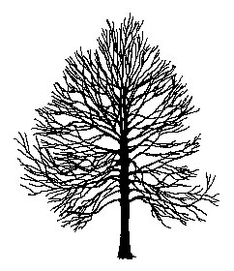

Scientific Name: Quercus phellos

Common Name: Willow Oak

Environmental Conditions:

Hardiness Zone: 6a

Soil Moisture:

occasionally  saturated or  very wet soil |  |  | consistently  moist, well  drained soil |  |  | occasional  periods of  dry soil |  |  | prolonged  periods of  dry soil
1 | 2 | 3 | 4 | 5 | 6 | 7 | 8 | 9 | 10 | 11 | 12

Sun/Shade: full sun

Salt: unknown
pH: < 7.5 (iron chlorosis in high pH soils)
Other: specify northern seed source if needed
Insect/Disease Factors: susceptible to trunk borers, scale, and oak wilt, although rarely serious or limiting, resistant to anthracnose

Growth Characteristics:
Height: 40’-60’ (can reach 100’+ in ideal conditions)
Width: 30’-60’
Form/Habit: pyramidal in youth, oval to round with age, dense crown, lower branches sometimes descending/pendulous

Rate: medium

Ornamental Characteristics:

Flower: pale yellow-green catkins, spring as leaves emerge

Fruit: acorn, small
Seasonal Foliage Color: light green in spring, dark green in summer (if soil has appropriate pH), color variable in fall (brown, yellow, bronze-orange, russet-red)

Bark: gray-brown, becoming lightly ridged and furrowed with age
Other: leaves persist throughout winter
Transplant Issues: best transplanted B&B
Management Issues: acorns may be a litter problem certain years, descending/pendulous lower branches may require removal where clearance is needed
Suggested Uses: wide street tree lawns/pits or parks preferred due to size
Cultivars: none known

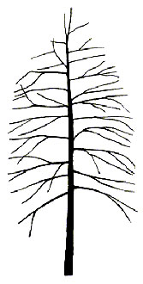

Scientific Name: Quercus robur

Common Name: English Oak

Environmental Conditions:

Hardiness Zone: 5b

Soil Moisture:

occasionally  saturated or  very wet soil |  |  | consistently  moist, well  drained soil |  |  | occasional  periods of  dry soil |  |  | prolonged  periods of  dry soil
1 | 2 | 3 | 4 | 5 | 6 | 7 | 8 | 9 | 10 | 11 | 12

Sun/Shade: full sun

Salt: some observed tolerance
pH: < 8.2
Insect/Disease Factors: powdery mildew is a serious problem, Attention!, Crimson Spire™, Regal Prince®, Rosehill®, Skymaster™, and Skyrocket™ show varying levels of resistance

Growth Characteristics:
Height: 40’-60’ (can reach 75’-100’+)
Width: 40’-60’
Form/Habit: broadly rounded, open
Rate: slow to medium

Ornamental Characteristics:

Flower: pale yellow-green catkins, spring as leaves emerge

Fruit: acorn

Seasonal Foliage Color: dark green to blue-green in summer, brown in fall

Bark: grayish black, deeply furrowed
Transplant Issues: moderately difficult to transplant bare root, better success in transplanting bare root in fall, do not attempt to transplant > 2” caliper trees bare root, best transplanted B&B

Management Issues: acorns may be a litter problem certain years
Suggested Uses: wide street tree lawns/pits or parks preferred due to size, suitable for CU-Structural Soil™
Cultivars: Attention! (‘DTR 105’, columnar form, dense, 15’ wide, dark green foliage, bronze fall color, good mildew resistance), Crimson Spire™ (‘Crimschmidt’, Q.alba x Q. robur, columnar form, 15’ wide, faster growing, dark green mildew resistant foliage, reddish fall color), Regal Prince® (‘Long’, Q. robur x Q. bicolor, zone 4, columnar to narrow oval habit, 15’-20’ wide, glossy bright green summer foliage, yellow fall color, highly mildew resistant), Rosehill’® (‘Asjes’, Q. robur x Q. bicolor, zone 4, narrow oval habit, 20’ wide, glossy pure green summer foliage, yellow fall color, good mildew resistance), Skymaster™ (‘Pyramich’, narrow when young, pyramidal with age, 25’-30’ wide, strong central leader, good branching angles, reportedly mildew resistant), Skyrocket™ (uniform columnar habit, 15’ wide, leafs out early, yellow-brown fall color, reportedly moderately mildew resistant)
* ‘Fastigiata’ (columnar form, 15’-20’ wide, not recommended due to variability from seed propagation, resulting in potential iron chlorosis in high pH soils and powdery mildew susceptibility)

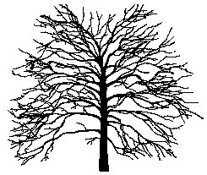

Scientific Name: Quercus rubra

Common Name: Northern Red Oak

Environmental Conditions:

Hardiness Zone: 3b

Soil Moisture:

occasionally  saturated or  very wet soil |  |  | consistently  moist, well  drained soil |  |  | occasional  periods of  dry soil |  |  | prolonged  periods of  dry soil
1 | 2 | 3 | 4 | 5 | 6 | 7 | 8 | 9 | 10 | 11 | 12

Sun/Shade: full sun

Salt: some observed tolerance
pH: < 7.5
Insect/Disease Factors: oak wilt is a serious problem in more southern areas, resistant to anthracnose

Growth Characteristics:
Height: 60’-80’ (can grow 90’-100’ in wild)
Width: 50’-70’

Form/Habit: round

Rate: fast for an oak

Ornamental Characteristics:

Flower: catkins, spring
Fruit: acorn, heavy crops at 3-5 year intervals
Seasonal Foliage Color: emerge reddish in spring, lustrous dark green in summer, russet-red to bright red in fall, sometimes disappoints with only yellow-brown fall color
Bark: gray, nearly black with age, wide flat-topped silver-gray ridges, separated by shallow fissures, deeply ridged and furrowed on older trunks

Transplant Issues: only transplant B&B, moderately difficult to transplant bare root
Management Issues: acorns may be a litter problem certain years

Suggested Uses: wide street tree lawns/pits or parks preferred due to size
Cultivars: none available
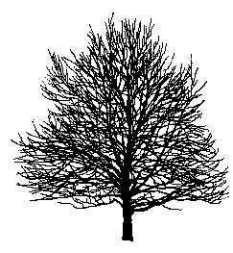

Scientific Name: Quercus shumardii

Common Name: Shumard Oak

Environmental Conditions:

Hardiness Zone: 5b or 6a

occasionally  saturated or  very wet soil |  |  | consistently  moist, well  drained soil |  |  | occasional  periods of  dry soil |  |  | prolonged  periods of  dry soil
1 | 2 | 3 | 4 | 5 | 6 | 7 | 8 | 9 | 10 | 11 | 12

Sun/Shade: full sun

Salt: unknown
pH: < 8.2

Insect/Disease Factors: seldom serious or limiting

Growth Characteristics:
Height: 60’-80’ (can reach 100’+ in wild)
Width: 45’-65’
Form/Habit: pyramidal in youth, oval to round with age
Rate: slow to medium

Ornamental Characteristics:

Flower: pale yellow-green catkins as leaves emerge

Fruit: acorn
Seasonal Foliage Color: dark green in summer, yellow-bronze possible in fall, russet-red in fall typical

Bark: gray-brown, developing somewhat platy ridges and furrows with age
Transplant Issues: moderately difficult to transplant B&B, best to transplant B&B
Management Issues: acorns may be a litter problem certain years, best to prune in late summer or fall due to “bleeding” in spring

Suggested Uses: wide street tree lawns/pits or parks preferred due to size
Cultivars: none available

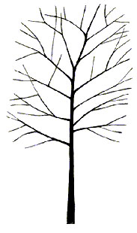

Scientific Name: Robinia pseudoacacia

Common Name: Black Locust

Environmental Conditions:

Hardiness Zone: 4b

Soil Moisture:

occasionally  saturated or  very wet soil |  |  | consistently  moist, well  drained soil |  |  | occasional  periods of  dry soil |  |  | prolonged  periods of  dry soil
1 | 2 | 3 | 4 | 5 | 6 | 7 | 8 | 9 | 10 | 11 | 12

Sun/Shade: prefers full sun, tolerates full shade
Salt: some observed tolerance
pH: < 8.2
Insect/Disease Factors: borers can be a serious problem, leaf miners may also be problematic

Growth Characteristics:

Height: 40’-50’ common, can grow 70’-80’
Width: 20’-35’
Form/Habit: open, irregular-oval, upright branching

Rate: fast

Ornamental Characteristics:

Flower: pendulous, white, 4”-8” long clusters, late spring, fragrant

Fruit: brown-black, flat, 2”-4”long pod, may persist into winter
Seasonal Foliage Color: dull blue-green in summer, yellow-green in fall

Bark: dark gray, with interlacing ridges, ropy appearance
Transplant Issues: easy to transplant B&B, ‘Pyramidalis’ (although cultivar not recommended) and ‘Purple Robe’ are easy to transplant < 2” caliper bare root
Management Issues: fruit litter could be problematic, as well as thorns, in certain locations
Suggested Uses: narrow or wide street tree lawns/pits (widely used as street tree in Europe), parks, suitable for CU-Structural Soil™, good in very difficult reclamation sites (fixes own nitrogen)
Cultivars: ‘Frisia’ (spines are red on young shoots, yellow foliage in summer, does not retain yellow color as well in cooler climates), ‘Idahoensis’ (commonly called Pink IdahoLocust, Robinia x ambigua, zone 3, 25’-40’ high, 15’-30’ wide, rose-pink flowers), ‘Purple Robe’ (zone 3, only 40’ high, rounded form, dark pink flowers, new growth has purple tint, bronze-green summer foliage, still yellowish in fall)
* ‘Pyramidalis’ (sometimes called ‘Fastigiata’, narrower, columnar form, spineless, sparse flowering) is not recommended as it is not as hardy as species and is subject to dieback
*see small tree section for Robinia cultivars under 30’ tall

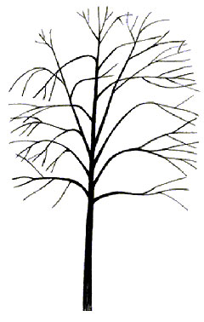

Scientific Name: Sorbus alnifolia

Common Name: Korean Mountainash

Environmental Conditions:

Hardiness Zone: 4b

Soil Moisture:

occasionally  saturated or  very wet soil |  |  | consistently  moist, well  drained soil |  |  | occasional  periods of  dry soil |  |  | prolonged  periods of  dry soil
1 | 2 | 3 | 4 | 5 | 6 | 7 | 8 | 9 | 10 | 11 | 12

Sun/Shade: prefers full sun, tolerates partial shade

Salt: unknown
pH: < 8.2
Insect/Disease Factors: Sorbus have potentially many minor pest problems and two major problems – fireblight and borers (borers are particularly problematic if tree is stressed or weakened), S. alnifolia is considered the least susceptible to borer injury but is reportedly slightly susceptible to fireblight

Growth Characteristics:
Height: 30’-40’ (can grow 50’-60’, although rarely)
Width: 20’-30’, can reach equal to height
Form/Habit: pyramidal in youth, oval to rounded with age
Rate: medium to fast

Ornamental Characteristics:

Flower: showy, white loose clusters, late spring, heavy flowering alternate years

Fruit: pink-red to orange-red berries in loose clusters, fall, persistent
Seasonal Foliage Color: lustrous dark green in summer, yellow to orange in fall

Bark: smooth silvery gray
Transplant Issues: easy to transplant B&B or < 2” caliper bare root
Management Issues: harder wooded than other Sorbus, hence storm damage less likely
Suggested Uses: narrow or wide street tree lawns/pits, parks, suitable for CU-Structural Soil™
Cultivars: none available

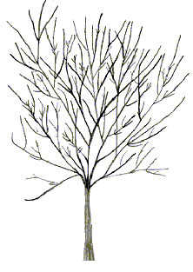
Scientific Name: Styphnolobium japonicum (Sophora japonica)
Common Name: Japanese Pagodatree or Scholar-tree

Environmental Conditions:

Hardiness Zone: 5b

Soil Moisture:

occasionally  saturated or  very wet soil |  |  | consistently  moist, well  drained soil |  |  | occasional  periods of  dry soil |  |  | prolonged  periods of  dry soil
1 | 2 | 3 | 4 | 5 | 6 | 7 | 8 | 9 | 10 | 11 | 12

Sun/Shade: full sun

Salt: some observed tolerance
pH: < 8.2
Insect/Disease Factors: twig die-back and stem canker common in colder zones, although not considered serious and are rarely limiting, Millstone™ less susceptible to stem canker than species, Regent® and ‘Princeton Upright’ resistant to leafhoppers

Growth Characteristics:

Height: 40’-60’
Width: 35’-55’
Form/Habit: oval to round, upright spreading branches
Rate: medium to fast

Ornamental Characteristics:

Flower: showy, creamy white, 6”-12” long clusters, summer
Fruit: bright green changing to yellow-brown pods in clusters, may persist through winter
Seasonal Foliage Color: lustrous bright green in summer, yellowish in fall, late to turn color in fall
Bark: grayish brown, furrowed with age, green bark on young branches (1-5 year old wood)
Transplant Issues: easy to transplant B&B
Management Issues: none of significance
Suggested Uses: narrow or wide street tree lawns/pits, parks, suitable for CU-Structural Soil™
Cultivars: Millstone™ (‘Halka’, good form, symmetrical, uniform, dense branching, deeper green foliage), ‘Princeton Upright’ (similar to ‘Regent’ except narrower, upright form, 25’-35’ wide), Regent® (fast growing, reportedly straighter trunk, flowers at younger age than species, deeper green foliage, resistance to leaf-chewing insects)

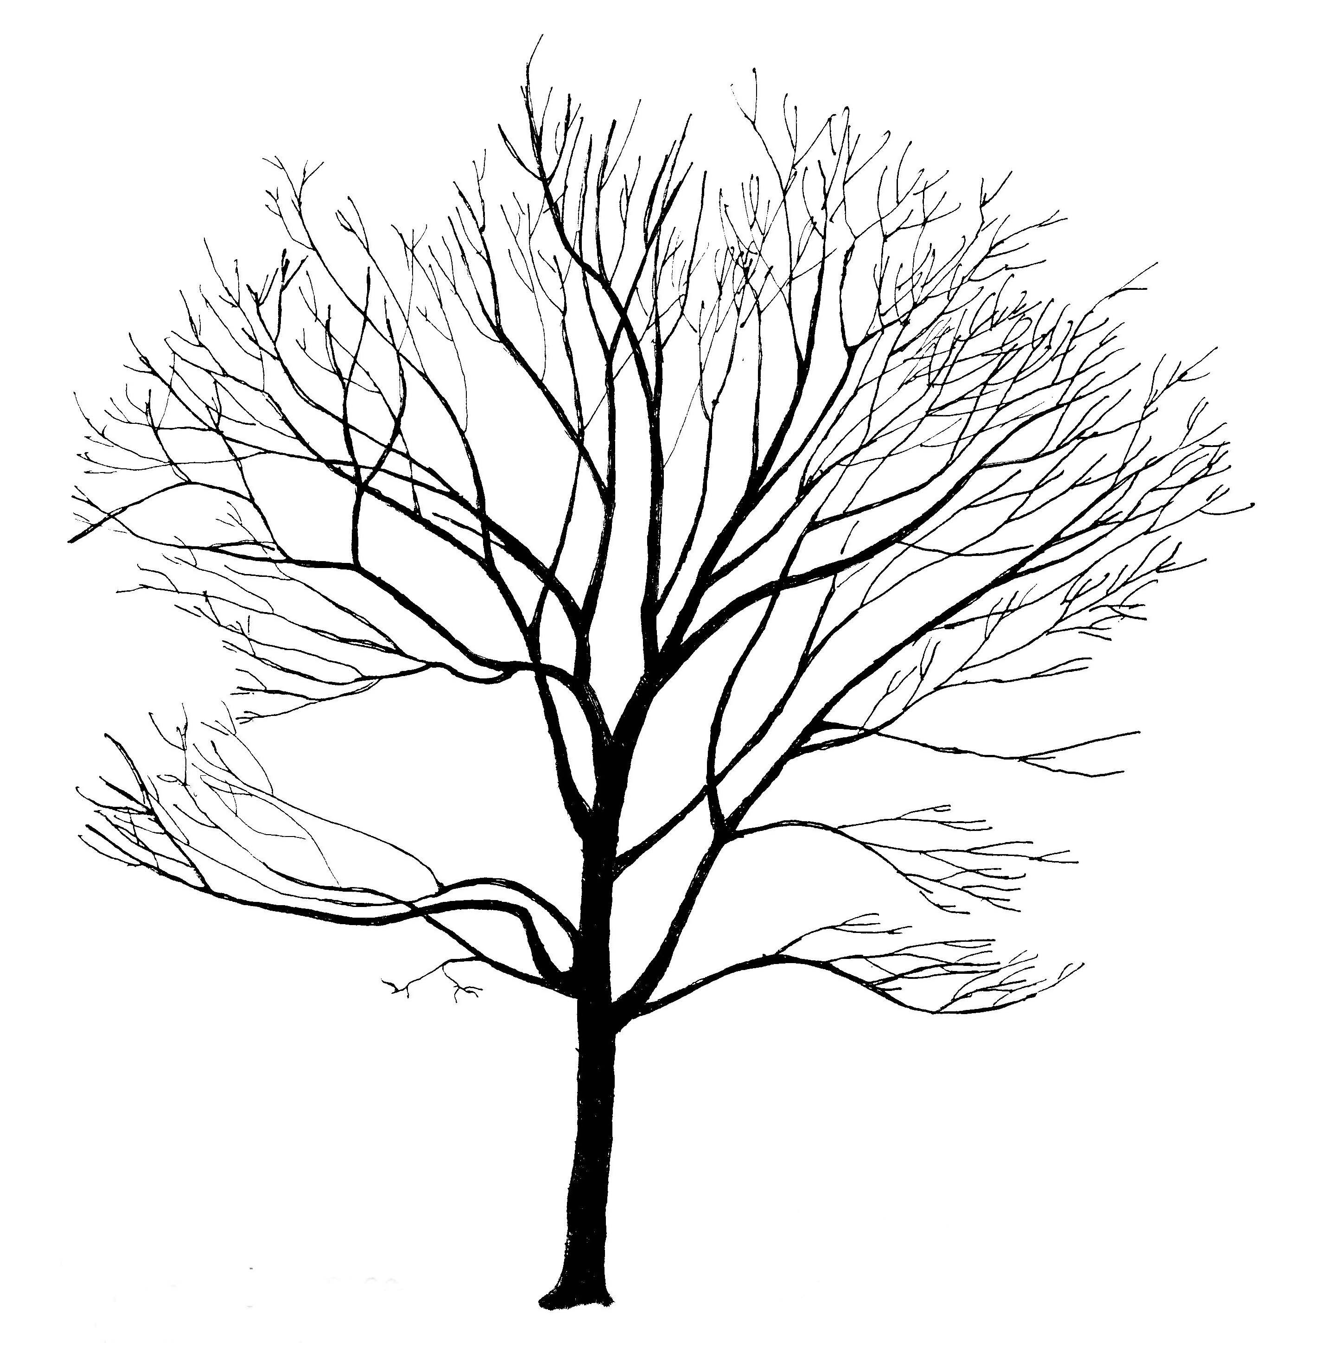

Scientific Name: Taxodium distichum

Common Name: Common Baldcypress

Environmental Conditions:
Hardiness Zone: 5a (4 with appropriate selection of genetic material)

Soil Moisture:

occasionally  saturated or  very wet soil |  |  | consistently  moist, well  drained soil |  |  | occasional  periods of  dry soil |  |  | prolonged  periods of  dry soil
1 | 2 | 3 | 4 | 5 | 6 | 7 | 8 | 9 | 10 | 11 | 12

Sun/Shade: full sun

Salt: some observed tolerance
pH: < 7.5
Insect/Disease Factors: none serious or limiting, ‘Shawnee Brave’ has mite resistant foliage

Growth Characteristics:

Height: 50’-70’
Width: 20’-40’
Form/Habit: columnar when young, slender pyramidal with age, horizontal branching, often with pendulous branchlets, straight tapered trunk is very short and buttressed at base

Rate: medium

Ornamental Characteristics:

Flower: not ornamentally important
Fruit: 1” globose cones, green to purple when young, brown at maturity
Seasonal Foliage Color: late to leaf out, bright light green in spring, soft green in summer, orange-brown to russet-brown in fall

Bark: attractive, reddish-brown and gray-brown, fibrous
Transplant Issues: difficult to transplant B&B or bare root, slow to recover from transplanting
Management Issues: none of significance
Suggested Uses: wide street tree lawns/pits with pruning or parks due to size, form and low branching habit
Cultivars: limited availability, ‘Shawnee Brave’ (zone 5b, narrower, mite resistant foliage, reportedly tolerates high pH soils), ‘Monarch of Illinois’ (wider-spreading)

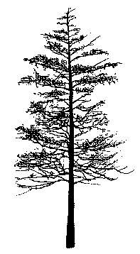

Scientific Name: Tilia americana

Common Name: Basswood

Environmental Conditions:

Hardiness Zone: 3a

Soil Moisture:

occasionally  saturated or  very wet soil |  |  | consistently  moist, well  drained soil |  |  | occasional  periods of  dry soil |  |  | prolonged  periods of  dry soil
1 | 2 | 3 | 4 | 5 | 6 | 7 | 8 | 9 | 10 | 11 | 12

Sun/Shade: full sun

Salt: sensitive
pH: < 8.2
Insect/Disease Factors: various pests are potentially problematic, although most are rarely serious, foliage feeding insects can damage and almost completely defoliate, scales and linden mites can be serious, susceptible to Japanese beetles

Growth Characteristics:

Height: 60’-80’, can grow 100’+
Width: 30’-60’
Form/Habit: pyramidal in youth, oval to rounded with age
Rate: medium to fast

Ornamental Characteristics:
Flower: light yellow, drooping clusters attached to pale greenish-yellow leaf-like bracts, early to mid-summer, very fragrant, attracts bees, flowers before T. cordata and T. tomentosa
Fruit: not ornamentally important, small nutlets, globose, attached to bracts, late summer
Seasonal Foliage Color: dark green in summer, green-yellow to pale yellow in fall (if any color), can develop unattractive brownish cast in early fall (late season discoloration)
Bark: not ornamentally important, gray to brown with narrow, flat-topped ridges, very tough and fibrous
Other: buds and twigs have potential winter interest, as they vary in color from brown to reddish to greenish and every combination of those colors
Transplant Issues: easy to transplant B&B
Management Issues: none of significance
Suggested Uses: narrow or wide street tree lawns/pits, parks, suitable for CU-Structural Soil™
Cultivars: ‘Boulevard’ (narrow pyramidal, yellow fall color), ‘Fastigiata’ or ‘Pyramidal’ (columnar in youth, pyramidal with age, reaching 25’ wide, may be slightly shorter, 50’ high, ascending branches, dark green foliage, availability may be limited), Legend™ (‘Wandell’, zone 4, distinctly pyramidal, good central leader, excellent branching structure, slightly smaller foliage, thick dark green leaves resistant to late season discoloration, red stem and bud color), ‘Lincoln’ (slender, upright, compact form, yellow fall color, listed as having lighter green foliage, also listed as having dark green foliage), ‘Redmond’ (T. americana x T. euchlora, densely pyramidal, larger leaves, buds/stems/foliage all resemble T. americana rather than T. euchlora, buds reddish, stems are red-green-brown mix, sometimes listed as having lighter green foliage), ‘Sentry’ (uniform symmetrical habit, branches silver-gray in youth)
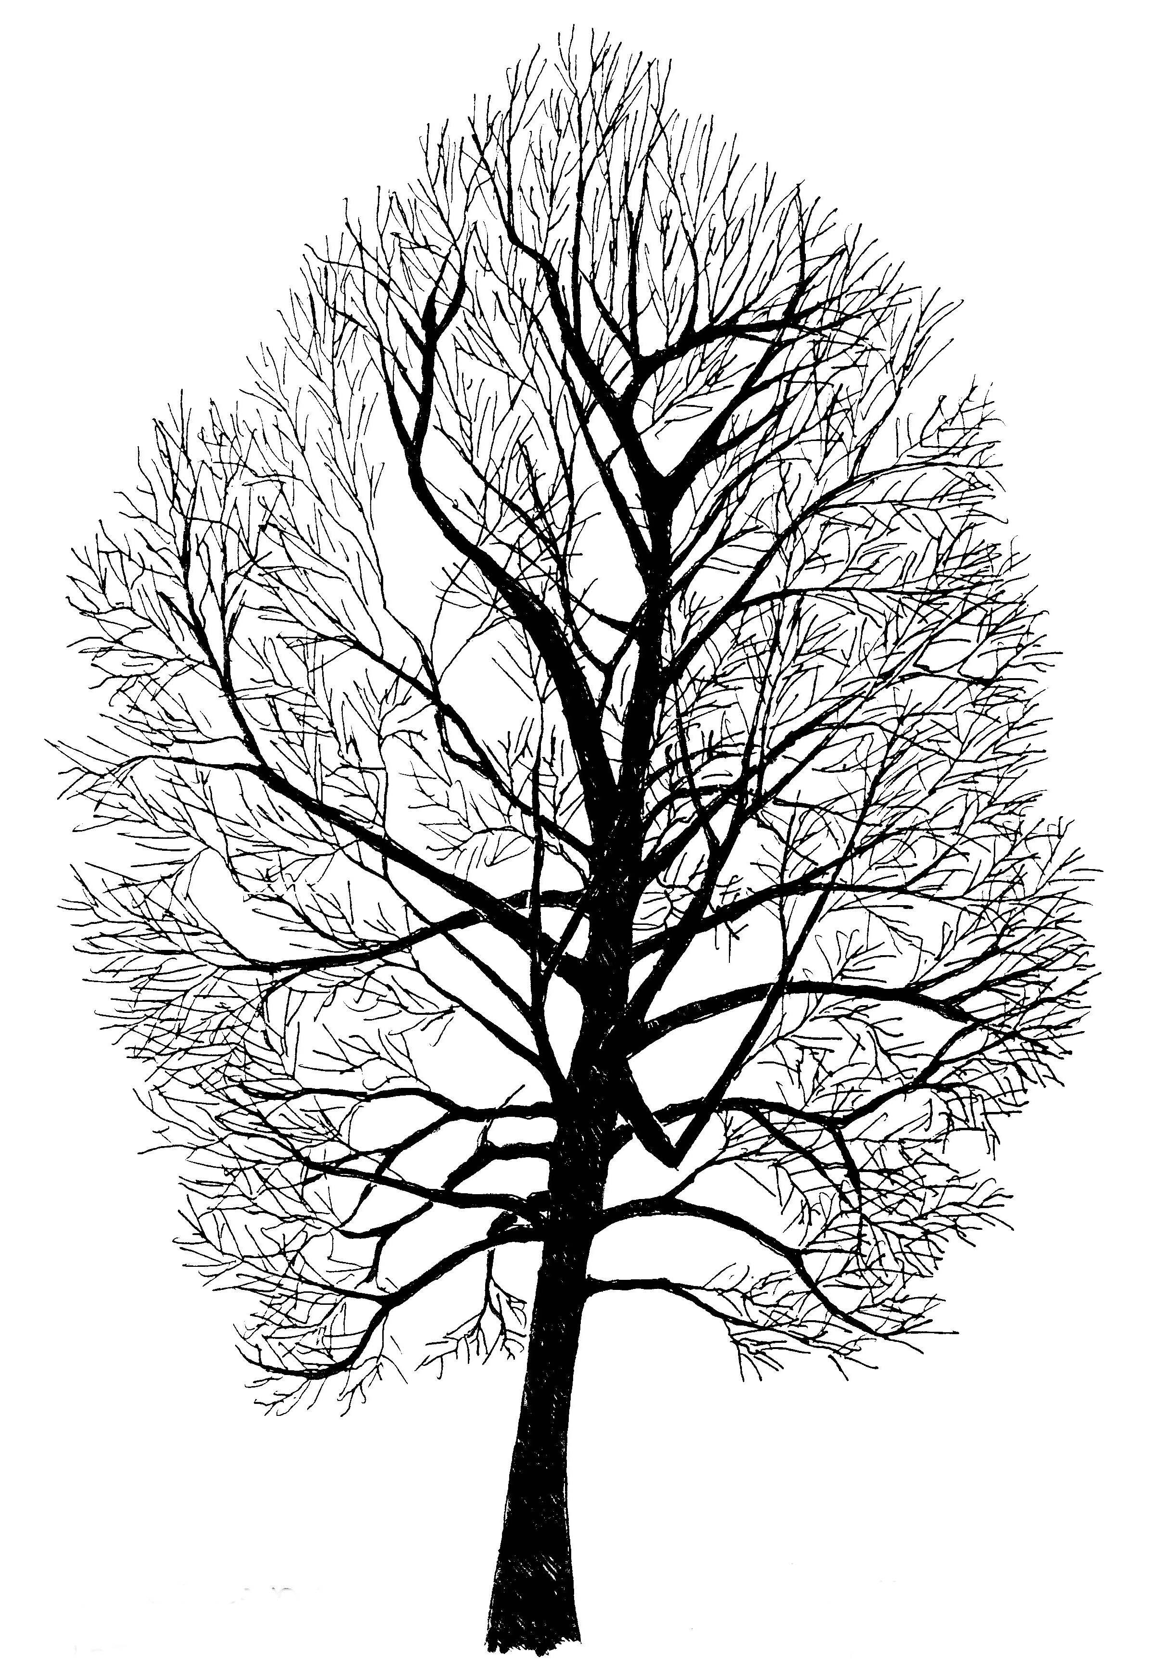

Scientific Name: Tilia cordata

Common Name: Littleleaf Linden

Environmental Conditions:

Hardiness Zone: 3b

Soil Moisture:

occasionally  saturated or  very wet soil |  |  | consistently  moist, well  drained soil |  |  | occasional  periods of  dry soil |  |  | prolonged  periods of  dry soil
1 | 2 | 3 | 4 | 5 | 6 | 7 | 8 | 9 | 10 | 11 | 12
*prolonged drought will lead to leaf scorch

Sun/Shade: full sun

Salt: sensitive
pH: < 8.2
Insect/Disease Factors: various pests are potentially problematic for Tilia, although most are rarely serious, aphids (highly susceptible) and Japanese beetles (especially Greenspire®) can be serious problems for T. cordata

Growth Characteristics:

Height: 50’-70’
Width: 30’-50’
Form/Habit: pyramidal in youth, upright-oval to pyramidal-rounded with age, dense, some cultivars available in multi-stem form (GreenSpire®)
Rate: medium to `fast

Ornamental Characteristics:
Flower: yellowish, drooping clusters attached to pale greenish-yellow leaf-like bracts, mid-summer, very fragrant, attracts bees, flowers after T. americana but before T. tomentosa
Fruit: not ornamentally important, small nutlets, globose, attached to bracts, late summer

Seasonal Foliage Color: dark shiny green in summer, yellow-green to yellow in fall
Bark: not ornamentally important, gray-brown, ridged and furrowed on older trunks

Transplant Issues: easy to transplant B&B or < 2” caliper bare root
Management Issues: none of significance
Suggested Uses: narrow or wide street tree lawns/pits, parks, suitable for CU-Structural Soil™

Cultivars: many are known, the following are more readily available selections
Chancellor® (‘Chancole’, fast growing, narrow in youth, becoming tightly pyramidal with age, 20’-30’ wide, symmetrical, upward branching, good branch angles, straight trunk, dense, gold-yellow fall color), Corinthian® (‘Corzam’, pyramidal, compact ,15’-25’ wide, straight central leader, uniform limb spacing, straight trunk, foliage smaller, thicker, glossier, and reportedly more blue-green), Fairview™ (fast growing, evenly spaced branching, thick and leathery foliage, less formal look than other cultivars due to a less dense habit), ‘Glenleven’ (reportedly very cold hardy, fast growing, pyramidal to narrow-oval, straight trunk, symmetrical branching, larger leaves, less dense than some other cultivars), Greenspire® (‘PNI 6025’, zone 4, pyramidal to narrow-oval, strong central leader, symmetrical branching habit), ‘Olympic’ (zone 4, symmetrical form, broadly pyramidal, better branching), ‘Rancho’ (upright-oval, 20’-30’ wide, vigorous, smaller leaves, good branch angles, heavy flowerings, very fragrant flower, partially resistant to Japanese beetles), Shamrock® (‘Baileyi’, zone 4, broadly pyramidal, more vigorous and more open habit than Greenspire®, symmetrical branching at an early age)
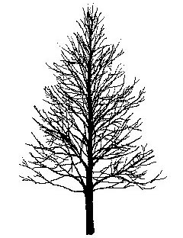

‘Glenleven’

Scientific Name: Tilia x euchlora (T. cordata x T. dasystyla)

Common Name: Crimean Linden

Environmental Conditions:

Hardiness Zone: 4

Soil Moisture:

occasionally  saturated or  very wet soil |  |  | consistently  moist, well  drained soil |  |  | occasional  periods of  dry soil |  |  | prolonged  periods of  dry soil
1 | 2 | 3 | 4 | 5 | 6 | 7 | 8 | 9 | 10 | 11 | 12
*reportedly more drought resistant than T. cordata

Sun/Shade: full sun

Salt: sensitive
pH: < 8.2
Insect/Disease Factors: various pests are potentially problematic for Tilia, although most are rarely serious, T. x euchlora more resistant to aphids than T. cordata

Growth Characteristics:

Height: 40’-60’
Width: 20’-30’
Form/Habit: broadly pyramidal in youth and often with age, sometimes more rounded with age, pendulous lower branches, dense
Rate: medium-fast

Ornamental Characteristics:
Flower: yellowish, drooping clusters attached to pale greenish-yellow leaf-like bracts, mid-summer, likely very fragrant and attractive to bees
Fruit: not ornamentally important, small nutlets, globose, attached to bracts, late summer

Seasonal Foliage Color: lustrous dark green in summer, green to yellow-green in fall
Bark: not ornamentally important, gray-brown, ridged and furrowed on older trunks

Other: buds and twigs are often more green in color
Transplant Issues: easy to transplant B&B or < 2” caliper bare root
Management Issues: basal suckering on grafted trees can be a maintenance problem, specify ‘own roots’ when possible
Suggested Uses: narrow or wide street tree lawns/pits, parks, suitable for CU-Structural Soil™
Cultivars: ‘Laurelhurst’ (compact, broadly pyramidal, straight trunk)
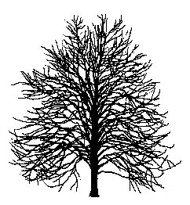

Scientific Name: Tilia tomentosa

Common Name: Silver Linden

Environmental Conditions:

Hardiness Zone: 5a

Soil Moisture:

occasionally  saturated or  very wet soil |  |  | consistently  moist, well  drained soil |  |  | occasional  periods of  dry soil |  |  | prolonged  periods of  dry soil
1 | 2 | 3 | 4 | 5 | 6 | 7 | 8 | 9 | 10 | 11 | 12
*tolerates drought better than T. cordata

Sun/Shade: full sun

Salt: unknown
pH: < 8.2
Other: tolerates heat better than T. cordata
Insect/Disease Factors: various pests are potentially problematic for Tilia, although most are rarely serious, aphids can be serious problem for T. tomentosa, less susceptible to Japanese beetles than other Tilia, ‘Sterling Silver’ resistant to Japanese beetles, ‘Satin Shadow’ reportedly resistant to Japanese beetles

Growth Characteristics:

Height: 50’-70’
Width: 35’-55’
Form/Habit: pyramidal in youth, pyramidal to upright-oval with age, generally dense and symmetrical

Rate: medium

Ornamental Characteristics:
Flower: yellowish, drooping clusters attached to pale greenish-yellow leaf-like bracts, mid-summer, very fragrant, latest flowering Tilia
Fruit: not ornamentally important, small nutlets, egg-shaped with a point, attached to bracts, late summer, often light seed crop
Seasonal Foliage Color: shiny dark green above, silvery and pubescent on underside in summer, green-yellow to yellow in fall
Bark: not ornamentally important, smooth light gray, eventually becoming gray-brown, ridged and furrowed on older trunks
Transplant Issues: moderately difficult to transplant B&B or bare root, better success in transplanting bare root in fall, do not attempt to transplant > 2” caliper trees bare root, slower to recover from transplanting than other Tilia

Management Issues: none of significance
Suggested Uses: narrow or wide street tree lawns/pits, parks, suitable for CU-Structural Soil™
Cultivars: Green Mountain® (‘PNI 6051’, fast growing, symmetrical, dense canopy), Sterling Silver™ (‘Wandell’, fast growing, symmetrical, dense canopy, resistant to Japanese beetles), Satin Shadow™ (‘Sashazam’, possibly more cold hardy, symmetrical, reportedly resistant to Japanese beetles)

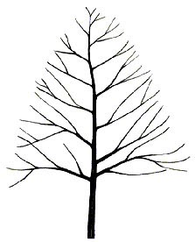

Sterling Silver™

Scientific Name: Ulmus americana

Common Name: American Elm Cultivars

Environmental Conditions:
Hardiness Zone: varies, 3b to 5a (see cultivar listing below)

Soil Moisture:

occasionally  saturated or  very wet soil |  |  | consistently  moist, well  drained soil |  |  | occasional  periods of  dry soil |  |  | prolonged  periods of  dry soil
1 | 2 | 3 | 4 | 5 | 6 | 7 | 8 | 9 | 10 | 11 | 12

Sun/Shade: full sun

Salt: some observed tolerance
pH: < 8.2
Insect/Disease Factors: all cultivars listed below show moderate to excellent resistance to Dutch elm disease (‘Valley Forge’ thought to have the highest resistance), although resistance to elm yellows (a fatal disease sometimes known as Phloem Necrosis) and elm leaf beetle (an insect that can cause severe damage in some areas) varies
Cultivar | Elm Yellows | Elm Leaf Beetle
‘New Harmony’ | resistant | resistant
‘Valley Forge’ | resistant | resistant
‘Delaware #2’ | susceptible | unknown
‘Princeton’ | unknown | resistant
‘Washington’ | moderately susceptible | unknown
* ‘Liberty’ is highly susceptibility to elm yellows and is not recommended due to variability of resistance to Dutch elm disease

Growth Characteristics:

Height: 60’-80’, can grow over 100’
Width: 40’-80’

Form/Habit: vase-shaped

Rate: medium to fast

Ornamental Characteristics:

Flower: not ornamentally important, inconspicuous

Fruit: ½” disc-shaped, matures in spring
Seasonal Foliage Color: lustrous green to dark green, often yellow in fall

Bark: dark gray, fissured, with broad, deep, intersecting ridges
Transplant Issues: easy to transplant B&B or < 2” caliper bare root

Management Issues: none of significance
Suggested Uses: narrow or wide street tree lawns/pits, parks, suitable for CU-Structural Soil™

Cultivars:
Most promising new cultivars: ‘New Harmony’ (zone 5 (4), broadly vase-shaped, more rounded than ‘Valley Forge’, yellow fall color), ‘Valley Forge’ (zone 5, upright arching, vase-shaped, classic American Elm shape, dense, yellow fall color)
Available: ‘Delaware #2’ (zone 3b (3a), broadly rounded vase-shaped, sometimes irregular habit, fast growing, bright green foliage), ‘Princeton’ (zone 4 (3b), upright vase-shaped, symmetrical, fast growing, leathery dark green foliage, yellow fall color),‘Washington’(zone 3b, classics vase-shape, glossy foliage)
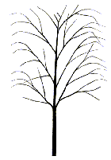

Scientific Name: Ulmus x species

Common Name: Elm Hybrids

Environmental Conditions:
Hardiness Zone: varies, 3b to 5a (see cultivar listing below)

Soil Moisture:

occasionally  saturated or  very wet soil |  |  | consistently  moist, well  drained soil |  |  | occasional  periods of  dry soil |  |  | prolonged  periods of  dry soil
1 | 2 | 3 | 4 | 5 | 6 | 7 | 8 | 9 | 10 | 11 | 12

Sun/Shade: full sun

Salt: some observed tolerance
pH: < 8.2
Insect/Disease Factors: all cultivars listed are resistant to Dutch elm disease, resistance to elm yellows (a fatal disease sometimes known as Phloem Necrosis) and elm leaf beetle (an insect that can cause severe damage in some areas) varies, see chart on page 114

Growth Characteristics:

Height: 50’-70’
Width: 40’-60’ typical, can equal height with age
Form/Habit: varies with cultivar, see cultivar chart on following page
Rate: medium to fast, many cultivars are noted as fast growing on cultivar chart on following page

Ornamental Characteristics:

Flower: not ornamentally important, inconspicuous

Fruit: ½” disc-shaped, matures in spring
Seasonal Foliage Color: green to dark green in summer (all cultivars listed as dark green except Vanguard™ and Commendation™), yellow in fall
Bark: gray to brown, ridged or scaly, varies with these hybrids, can be attractive but none considered highly ornamental as U. parvifolia species and cultivars except ‘Frontier’ (gray-green bark with orange lenticels due to U. parvifolia partial parentage)
Transplant Issues: easy to transplant B&B or < 2” caliper bare root (except ‘Frontier’, which is difficult to transplant bare root)
Management Issues: plants propagated on ‘own roots’ are preferred, specify when possible
Suggested Uses: narrow or wide street tree lawns/pits, parks, suitable for CU-Structural Soil™
Cultivars: see chart on following page

'Homestead'

Ulmus x species (Elm Hybrids):

Culitvar | Growth Rate  and Size  (if differs from previous page) | Form/Habit | Foliage  (if differs from previous page)
Zone 3
‘Discovery’  (possibly 2b) | more compact,  45’ high, 35’ wide | upright oval to vase-shaped in youth, develops arching vase-shape with age, symmetrical
‘New Horizon’ | fast growing | upright, full crown | large leaves,  fall color unknown
Zone 4
‘Prospector’ | typically shorter, 40’ high, 30’ wide, fast growing | vase-shaped, American Elm-like but more dense | larger leaves, emerges with orange tint
‘Regal’ |  | pyramidal to oval, open, sometimes upright branching, potentially good wide branching angles, strong central leader | not glossy,  little fall color
‘Sapporo Autumn Gold’ | fast growing | conical in youth, potentially vase-shaped and American Elm like, upright and irregular branching, densely branched | emerges with red tint
‘Urban’ (4a) | fast growing | pyramidal to broadly columnar, strong central leader
Vanguard™ (‘MortonPlainsman’) | grows into mid-summer | upright vase-shaped | waxy, glossy, slightly folded
Zone 4 to 5
Accolade™  (‘Morton’) | fast growing | vase-shaped, arching, American Elm-like | glossy
Danada Charm™ (‘Morton Red Tip’) | fast growing | vase-shaped, arching, very American Elm-like | glossy, emerges red
Zone 5
Commendation™ (‘Morton Stalwart’) | fast growing | upright oval, symmetrical | larger leaves
‘Frontier’ | may have slightly smaller stature,  fast growing | pyramidal to upright oval when young, develops vase-shape with age | glossy, emerges with reddish tint, red to reddish-purple in fall, long lasting fall color
‘Homestead’ (5a) |  | pyramidal to oval, usually becoming arching with age, dense branching when young, symmetrical | dense foliage
‘Patriot’ |  | stiffly upright, vase-shaped, may stay narrower
‘Pioneer’ | fast growing | broad pyramidal in youth, rounded with age, some branches arching, dense | larger leaves
Triumph™  (‘Morton Glossy’) |  | upright oval to vase-shaped, arching, strong branching, symmetrical | glossy

Ulmus x species (Elm Hybrids) Disease Resistance: all listed cultivars are Dutch elm disease resistant

Cultivar | Elm Yellows | Elm Leaf Beetle
‘Discovery’ | resistant | resistant
‘New Horizon’ | unknown | moderately susceptible
‘Prospector’ | resistant | resistant
‘Regal’ | unknown | susceptible
‘Sapporo Autumn Gold’ | unknown | susceptible
‘Urban’ | resistant | very susceptible
Vanguard™ (‘Morton Plainsman’) | reportedly resistant | moderately resistant
Accolade™ (‘Morton’) | reportedly resistant | resistant
Danada Charm™ (‘Morton Red Tip’) | reportedly resistant | unknown but likely resistant
Commendation ™ (‘Morton Stalwart’) | reportedly resistant | unknown
‘Frontier’ | tolerant, likely resistant | moderately resistant
‘Homestead’ | resistant | susceptible
‘Patriot’ | resistant | resistant
‘Pioneer’ | resistant | susceptible
Triumph™ (‘Morton Glossy’) | reportedly resistant | unknown

Ulmus x spp (Elm Hybrids) Parentage:

Accolade™ (‘Morton’)
(U. japonica x U. wilsoniana)

Commendation ™ (‘Morton Stalwart’)
((U. japonica x U. wilsoniana ‘Morton’ ) x (U. pumila x U. carpinifolia))

Danada Charm™ (‘Morton Red Tip’)
(U. japonica x U. wilsoniana)

‘Discovery’
(not hybrid, U. davidiana var. japonica)

‘Frontier’
(U. parvifolia x U. carpinifolia)

‘New Horizon’
(U. japonica x U. pumila)

‘Homestead’
(complex, involving U. pumila, U. x hollandica, and U. carpinifolia)

‘Patriot’
(complex, crossing ‘Urban’ (complex parentage listed below) with a selection of U. wilsoniana), ‘Pioneer’
(U. glabra x U. carpinifolia)

‘Prospector’
(not hybrid, U. wilsoniana)

‘Regal’
(complex, cross ‘Commelin’ (U. x hollandica ‘Vegata’ x U. carpinifolia #1) with
‘N215’ (U. pumila x U. carpinifolia ‘Hoersholmiensis’))

‘Sapporo Autumn Gold’
(U. japonica x U. pumila)

Triumph™ (‘Morton Glossy’)
((U. japonica x U. wilsoniana ‘Morton’) x ((U. japonica x U. pumila ‘Morton Plainsman’))

‘Urban’
(complex, involving U. x hollandica ‘Vegata’, U. carpinifolia, and U. pumila)

Vanguard™ (‘Morton Plainsman’)
(U. japonica x U. pumila)

Scientific Name: Ulmus parvifolia

Common Name: Chinese Elm or Lacebark Elm

Environmental Conditions:

Hardiness Zone: 5b

Soil Moisture:

occasionally  saturated or  very wet soil |  |  | consistently  moist, well  drained soil |  |  | occasional  periods of  dry soil |  |  | prolonged  periods of  dry soil
1 | 2 | 3 | 4 | 5 | 6 | 7 | 8 | 9 | 10 | 11 | 12

Sun/Shade: full sun

Salt: some observed tolerance
pH: < 8.2
Insect/Disease Factors: species shows reliably good resistance to Dutch elm disease, elm yellows, and elm leaf beetle, as well as Japanese beetle

Growth Characteristics:

Height: 40’-75’
Width: 30’-75’
Form/Habit: variable, rounded or vase-shaped, often with pendulous branchlets, some almost American Elm-like with upright-spreading branches, while others are broader than tall with broad-spreading branches
Rate: medium to fast

Ornamental Characteristics:

Flower: not ornamentally important, inconspicuous, late summer to early fall
Fruit: 1/3” disc-like samara, ripens in fall
Seasonal Foliage Color: lustrous dark green in summer, color varies in fall, yellow to reddish purple
Bark: extremely ornamental, exfoliates and mottles in combinations of gray, green, orange, and brown, often with burnt orange corky lenticles
Transplant Issues: transplant B&B
Management Issues: none of significance
Suggested Uses: narrow or wide street tree lawns/pits, parks, suitable for CU-Structural Soil™
Cultivars: New cultivars selected for various ornamental characteristics and/or cold hardiness are becoming increasingly available. The following newer cultivars are hardy to Zone 5 and currently available: ‘Dynasty’ (one of the first introductions, hence is more easily available cultivar, upright vase-shaped, 50’ high, 45’ wide, dull orange to red fall color but bark extremely inferior to following cultivars and often not even considered ornamental), Allee® (‘Emerald Vase’ or ‘Emer II’, upright-spreading form, 70’ high, 60’ wide, dense canopy, trunk irregularly fluted, excellent bark pattern – even on surface roots and 1”-2” diameter branches, bark has burnt orange corky lenticels, subdued yellow fall color), Athena® (‘Emerald Isle’ of ‘Emer I’, broad-spreading habit, rounded/globe-shaped, 40’ high, 55’ wide, dense canopy, excellent bark pattern begins 2’ off the ground, bark has burnt orange corky lenticels, leathery foliage, very dark green-almost black-in summer, bronze-brown in fall), ‘Ohio’ (moderately vase-shaped, probably 40’-50’ high, 35’-45’ wide, perhaps larger, appears more loose and open, attractive gray-orange exfoliating bark, smaller leaves, grass green summer foliage, grayish-red fall color, fruit ripens red-purple color), ‘Pathfinder’ (vase-shaped, probably 35’-45’ high, 30’-40’ wide, perhaps larger, sometimes strong central leader, bark likely similar to ‘Ohio’–attractive gray-orange exfoliating, yellow-green leaves in summer, grayish-red in fall, fruit ripens red-purple color), *Three cultivars selected for cold hardiness (possibly into zone 4) that may become more available in the near future: ‘Hallelujah’ (fast growing, excellent foliage and bark detail), ‘Matthew’ (upright vase-shape, strong branches, bark exfoliates at early age), and ‘Zettler’ (strong, upright habit, excellent branching structure)

Scientific Name: Zelkova serrata

Common Name: Japanese Zelkova

Environmental Conditions:

Hardiness Zone: 5b

Soil Moisture:

occasionally  saturated or  very wet soil |  |  | consistently  moist, well  drained soil |  |  | occasional  periods of  dry soil |  |  | prolonged  periods of  dry soil
1 | 2 | 3 | 4 | 5 | 6 | 7 | 8 | 9 | 10 | 11 | 12

Sun/Shade: full sun

Salt: some observed tolerance
pH: < 8.2

Insect/Disease Factors: none serious or limiting

Growth Characteristics:
Height: 50’-70’ (can reach 120’ in wild)
Width: 40’-60’
Form/Habit: vase-shaped, generally upright arching branches, short trunked
Rate: medium, possibly fast in youth

Ornamental Characteristics:

Flower: not ornamentally important, usually present as leaves are emerging

Fruit: not ornamentally important, ripens in fall
Seasonal Foliage Color: medium or dark green in summer, variable color in fall, often russet-yellow, but full range possible - brown/yellow/orange/red/purple
Bark: extremely ornamental, reddish brown and cherry-like in youth, exfoliates and mottles with age in oranges, grays and browns

Transplant Issues: easy to transplant B&B or < 2” caliper bare root
Management Issues: narrow crotch angles and poor branch attachments which may give rise to splitting and form damage when older
Suggested Uses: narrow or wide street tree lawns/pits, parks, suitable for CU-Structural Soil™

Cultivars:
Common: following three are fast growing selections (‘Halka’ is fastest, followed by Green Vase®, then Village Green™), Green Vase® (60’-70’ high, upright vase-shaped, orange-brown to bronze-red fall color), ‘Halka’ (60’-70’ high, graceful aching branches, often better branch attachment, most American Elm-like, summer foliage color not dark green like other cultivars, yellowish fall color), Village Green™ (50’-60’ high, broadly vase-shaped, width equal to height, dark green foliage, rusty red fall color)
Available: ‘Green Veil’ (listed as zone 4, dark green leaves, branchlets somewhat pendulous, not as fast growing as most common three culitvars listed above), ‘Illinois Hardy’ (possibly more cold hardy, zone 5a), ‘Musashino’ (narrower, upright form, 20’ wide, yellow fall color), ‘Spring Grove’ (dark green foliage, wine red fall color)
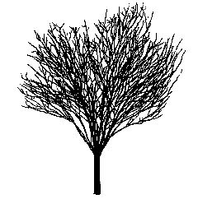

Green Vase®

TREES GROUPED BY SITE OR PLANTING CONDITIONS

I. SOIL MOISTURE AND pH CHART

BOTANICAL NAME | COMMON NAME
BOTANICAL NAME | COMMON NAME | occasionally  saturated or  very wet soil |  |  | consistently  moist, well  drained soil |  |  | occasional  periods of  dry soil |  |  | prolonged  periods of  dry soil
BOTANICAL NAME | COMMON NAME | 1 | 2 | 3 | 4 | 5 | 6 | 7 | 8 | 9 | 10 | 11 | 12
pH < 7.0
Acer rubrum | Red Maple
Acer rubrum | Red Sunset®, ‘Bowhall’ | 1 | 2 | 3 | 4 | 5 | 6 | 7 | 8 | 9 | 10 | 11 | 12
Acer rubrum | ‘Autumn Flame’,  October Glory® | 1 | 2 | 3 | 4 | 5 | 6 | 7 | 8 | 9 | 10 | 11 | 12
Acer rubrum | Northwood®, ‘Karpick’ | 1 | 2 | 3 | 4 | 5 | 6 | 7 | 8 | 9 | 10 | 11 | 12
Betula nigra  ‘Cully’ & ‘BNMTF’ | Heritage® & Dura-Heat™  River Birch | 1 | 2 | 3 | 4 | 5 | 6 | 7 | 8 | 9 | 10 | 11 | 12
Quercus palustris | Pin Oak | 1 | 2 | 3 | 4 | 5 | 6 | 7 | 8 | 9 | 10 | 11 | 12
pH < 7.5
Acer buergerianum | Trident Maple | 1 | 2 | 3 | 4 | 5 | 6 | 7 | 8 | 9 | 10 | 11 | 12
Acer saccharum | Sugar Maple | 1 | 2 | 3 | 4 | 5 | 6 | 7 | 8 | 9 | 10 | 11 | 12
Acer x freemanii | Freeman Maple | 1 | 2 | 3 | 4 | 5 | 6 | 7 | 8 | 9 | 10 | 11 | 12
Amelanchier species | Serviceberry  Species and Hybrids | 1 | 2 | 3 | 4 | 5 | 6 | 7 | 8 | 9 | 10 | 11 | 12
Betula populifolia  ‘Whitespire Sr.’ | Whitespire Sr. Gray Birch | 1 | 2 | 3 | 4 | 5 | 6 | 7 | 8 | 9 | 10 | 11 | 12
Carpinus caroliniana | Ironwood | 1 | 2 | 3 | 4 | 5 | 6 | 7 | 8 | 9 | 10 | 11 | 12
Celtis laevigata | Sugar Hackberry | 1 | 2 | 3 | 4 | 5 | 6 | 7 | 8 | 9 | 10 | 11 | 12
Liquidambar styraciflua | American Sweetgum | 1 | 2 | 3 | 4 | 5 | 6 | 7 | 8 | 9 | 10 | 11 | 12
Nyssa sylvatica | Black Tupelo | 1 | 2 | 3 | 4 | 5 | 6 | 7 | 8 | 9 | 10 | 11 | 12
Prunus ‘Accolade’ | Accolade Flowering Cherry | 1 | 2 | 3 | 4 | 5 | 6 | 7 | 8 | 9 | 10 | 11 | 12
Prunus ‘Snow Goose’ | Snow Goose Cherry | 1 | 2 | 3 | 4 | 5 | 6 | 7 | 8 | 9 | 10 | 11 | 12
Prunus sargentii | Sargent Cherry | 1 | 2 | 3 | 4 | 5 | 6 | 7 | 8 | 9 | 10 | 11 | 12
Prunus virginiana  ‘Canada Red Select’ | Canada Red Chokecherry | 1 | 2 | 3 | 4 | 5 | 6 | 7 | 8 | 9 | 10 | 11 | 12
Quercus acutissima | Sawtooth Oak | 1 | 2 | 3 | 4 | 5 | 6 | 7 | 8 | 9 | 10 | 11 | 12
Quercus bicolor | Swamp White Oak | 1 | 2 | 3 | 4 | 5 | 6 | 7 | 8 | 9 | 10 | 11 | 12
Quercus coccinea | Scarlet Oak | 1 | 2 | 3 | 4 | 5 | 6 | 7 | 8 | 9 | 10 | 11 | 12
Quercus imbricaria | Shingle Oak | 1 | 2 | 3 | 4 | 5 | 6 | 7 | 8 | 9 | 10 | 11 | 12
Quercus phellos | Willow Oak | 1 | 2 | 3 | 4 | 5 | 6 | 7 | 8 | 9 | 10 | 11 | 12
Quercus rubra | Northern Red Oak | 1 | 2 | 3 | 4 | 5 | 6 | 7 | 8 | 9 | 10 | 11 | 12
Taxodium distichum | Common Baldcypress | 1 | 2 | 3 | 4 | 5 | 6 | 7 | 8 | 9 | 10 | 11 | 12
pH < 8.2
Acer campestre | Hedge Maple | 1 | 2 | 3 | 4 | 5 | 6 | 7 | 8 | 9 | 10 | 11 | 12
Acer miyabei | Miyabei Maple | 1 | 2 | 3 | 4 | 5 | 6 | 7 | 8 | 9 | 10 | 11 | 12
Acer platanoides | Norway Maple | 1 | 2 | 3 | 4 | 5 | 6 | 7 | 8 | 9 | 10 | 11 | 12
Acer pseudoplatanus | Sycamore Maple | 1 | 2 | 3 | 4 | 5 | 6 | 7 | 8 | 9 | 10 | 11 | 12
Acer tataricum | Tartarian Maple | 1 | 2 | 3 | 4 | 5 | 6 | 7 | 8 | 9 | 10 | 11 | 12
Acer tataricum ssp. ginnala | Amur Maple | 1 | 2 | 3 | 4 | 5 | 6 | 7 | 8 | 9 | 10 | 11 | 12
Acer truncatum | Shantung Maple | 1 | 2 | 3 | 4 | 5 | 6 | 7 | 8 | 9 | 10 | 11 | 12

BOTANICAL NAME | COMMON NAME
BOTANICAL NAME | COMMON NAME | occasionally  saturated or  very wet soil |  |  | consistently  moist, well  drained soil |  |  | occasional  periods of  dry soil |  |  | prolonged  periods of  dry soil
BOTANICAL NAME | COMMON NAME | 1 | 2 | 3 | 4 | 5 | 6 | 7 | 8 | 9 | 10 | 11 | 12
pH < 8.2 (continued)
Aesculus x carnea | Red Horsechestnut | 1 | 2 | 3 | 4 | 5 | 6 | 7 | 8 | 9 | 10 | 11 | 12
Alnus glutinosa | European Alder | 1 | 2 | 3 | 4 | 5 | 6 | 7 | 8 | 9 | 10 | 11 | 12
Carpinus betulus | European Hornbeam | 1 | 2 | 3 | 4 | 5 | 6 | 7 | 8 | 9 | 10 | 11 | 12
Catalpa speciosa | Northern Catalpa | 1 | 2 | 3 | 4 | 5 | 6 | 7 | 8 | 9 | 10 | 11 | 12
Celtis occidentalis | Common Hackberry | 1 | 2 | 3 | 4 | 5 | 6 | 7 | 8 | 9 | 10 | 11 | 12
Cercidiphyllum japonicum | Katsura Tree | 1 | 2 | 3 | 4 | 5 | 6 | 7 | 8 | 9 | 10 | 11 | 12
Cercis canadensis | Eastern Redbud | 1 | 2 | 3 | 4 | 5 | 6 | 7 | 8 | 9 | 10 | 11 | 12
Cladrastis kentukea | Yellowwood | 1 | 2 | 3 | 4 | 5 | 6 | 7 | 8 | 9 | 10 | 11 | 12
Cornus mas | Corneliancherry Dogwood | 1 | 2 | 3 | 4 | 5 | 6 | 7 | 8 | 9 | 10 | 11 | 12
Corylus colurna | Turkish Filbert | 1 | 2 | 3 | 4 | 5 | 6 | 7 | 8 | 9 | 10 | 11 | 12
Cotinus obovatus | American Smoketree | 1 | 2 | 3 | 4 | 5 | 6 | 7 | 8 | 9 | 10 | 11 | 12
Crataegus crus-galli  var. inermis | Thornless Cockspur  Hawthorn | 1 | 2 | 3 | 4 | 5 | 6 | 7 | 8 | 9 | 10 | 11 | 12
Crataegus phaenopyrum | Washington Hawthorn | 1 | 2 | 3 | 4 | 5 | 6 | 7 | 8 | 9 | 10 | 11 | 12
Crataegus punctata  var. inermis ‘Ohio Pioneer’ | Ohio Pioneer  Dotted Hawthorn | 1 | 2 | 3 | 4 | 5 | 6 | 7 | 8 | 9 | 10 | 11 | 12
Crataegus viridis ‘Winter King’ | Winter King Hawthorn | 1 | 2 | 3 | 4 | 5 | 6 | 7 | 8 | 9 | 10 | 11 | 12
Eucommia ulmoides | Hardy Rubber Tree | 1 | 2 | 3 | 4 | 5 | 6 | 7 | 8 | 9 | 10 | 11 | 12
Fraxinus americana | White Ash | 1 | 2 | 3 | 4 | 5 | 6 | 7 | 8 | 9 | 10 | 11 | 12
Fraxinus excelsior | European Ash | 1 | 2 | 3 | 4 | 5 | 6 | 7 | 8 | 9 | 10 | 11 | 12
Fraxinus ‘Northen Gem’ and  ‘Northern Treasure’ | Northen Gem Ash and  Northern Treasure Ash | 1 | 2 | 3 | 4 | 5 | 6 | 7 | 8 | 9 | 10 | 11 | 12
Fraxinus pennsylvanica | Green Ash | 1 | 2 | 3 | 4 | 5 | 6 | 7 | 8 | 9 | 10 | 11 | 12
Ginkgo biloba | Ginkgo | 1 | 2 | 3 | 4 | 5 | 6 | 7 | 8 | 9 | 10 | 11 | 12
Gleditsia triacanthos  var. inermis | Thornless Common  Honeylocust | 1 | 2 | 3 | 4 | 5 | 6 | 7 | 8 | 9 | 10 | 11 | 12
Gymnocladus dioicus | Kentucky Coffeetree | 1 | 2 | 3 | 4 | 5 | 6 | 7 | 8 | 9 | 10 | 11 | 12
Koelreuteria paniculata | Goldenraintree | 1 | 2 | 3 | 4 | 5 | 6 | 7 | 8 | 9 | 10 | 11 | 12
Liriodendron tulipifera | Tuliptree | 1 | 2 | 3 | 4 | 5 | 6 | 7 | 8 | 9 | 10 | 11 | 12
Maclura pomifera var. inermis | Osage Orange | 1 | 2 | 3 | 4 | 5 | 6 | 7 | 8 | 9 | 10 | 11 | 12
Malus species | Crabapple | 1 | 2 | 3 | 4 | 5 | 6 | 7 | 8 | 9 | 10 | 11 | 12
Metasequoia glyptostroboides | Dawn Redwood | 1 | 2 | 3 | 4 | 5 | 6 | 7 | 8 | 9 | 10 | 11 | 12
Ostrya virginiana | American Hophornbeam | 1 | 2 | 3 | 4 | 5 | 6 | 7 | 8 | 9 | 10 | 11 | 12
Parrotia persica | Persian Parrotia | 1 | 2 | 3 | 4 | 5 | 6 | 7 | 8 | 9 | 10 | 11 | 12
Phellodendron amurense | Amur Corktree | 1 | 2 | 3 | 4 | 5 | 6 | 7 | 8 | 9 | 10 | 11 | 12
Platanus x acerifolia | London Planetree | 1 | 2 | 3 | 4 | 5 | 6 | 7 | 8 | 9 | 10 | 11 | 12
Pyrus betulaefolia | Birchleaf Pear | 1 | 2 | 3 | 4 | 5 | 6 | 7 | 8 | 9 | 10 | 11 | 12
Pyrus calleryana | Callery Pear | 1 | 2 | 3 | 4 | 5 | 6 | 7 | 8 | 9 | 10 | 11 | 12
Pyrus fauriei ‘Westwood’ | Korean Sun™ Pear | 1 | 2 | 3 | 4 | 5 | 6 | 7 | 8 | 9 | 10 | 11 | 12
Pyrus ussuriensis | Ussurian Pear | 1 | 2 | 3 | 4 | 5 | 6 | 7 | 8 | 9 | 10 | 11 | 12
Quercus macrocarpa | Bur Oak | 1 | 2 | 3 | 4 | 5 | 6 | 7 | 8 | 9 | 10 | 11 | 12
Quercus muehlenbergii | Chinkapin Oak | 1 | 2 | 3 | 4 | 5 | 6 | 7 | 8 | 9 | 10 | 11 | 12
Quercus robur | English Oak | 1 | 2 | 3 | 4 | 5 | 6 | 7 | 8 | 9 | 10 | 11 | 12
Quercus shumardii | Schumard Oak | 1 | 2 | 3 | 4 | 5 | 6 | 7 | 8 | 9 | 10 | 11 | 12

BOTANICAL NAME | COMMON NAME
BOTANICAL NAME | COMMON NAME | occasionally  saturated or  very wet soil |  |  | consistently  moist, well  drained soil |  |  | occasional  periods of  dry soil |  |  | prolonged  periods of  dry soil
BOTANICAL NAME | COMMON NAME | 1 | 2 | 3 | 4 | 5 | 6 | 7 | 8 | 9 | 10 | 11 | 12
pH < 8.2 (continued)
Robinia pseudoacacia | Black Locust | 1 | 2 | 3 | 4 | 5 | 6 | 7 | 8 | 9 | 10 | 11 | 12
Sorbus alnifolia | Korean Mountainash | 1 | 2 | 3 | 4 | 5 | 6 | 7 | 8 | 9 | 10 | 11 | 12
Sorbus intermedia | Swedish Mountainash | 1 | 2 | 3 | 4 | 5 | 6 | 7 | 8 | 9 | 10 | 11 | 12
Sorbus x hybrida and  Sorbus x thuringiaca | Oak-Leaf Mountainash | 1 | 2 | 3 | 4 | 5 | 6 | 7 | 8 | 9 | 10 | 11 | 12
Styphnolobium japonicum  (Sophora japonica) | Japanese Pagodatree | 1 | 2 | 3 | 4 | 5 | 6 | 7 | 8 | 9 | 10 | 11 | 12
Syringa reticulata | Japanese Tree Lilac | 1 | 2 | 3 | 4 | 5 | 6 | 7 | 8 | 9 | 10 | 11 | 12
Tilia americana | Basswood | 1 | 2 | 3 | 4 | 5 | 6 | 7 | 8 | 9 | 10 | 11 | 12
Tilia cordata | Littleleaf Linden | 1 | 2 | 3 | 4 | 5 | 6 | 7 | 8 | 9 | 10 | 11 | 12
Tilia x euchlora | Crimean Linden | 1 | 2 | 3 | 4 | 5 | 6 | 7 | 8 | 9 | 10 | 11 | 12
Tilia tomentosa | Silver Linden | 1 | 2 | 3 | 4 | 5 | 6 | 7 | 8 | 9 | 10 | 11 | 12
Ulmus americana | American Elm | 1 | 2 | 3 | 4 | 5 | 6 | 7 | 8 | 9 | 10 | 11 | 12
Ulmus parvifolia | Chinese Elm | 1 | 2 | 3 | 4 | 5 | 6 | 7 | 8 | 9 | 10 | 11 | 12
Ulmus x species | Elm Hybrids | 1 | 2 | 3 | 4 | 5 | 6 | 7 | 8 | 9 | 10 | 11 | 12
Viburnum sieboldii | Siebold Viburnum | 1 | 2 | 3 | 4 | 5 | 6 | 7 | 8 | 9 | 10 | 11 | 12
Zelkova serrata | Japanese Zelkova | 1 | 2 | 3 | 4 | 5 | 6 | 7 | 8 | 9 | 10 | 11 | 12

II. TREES THAT TOLERATE PARTIAL SHADE

BOTANICAL NAME | COMMON NAME
Acer miyabei | Miyabei Maple
+Acer platanoides | Norway Maple
Acer psuedoplatanus | Sycamore Maple
Acer saccharum | Sugar Maple
Acer tataricum | Tartarian Maple
Acer tataricum ssp. ginnala | Amur Maple
Alnus glutinosa | European Alder
Amelanchier species | Serviceberry Species and Hybrids
Betula nigra ‘Cully’ & ‘BNMTF’ | Heritage®& Dura-Heat™ River Birch
*Carpinus caroliniana | Ironwood
Celtis laevigata | Sugar Hackberry
Celtis occidentalis | Common Hackberry
Cercidiphyllum japonicum | Katsura Tree
Cercis canadensis | Eastern Redbud
Cornus mas | Corneliancherry Dogwood
Ostrya virginiana | American Hophornbeam
Parrotia persica | Persian Parrotia
+Robinia pseudoacacia | Black Locust
Sorbus alnifolia | Korean Mountainash
Sorbus x hybrida and  Sorbus x thuringiaca | Oak-Leaf Mountainash
Syringa reticulata | Japanese Tree Lilac
Viburnum sieboldii | Siebold Viburnum
* prefers partial shade
+ tolerates full shade

III. TREES OBSERVED TO HAVE SOME SALT TOLERANCE

BOTANICAL NAME | COMMON NAME
Acer buergerianum | Trident Maple
Acer campestre | Hedge Maple
Acer platanoides | Norway Maple
Acer pseudoplatanus | Sycamore Maple
Acer tataricum | Tartarian Maple
Acer tataricum ssp. ginnala | Amur Maple
Alnus glutinosa | European Alder
Cercis canadensis | Eastern Redbud
Cornus mas | Corneliancherry Dogwood
Crataegus crus-galli var. inermis | Thornless Cockspur Hawthorn
Crataegus phaenopyrum | Washington Hawthorn
Crataegus punctata var.  inermis ‘Ohio Poineer’ | Ohio Pioneer Dotted Hawthorn
Crataegus viridis ‘Winter King’ | ‘Winter King’ Hawthorn
Fraxinus americana | White Ash
Fraxinus excelsior | European Ash
Fraxinus pennsylvanica | Green Ash
Ginkgo biloba | Ginkgo
Gleditsia triacanthos var. inermis | Thornless Common Honeylocust
Koelreuteria paniculata | Goldenraintree
Maclura pomifera var. inermis | Osage Orange
Malus species | Crabapple
Nyssa sylvatica | Black Tupelo
Platanus x acerifolia | London Planetree
Prunus ‘Accolade’ | Accolade Flowering Cherry
Prunus sargentii | Sargent Cherry
Pyrus calleryana | Callery Pear
Quercus acutissima | Sawtooth Oak
Quercus robur | English Oak
Quercus rubra | Northern Red Oak
Robinia pseudoacacia | Black Locust
Styphnolobium japonicum  (Sophora japonica) | Japanese Pagodatree
Syringa reticulata | Japanese Tree Lilac
Taxodium distichum | Common Baldcypress
Ulmus americana | American Elm
Ulmus parvifolia | Chinese Elm
Ulmus x species | Elm Hybrids
Zelkova serrata | Japanese Zelkova

IV. trees sensitive to salt

BOTANICAL NAME | COMMON NAME
Acer rubrum | Red Maple
Acer saccharum | Sugar Maple
Amelanchier species | Serviceberry Species and Hybrids
Carpinus betulus | European Hornbeam
Carpinus caroliniana | Ironwood
Cercidiphyllum japonicum | Katsura Tree
Liriodendron tulipifera | Tuliptree
Ostrya virginiana | American Hophornbeam
Quercus palustris | Pin Oak
Tilia americana | Basswood
Tilia cordata | Littleleaf Linden
Tilia x euchlora | Crimean Linden

V. TREES SUITABLE FOR USE IN CU-STRUCTURAL SOIL™

BOTANICAL NAME | COMMON NAME
Acer campestre | Hedge Maple
Acer miyabei | Miyabei Maple
Acer platanoides | Norway Maple
Acer pseudoplatanus | Sycamore Maple
Acer truncatum | Shantung Maple
Carpinus betulus | European Hornbeam
Catalpa speciosa | Northern Catalpa
Celtis occidentalis | Common Hackberry
Cercis canadensis | Eastern Redbud
Cornus mas | Corneliancherry Dogwood
Corylus colurna | Turkish Filbert
Crataegus crus-galli var. inermis | T Thornless Cockspur Hawthorn
Crataegus phaenopyrum | Washington Hawthorn
Crataegus punctata var. inermis ‘Ohio Pioneer’ | Ohio Pioneer Dotted Hawthorn
Crataegus viridis ‘Winter King’ | Winter King Hawthorn
Eucommia ulmoides | Hardy Rubber Tree
Fraxinus americana | White Ash
Fraxinus excelsior | European Ash
Fraxinus ‘Northen Gem’ and  ‘Northern Treasure’ | Northen Gem Ash and  Northern Treasure Ash
Fraxinus pennsylvanica | Green Ash
Ginkgo biloba | Ginkgo
Gleditsia triacanthos var. inermis | Thornless Common Honeylocust
Gymnocladus dioicus | Kentucky Coffeetree
Koelreuteria paniculata | Goldenraintree
Maclura pomifera var. inermis | Osage Orange
Malus species | Crabapple
Parrotia persica | Persian Parrotia
Phellodendron amurense | Amur Corktree
Platanus x acerifolia | London Planetree
Pyrus betulaefolia | Birchleaf Pear
Pyrus calleryana | Callery Pear
Pyrus fauriei ‘Westwood’ | Korean Sun™ Pear
Pryus ussuriensis | Ussurian Pear
Quercus macrocarpa | Bur Oak
Quercus muehlenbergii | Chinkapin Oak
Quercus robur | English Oak
Robinia pseudoacacia | Black Locust
Sorbus alnifolia | Korean Mountainash
Sorbus intermedia | Swedish Mountainash
Sorbus x hybrida and  Sorbus x thuringiaca | Oak-Leaf Mountainash
Styphnolobium japonicum  (Sophora japonica) | Japanese Pagodatree
Syringa reticulata | Japanese Tree Lilac
Tilia americana | Basswood
Tilia cordata | Littleleaf Linden
Tilia x euchlora | Crimean Linden
Tilia tomentosa | Silver Linden
Ulmus americana | American Elm
Ulmus parvifolia | Chinese Elm
Ulmus x species | Elm Hybrids
Zelkova serrata | Japanese Zelkova

VI. TREES EASY TO TRANSPLANT < 2” CALIPER BARE ROOT

BOTANICAL NAME | COMMON NAME
Acer campestre | Hedge Maple
Acer x freemanii | Freeman Maple
Acer miyabei | Miyabei Maple
Acer tartaricum | Tartaricum Maple
Acer tartaricum ssp. ginnala | Amur Maple
Acer platanoides | Norway Maple
Acer pseudoplatanus | Sycamore maple
Acer rubrum | Red Maple
Acer saccharum | Sugar Maple
Acer truncatum | Shantung Maple
Aesculus x carnea | Red Horsechestnut
Amelanchier species | Serviceberry Species and Hybrids
Catalpa speciosa | Northen Catalpa
Cercidiphyllum japonicum | Katsura Tree
Cladrastis kentukea | Yellowwood
Cornus mas | Corneliancherry Dogwood
Fraxinus americana | White Ash
Fraxinus excelsior | European Ash
Fraxinus pennsylvanica | Green Ash
Gleditsia triacanthos var. inermis | Thornless Common Honeylocust
Gymnocladus dioicus | Kentucky Coffeetree
Koelreuteria paniculata | Goldenraintree
Malus species | Crabapple
Parrotia persica | Persian Parrotia
Phellodendron amurense | Amur Corktree
Platanus x acerifolia | London Planetree
Prunus ‘Accolade’ | Accolade Flowering Cherry
Prunus sargentii | Sargent Cherry
Prunus virginiana ‘Canada Red Select’ | Cananda Red Chokecherry
Pryus calleryana | Callery Pear
Pyrus betulaefolia | Birchleaf Pear
Pyrus fauriei ‘Westwood’ | Korean Sun™ Pear
Pyrus ussuriensis | Ussarian Pear
Quercus bicolor | Swamp White Oak
Robinia pseudoacacia cultivars:  ‘Purple Robe,’ ‘Prymidalis,’  ‘Globosum,’ ‘Bessoniana’ | Black Locust
Sorbus alnifolia | Korean Mountainash
Sorbus intermedia | Swedish Mountainash
Sorbus x hybrida and  Sorbus x thuringiaca | Oak-Leaf Mountainash
Syringa reticulata | Japanese Tree Lilac
Tilia cordata | Littleleaf Linden
Tilia x euchlora | Crimean Linden
Ulmus americana | American Elm
Ulmus x species, except ‘Frontier’ | Elm Hybrids
Viburnum sieboldii | Siebold Viburnum
Zelkova serrata | Japanese Zelkova

VI. TREES MODERATELY DIFFICULT TO TRANSPLANT BARE ROOT
(Note: with below species we have better success transplanting in fall
and do not attempt to transplant > 2” caliper trees bare root)

BOTANICAL NAME | COMMON NAME
Alnus glutinosa | European Alder
Betula spp. | Birch Species
Celtis laevigata | Sugar Hackberry
Celtis occcidentalis | Common Hackberry
Cercis canadensis | Eastern Redbud
Crataegus crus-galli var. inermis | Thornless Cockspur Hawthorn
Crataegus viridis ‘Winter King’ | ‘Winter King’ Hawthorn
Quercus palustris | Pin Oak
Quercus robur | English Oak
Quercus rubra | Nothern Red Oak
Tilia tomentosa | Silver Linden

VIII. TREES DIFFICULT TO TRANSPLANT BARE ROOT

BOTANICAL NAME | COMMON NAME
Carpinus betulus | European Hornbeam
Carpinus caroliniana | Ironwood
Corylus colurna | Turkish Filbert
Cotinus obovatus | American Smoketree
Crataegus phaenopyrum | Washington Hawthorn
Ginkgo biloba | Ginkgo
Liriodendron tulipifera | Tuliptree
Ostrya virginiana | American Hophornbeam
Quercus coccinea | Scarlet Oak
Quercus imbricaria | Shingle Oak
Quercus macrocarpa | Bur Oak
Quercus muehlenbergii | Chinkapin Oak
Taxodium distichum | Common Baldcypress
Ulmus ‘Fontier’ | Frontier Elm

TRANSPLANTING GUIDE

Planting guide covers:

Selecting high-quality nursery trees

Handling, transporting and storing nursery trees

Transplanting ball and burlap, container and bare root trees

Post-planting maintenance

1. Selecting high-quality nursery trees
The goal in selecting nursery plants is to purchase those plants most likely to become successfully established and to mature in the landscape in order to meet design expectations with a minimum of maintenance. To do that, choose plants with good root systems and healthy, well-formed and undamaged crowns and trunks. In addition, any plant that you purchase should have a professional pedigree: grown in a nursery, dug and prepared for shipping by trained workers, and maintained properly while awaiting purchase. That is, buy plants from nurseries with good reputations and whose people you trust. Chances are that plants from reputable nurseries will have been treated properly and will establish reliably.

There are specific characteristics to look for (and look out for) when selecting nursery plants.

a. Trunk and Branch Characteristics
1. Buy plants that have a form typical of the species.
2. Shoots should show good vigor and growth.
3. Branches should be well-spaced and have good branch attachment. Avoid narrow branch attachments that may have included bark.
4. Crowns should be reasonably free of wounds and/or evidence of insect damage and/or disease.
5. Avoid top-heavy trees and plants that have been severely headed back.
6. Trunks should be straight, free from wounds or diseases and show trunk flare and proper trunk taper.

b. Foliage Characteristics
1. Foliage should have good color, with no sign of insect pests and/or diseases.
2. There should be an adequate number and size of leaves.
3. Avoid plants with leaf margins that are scorched. It is a sign of water stress.

c. Root and Rootball Characteristics
- 1. All plants should have an adequate-sized rootball as specified by the American
- Standard for Nursery Stock.
2. Roots should have a good connection with the shoots—if you gently rock the plant, the entire rootball should move.
3. Ball and burlap rootballs should be covered with natural burlap.
4. Container plants should not be pot-bound and, if you gently remove a plant from its pot, you should see healthy whitish root tips.
5. Avoid plants with kinked root systems. It is hard to determine if a plant has a kinked root, but if you see one, do not buy that plant.
6. Avoid plants with weedy rootballs.

2. Handling, transporting and storing nursery trees
The objective in handling, transporting and storing nursery plants is to minimize water stress and ensure a good connection between the roots and the shoots. To minimize water stress, use techniques in handling, transporting and storing plants that reduce transpirational stress while providing enough water to meet plant requirements. The following are recommended techniques for nursery plants (the most important recommendations appear in boldface type).

a. Handling
1. Always carry the plant by the rootball, never solely by the trunk or branches.
2. Keep any wrap or other protection on the plant when handling, transporting or storing.
3. Avoid dropping or crushing the rootball.
4. Pad the edges of machinery that handles plants to avoid wounding.
5. Tie up branches with a gentle hand. They can easily crack or break.

b. Transporting
1. Tarp all plants in transit, preferably with a breathable mesh covering.
2. Rootballs should be moist before transporting.
3. Plants should be placed in truck so there is a minimum of shifting and movement while in transit.
4. If possible, support trunks.

c. Storing Trees at the Jobsite or Holding Yard
1. Make sure plants are well watered. Daily or even more frequent irrigation may be needed during summer months.
2. Store plants in a shady location.
3. Group plants together.
4. Heel plants into mulch or soil if they are to be stored for a long time.

3. Transplanting ball and burlap, container and bare root trees
The goal in transplanting is to make every effort to allow the plant to become established quickly by encouraging the swift regeneration and regrowth of the root system. To do this, the planting hole should be wide and shallow (mimicking the shape of the plant’s root system), backfilled appropriately, and the tree or shrub planted at the proper depth. The decision on whether or not to amend the backfill with organic material depends on the soil texture and drainage characteristics of the site.

a. The Planting Hole
1. Dig the planting hole 2 - 3 times the diameter (width) of the rootball and no deeper than the depth of the rootball.
2. Loosening or tilling the entire landscape bed is preferred over digging individual planting holes. If compacted, add at least 30% organic matter to the entire site - not just within the individual hole.
3. Avoid planting when the soil is very moist because wet soil has a tendency to glaze and become compacted.

b. Removing Rootball Coverings
In general, rootball coverings that will impede root growth should be removed. Not all materials that look like natural burlap (which degrades slowly, but surely) are natural burlap, and may not degrade much, if at all. Depending on what type of burlap was used, you will have to be more or less vigorous in your efforts to remove it before planting.

Natural burlap Remove excess burlap from around rootball and any burlap that has been wrapped around the trunk. Be sure that there will be good soil contact between the rootball and the backfill.
Synthetic burlap, treated burlap, carpet backing, synthetic/natural blend It is best to remove the burlap—but be careful to keep the rootball intact. If you do not think you can pull all the burlap away from the plant without the rootball remaining intact, cut away as much as possible.
Natural and synthetic twine Remove all twine that is wrapped around the trunk of the tree or shrub.

Wire baskets Use this two-step approach to remove wire baskets without jeopardizing the rootball:
1. before the plant is placed in the hole, cut away the bottom few “rungs” of the basket
2. place the plant in the hole, using the remaining part of the basket to move and face the plant, backfill up to the wire, then remove the remaining wire. In this way, the wire basket is removed only when the plant is stable in the planting hole.
Container plants If the plant is not pot bound, tease out the roots with your fingers. If the plant is pot bound, make four 1" slices with a knife, spade or trowel down the sides of the pot and also slice the bottom of the rootball. Tease out roots with your fingers.

c. Placing the Tree in the Hole and Backfilling
1. Place the plant in the hole by handling the rootball only. Face and plumb the plant appropriately.
2. Plant tree at the proper depth. The rootball should be set so that the trunk flare is exactly at the existing grade in loamy or sandy soils, and above the existing grade in clayey or poorly drained soils (up to 1/3 rd of the ball can be above the existing grade). Make sure that you have uncovered the trunk flare. Soil can be added inadvertently covering the flare during digging at the nursery.
3. Backfill firmly, but without overly compacting the soil. Try to eliminate air pockets. Some landscapers partially backfill the hole, irrigate, then allow the water to fully drain before completing the backfilling. This helps eliminate air pockets.
4. Do not cover the trunk with soil; the backfill should come right up to the rootball, but little, if any soil should cover the rootball.
5. If you wish, form a 2 - 3" soil rim at the edge of the planting hole. The rim helps hold in water and direct it to the roots, but be sure to remove the rim within two years (roots should be beyond the planting hole by then).
6. There is no need to fertilize the tree or shrub at planting. If you feel you must fertilize—go lightly! Incorporate no more than 1 - 2 pounds of slow-release nitrogen per 1000 square feet in the backfill. Too much fertilizer will burn the roots.
7. Avoid planting when the soil is very moist. It is difficult to work the soil, and the risk of glazing and compacting the soil is great.

d. Planting Bare Root Trees
Bare root trees are handled and planted in much the same manner as balled and burlapped and container plants. The planting hole is dug 2 - 3 times the width of the root mass, and dug only as deep as the roots. The decision to amend or not to amend hinges on soil texture as previously described. There are, however, a few techniques that you can use to increase the success of bare root plantings.
1. Research at Cornell University has shown that dipping the roots of a recently dug bare root tree in a slurry of hydrogel and water aids in preventing the desiccation of the roots in transit between the nursery and the planting site. The slurry creates a reservoir of water that helps the roots avoid desiccation.
2. If you must store bare root trees for a few days before planting, keep the them in a cool, shaded location.
3. If root ends appear jagged or split, cut them cleanly with a sterilized pair of pruning shears.
4. When backfilling, be sure that you fill all air spaces with soil—avoid large pockets of air which inhibit root growth.
5. Stake if necessary and water in well.
*For a complete description of bare root transplanting contact the Urban Horticulture Institute to receive the Creating the Urban Forest: The Bare Root Method booklet and/or video. The booklet is available on line at the UHI website: <http://www.hort.cornell.edu/uhi>
e. Completing the Planting
1. Create a mulch ring using a layer of 2 - 3" of mulch. Do not over-apply mulch, and keep it away from the trunk. There should not be any mulch touching the trunk.
2. Water the tree in well. Irrigating supplies needed water, helps to remove air pockets and improves soil contact with the rootball.
3. Prune to remove dead, diseased, damaged, crossing branches and competing leaders.
4. Stake the tree only if necessary. Know that any material you use on a tree must be removed within a year to prevent girdling. If you must stake, stake so the tree can move in the wind and use materials that minimize rubbing.

4. Post-planting Maintenance

a. Maintenance in the First Growing Season
1. Irrigate the plants as frequently as is necessary to keep rootball moist, but not too wet. As a rule of thumb, start with two waterings per week for the first few months, then drop to once a week through the rest of the growing season. When you water, water well.
2. Maintain the 2 - 3" mulch layer. Keep weeds to a minimum.
3. Use fertilizer only if you have determined, by visual inspection of growth and/or by a nutrient analysis test, that the plant requires additional nutrients. Usually, nitrogen is the only deficient nutrient. If you choose to fertilize, broadcast 1-2 pounds of nitrogen per 1000 square feet per year of a slow release fertilizer before budbreak.
4. After the first growing season, evaluate the structure of the plant and do any necessary structural pruning.

b. Planting in Poorly Drained Soils
Most plants cannot live in waterlogged or poorly drained soils. If you must plant in poorly drained soils, be sure that the species you have selected tolerate wet soil. In addition to planting high, you may need to take additional steps to improve drainage within the planting hole.

1. Plant high as described for clayey soils. The mound that is created by planting high reduces the amount of water that enters the planting hole—water simply runs off the mound and away from the rootball.
2. Place the rootball on a pedestal of undisturbed soil so that excess water can pool below the rootball before the water slowly moves further down the soil profile.
3. Install a sump at the bottom of the planting hole that acts as a reservoir for excess water. A sump is made by using a post-hole digger to dig a 2 - 3' deep hole at the bottom of the planting hole, but as near to the rootball as possible. Place a slotted plastic pipe in the hole and fill the pipe with gravel. Cover the top of the pipe with geotextile fabric.

